TwinCAT connect with LAUNCHXL-F28P65X properly in OP mode.
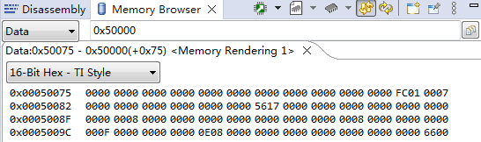
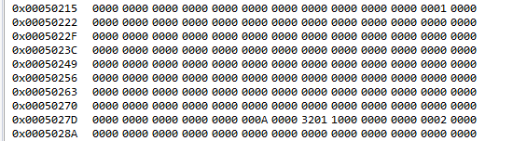

After TwinCAT connect with LAUNCHXL-F28P65X in OP mode，disconnect the CABLE then Connect the Cable to the PC until the issue is reproduced, TwinCAT cannot connect with LAUNCHXL-F28P65X，2 LEDs in RJ45 is turned off，PC shows the internet CABLE is disconnected
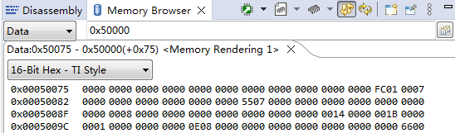
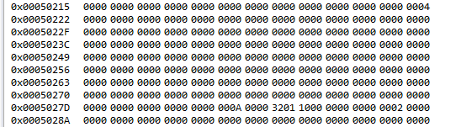

After TwinCAT connect with LAUNCHXL-F28P65X in OP mode，Power cycle the board until the issue is reproduced, TwinCAT cannot connect with LAUNCHXL-F28P65X，2 LEDs in RJ45 is turned off，PC shows the internet CABLE is disconnected
