#include "DSP2803x_Device.h"
#include "IQmathLib.h"

extern void InitSysCtrl(void);
extern void InitPieCtrl(void);
extern void InitPieVectTable(void);

void Gpio_select(void);
void Setup_ePWM1(void);

interrupt void ePWM1A_compare_isr(void);

unsigned long int TBPD=20000;
static unsigned int index1 = 0;
int a,b;

//###########################################################################
// main code
//###########################################################################
void main(void)
{
InitSysCtrl(); // Basic Core Init from DSP2803x_SysCtrl.c

EALLOW;
SysCtrlRegs.WDCR= 0x00AF; // Re-enable the watchdog
EDIS; // 0x00AF to NOT disable the Watchdog, Prescaler = 64

DINT; // Disable all interrupts

Gpio_select();

InitPieCtrl(); // basic setup of PIE table; from DSP2803x_PieCtrl.c

InitPieVectTable(); // default ISR's in PIE

Setup_ePWM1(); // Initialization of ePWM1A

EALLOW;
PieVectTable.EPWM1_INT = &ePWM1A_compare_isr; // Assigning "ePWM1_compare_isr" to EPwm Interrupt
EDIS;

PieCtrlRegs.PIEIER3.bit.INTx1 = 1; // Enable EPWM1A INT in the PIE: Group 3 interrupt 1

IER |= 0x4; // enable interrupt core line 3 (INT3).

EINT;
ERTM;

while(1)
{

EALLOW;
SysCtrlRegs.WDKEY = 0x55; // service WD #1
EDIS;
}

}

void Gpio_select(void)
{
EALLOW;
GpioCtrlRegs.GPAMUX1.all = 0; // GPIO15 ... GPIO0 = General Puropse I/O
GpioCtrlRegs.GPAMUX1.bit.GPIO0 = 1; // ePWM1A is Activated

GpioCtrlRegs.GPAMUX2.all = 0; // GPIO31 ... GPIO16 = General Purpose I/O
GpioCtrlRegs.GPBMUX1.all = 0; // GPIO44 ... GPIO32 = General Purpose I/O
EDIS;
}

void Setup_ePWM1(void)
{
// ****************************** ePWM1A ****************************************

EPwm1Regs.TBCTL.bit.CLKDIV = 0x0000; // CLKDIV = 1
EPwm1Regs.TBCTL.bit.HSPCLKDIV = 0x0001; // HSPCLKDIV = 2
EPwm1Regs.TBCTL.bit.CTRMODE = 0x0000; // Up Count mode
EPwm1Regs.TBCTL.bit.SYNCOSEL = 0x2; // Sync Output select CTR = CMPB

EPwm1Regs.TBPRD = TBPD; // For 1.5KHz PWM to generate 50Hz sine

EPwm1Regs.ETSEL.all = 0;
EPwm1Regs.ETSEL.bit.INTEN = 1; // interrupt enable for ePWM1
EPwm1Regs.ETSEL.bit.INTSEL = 2; // interrupt on PRD match (CTR = PRD)
EPwm1Regs.ETPS.bit.INTPRD = 1; // interrupt on first event

//---------------------------------------------------------------------------------------
}

interrupt void ePWM1A_compare_isr(void)
{

// Service watchdog every interrupt
EALLOW;
SysCtrlRegs.WDKEY = 0xAA; // service WD #2
EDIS;

if(index1 % 2 == 0)
{
EPwm1Regs.CMPB = 0;
}
else
{
EPwm1Regs.CMPB = EPwm1Regs.TBPRD;
}

if(index1 % 2 == 0)
{
//a = index1;
EPwm1Regs.TBCTL.bit.PHSDIR = 1; // Up count after Sync

EPwm1Regs.AQCTLA.bit.CAU = 0x2; // Set EPwm1A on CMPA Up
EPwm1Regs.AQCTLA.bit.PRD = 0x1; // Clear EPwm1A on TBPRD
}
else
{
//b = index1;
EPwm1Regs.TBCTL.bit.PHSDIR = 0; // Down count after Sync

EPwm1Regs.AQCTLA.bit.CAD = 0x2; // Set EPwm1A on CMPA Down
EPwm1Regs.AQCTLA.bit.ZRO = 0x1; // Clear EPwm1A on ZERO
}

EPwm1Regs.CMPA.half.CMPA = _IQsat(_IQ30mpy(_IQ30(0.2),EPwm1Regs.TBPRD),EPwm1Regs.TBPRD,0);

index1 += 1; // use next element out of lookup table
if(index1>30)
{
index1 = 1;
}

EPwm1Regs.ETCLR.bit.INT = 1; // Clear ePWM1 Interrupt flag

PieCtrlRegs.PIEACK.all = PIEACK_GROUP3; // or 4 (0000000000000100)

}

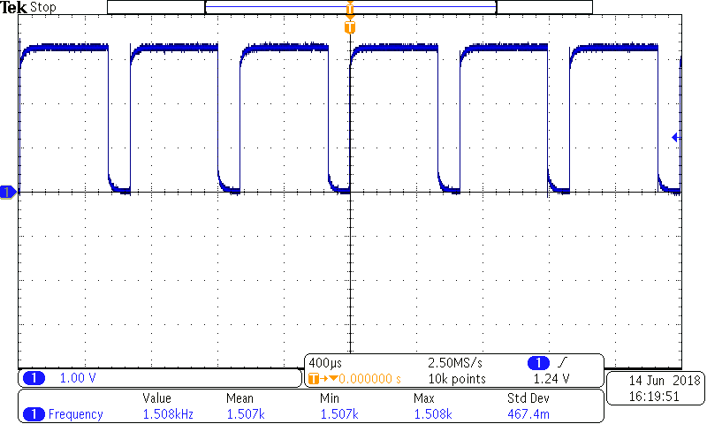

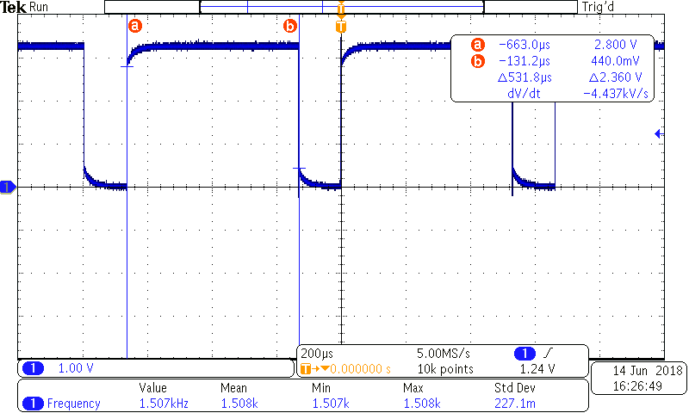

- Here only up-count is working. Down-count is not working.

