#include "DSP2803x_Device.h"
#include "IQmathLib.h"

extern void InitSysCtrl(void);
extern void InitPieCtrl(void);
extern void InitPieVectTable(void);

void Gpio_select(void);
void Setup_ePWM1(void);

interrupt void ePWM1A_compare_isr(void);

unsigned long int TBPD=20000;
static unsigned int index1 = 0;
int a,b;

//###########################################################################
// main code
//###########################################################################
void main(void)
{
InitSysCtrl(); // Basic Core Init from DSP2803x_SysCtrl.c

EALLOW;
SysCtrlRegs.WDCR= 0x00AF; // Re-enable the watchdog
EDIS; // 0x00AF to NOT disable the Watchdog, Prescaler = 64

DINT; // Disable all interrupts

Gpio_select();

InitPieCtrl(); // basic setup of PIE table; from DSP2803x_PieCtrl.c

InitPieVectTable(); // default ISR's in PIE

EALLOW;
PieVectTable.EPWM1_INT = &ePWM1A_compare_isr; // Assigning "ePWM1_compare_isr" to EPwm Interrupt
EDIS;

PieCtrlRegs.PIEIER3.bit.INTx1 = 1; // Enable EPWM1A INT in the PIE: Group 3 interrupt 1

IER |= 0x4; // enable interrupt core line 3 (INT3).

// Enable control – interrupts (EINT) and debug – interrupts (ERTM) globally.
// This is done by adding the two code macros:

EINT;
ERTM;

while(1)
{
Setup_ePWM1(); // Initialization of ePWM1A

EALLOW;
SysCtrlRegs.WDKEY = 0x55; // service WD #1
EDIS;

}

}

void Gpio_select(void)
{
EALLOW;
GpioCtrlRegs.GPAMUX1.all = 0; // GPIO15 ... GPIO0 = General Puropse I/O
GpioCtrlRegs.GPAMUX1.bit.GPIO0 = 1; // ePWM1A is Activated

GpioCtrlRegs.GPAMUX2.all = 0; // GPIO31 ... GPIO16 = General Purpose I/O
GpioCtrlRegs.GPBMUX1.all = 0; // GPIO44 ... GPIO32 = General Purpose I/O
EDIS;
}

void Setup_ePWM1(void)
{
// ****************************** ePWM1A ****************************************

EPwm1Regs.TBCTL.bit.CLKDIV = 0x0000; // CLKDIV = 1
EPwm1Regs.TBCTL.bit.HSPCLKDIV = 0x0001; // HSPCLKDIV = 2
EPwm1Regs.TBCTL.bit.CTRMODE = 0x0000; // Up Count mode
EPwm1Regs.AQCTLA.bit.CAU = 0x2; // Set EPwm1A on CMPA UP
EPwm1Regs.AQCTLA.bit.CAD = 0x1; // Clear EPwm1A on TBPRD

if(index1 % 2 == 0)
{
a = index1;
EPwm1Regs.TBCTL.bit.PHSDIR = 1; // Up count after Sync

EPwm1Regs.AQCTLA.bit.CAU = 0x2; // Set EPwm1A on CMPA Up
EPwm1Regs.AQCTLA.bit.PRD = 0x1; // Clear EPwm1A on TBPRD
}
else
{
b = index1;
EPwm1Regs.TBCTL.bit.PHSDIR = 0; // Down count after Sync

EPwm1Regs.AQCTLA.bit.CAD = 0x2; // Set EPwm1A on CMPA Down
EPwm1Regs.AQCTLA.bit.ZRO = 0x1; // Clear EPwm1A on ZERO
}

EPwm1Regs.TBPRD = TBPD; // For 1.5KHz PWM to generate 50Hz sine

EPwm1Regs.ETSEL.all = 0;
EPwm1Regs.ETSEL.bit.INTEN = 1; // interrupt enable for ePWM1
// EPwm1Regs.ETSEL.bit.INTSEL = 2; // interrupt on PRD match (CTR = PRD)
EPwm1Regs.ETPS.bit.INTPRD = 1; // interrupt on first event

//---------------------------------------------------------------------------------------
}

interrupt void ePWM1A_compare_isr(void)
{

// Service watchdog every interrupt
EALLOW;
SysCtrlRegs.WDKEY = 0xAA; // service WD #2
EDIS;

EPwm1Regs.CMPA.half.CMPA = _IQsat(_IQ30mpy(_IQ30(0.2),EPwm1Regs.TBPRD),EPwm1Regs.TBPRD,0);

index1 += 1; // use next element out of lookup table
if(index1>30)
{
index1 = 1;
}

EPwm1Regs.ETCLR.bit.INT = 1; // Clear ePWM1 Interrupt flag

PieCtrlRegs.PIEACK.all = PIEACK_GROUP3; // or 4 (0000000000000100)

}
//===========================================================================
// End of SourceCode.
//===========================================================================

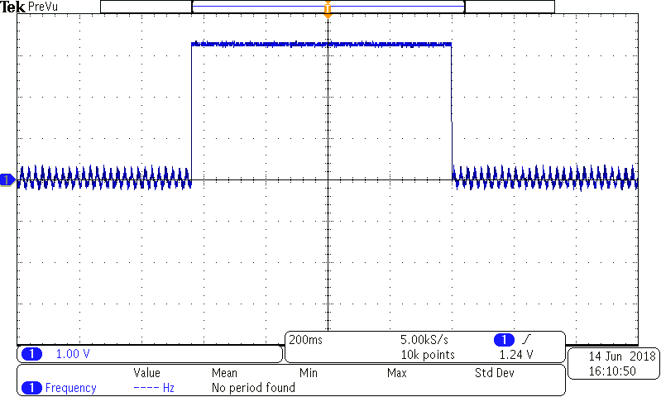

After terminating the program, it is showing the following (different addresses) for each run time
No source available for "0x3f64ca"
No source available for "0x3f64a3"
No source available for "0x3f649c" ………….

