#include "DSP28x_Project.h" // Device Headerfile and Examples Include File
#include "math.h"
#include "float.h"
#include "FPU.h"

#define RFFT_STAGES 9
#define RFFT_SIZE (1 << RFFT_STAGES)
#define ADC_MODCLK 0x4
#define ADC_BUF_LEN RFFT_SIZE // ADC buffer length
#define ADC_SAMPLE_PERIOD 3124 // 3124 = (3125-1) = 48 KHz sampling w/ 150 MHz SYSCLKOUT

#define F_PER_SAMPLE 48000.0L/(float)RFFT_SIZE //Internal sampling rate is 48kHz

RFFT_ADC_F32_STRUCT rfft_adc;
RFFT_F32_STRUCT rfft;

float32 RFFToutBuff[RFFT_SIZE]; //Calculated FFT result
float32 RFFTF32Coef[RFFT_SIZE]; //Coefficient table buffer
float32 RFFTmagBuff[RFFT_SIZE/2+1]; //Magnitude of frequency spectrum

//--- Global Variables
Uint16 AdcBuf[ADC_BUF_LEN]; // ADC buffer allocation

volatile Uint16 FFTStartFlag = 0; // One frame data ready flag

Uint16 DEBUG_TOGGLE = 1; // Used in realtime mode investigation
float32 freq; // Frequency of single-frequency-component signal
// Prototype statements for functions found within this file.
interrupt void adc_isr(void);

/**********************************************************************
* Function: main()
*
* Description: Main function for C2833x Real-time RFFT
**********************************************************************/
void main(void)
{
Uint16 i,j;

//--- CPU Initialization
InitSysCtrl(); // Initialize the CPU (FILE: SysCtrl.c)
InitGpio(); // Initialize the shared GPIO pins (FILE: Gpio.c)
InitPieCtrl(); // Initialize and enable the PIE (FILE: PieCtrl.c)

//--- Peripheral Initialization
InitAdc(); // Initialize the ADC (FILE: Adc.c)
InitPieVectTable();

EALLOW;
SysCtrlRegs.HISPCP.all = ADC_MODCLK;
EDIS;

// Interrupts that are used in this example are re-mapped to
// ISR functions found within this file.
EALLOW; // This is needed to write to EALLOW protected register
PieVectTable.ADCINT = &adc_isr;

GpioCtrlRegs.GPBMUX1.bit.GPIO34 = 0;
GpioCtrlRegs.GPBDIR.bit.GPIO34 = 1;

EDIS; // This is needed to disable write to EALLOW protected registers

AdcRegs.ADCMAXCONV.all = 0x0001; // Setup 2 conv's on SEQ1
AdcRegs.ADCCHSELSEQ1.bit.CONV00 = 0x0; // Setup ADCINA3 as 1st SEQ1 conv.
AdcRegs.ADCCHSELSEQ1.bit.CONV01 = 0x1; // Setup ADCINA2 as 2nd SEQ1 conv.
AdcRegs.ADCTRL2.bit.EPWM_SOCA_SEQ1 = 1;// Enable SOCA from ePWM to start SEQ1
AdcRegs.ADCTRL2.bit.INT_ENA_SEQ1 = 1; // Enable SEQ1 interrupt (every EOS)

// Assumes ePWM1 clock is already enabled in InitSysCtrl();
EPwm1Regs.ETSEL.bit.SOCAEN = 1; // Enable SOC on A group
EPwm1Regs.ETSEL.bit.SOCASEL = 4; // Select SOC from from CPMA on upcount
EPwm1Regs.ETPS.bit.SOCAPRD = 1; // Generate pulse on 1st event
// EPwm1Regs.CMPA.half.CMPA = 0x0080; // Set compare A value
EPwm1Regs.TBPRD = 0xFFFF; // Set period for ePWM1
EPwm1Regs.TBCTL.bit.CTRMODE = 0; // count up and start

PieCtrlRegs.PIEIER1.bit.INTx6 = 1;
IER |= M_INT1; // Enable CPU Interrupt 1

EINT;
ERTM;

rfft_adc.Tail = &rfft.OutBuf; //Link the RFFT_ADC_F32_STRUCT to
//RFFT_F32_STRUCT. Tail pointer of
//RFFT_ADC_F32_STRUCT is passed to
//the OutBuf pointer of RFFT_F32_STRUCT
rfft.FFTSize = RFFT_SIZE; //Real FFT size
rfft.FFTStages = RFFT_STAGES; //Real FFT stages
rfft_adc.InBuf = &AdcBuf[0]; //Input buffer
rfft.OutBuf = &RFFToutBuff[0]; //Output buffer
rfft.CosSinBuf = &RFFTF32Coef[0]; //Twiddle factor
rfft.MagBuf = &RFFTmagBuff[0]; //Magnitude output buffer

RFFT_f32_sincostable(&rfft); //Calculate twiddle factor

//Clean up output buffer
for (i=0; i < RFFT_SIZE; i++)
{
RFFToutBuff[i] = 0;
}

//Clean up magnitude buffer
for (i=0; i < RFFT_SIZE/2; i++)
{
RFFTmagBuff[i] = 0;
}

//--- Enable global interrupts
asm(" CLRC INTM, DBGM"); // Enable global interrupts and realtime debug

//--- Main Loop
while(1) // endless loop - wait for an interrupt
{
if(FFTStartFlag) // If one frame data ready, then do FFT
{
RFFT_adc_f32u(&rfft_adc); // This version of FFT doesn't need buffer alignment
RFFT_f32_mag(&rfft); // Calculate spectrum amplitude

j = 1;
freq = RFFTmagBuff[1];
for(i=2;i<RFFT_SIZE/2+1;i++)
{
//Looking for the maximum valude of spectrum magnitude
if(RFFTmagBuff[i] > freq)
{
j = i;
freq = RFFTmagBuff[i];
}
}

freq = F_PER_SAMPLE * (float)j; //Convert normalized digital frequency to analog frequency

FFTStartFlag = 0; //Start collecting the next frame of data
}
asm(" NOP");
}
} //end of main()

interrupt void adc_isr(void)
{
static Uint16 *AdcBufPtr = AdcBuf; // Pointer to ADC data buffer
static volatile Uint16 GPIO34_count = 0; // Counter for pin toggle

PieCtrlRegs.PIEACK.all = PIEACK_GROUP1; // Must acknowledge the PIE group
GpioDataRegs.GPBTOGGLE.bit.GPIO34 = 1; // 880 micro sec
//--- Manage the ADC registers
AdcRegs.ADCTRL2.bit.RST_SEQ1 = 1; // Reset SEQ1 to CONV00 state
AdcRegs.ADCST.bit.INT_SEQ1_CLR = 1; // Clear ADC SEQ1 interrupt flag

//--- Read the ADC result
*AdcBufPtr++ = AdcMirror.ADCRESULT0; // Read the result

//--- Brute-force the circular buffer
if( AdcBufPtr == (AdcBuf + ADC_BUF_LEN) )
{
AdcBufPtr = AdcBuf; // Rewind the pointer to the beginning
FFTStartFlag = 1; // One frame data ready
}

//--- Example: Toggle GPIO18 so we can read it with the ADC
if(DEBUG_TOGGLE == 1)
{
GpioDataRegs.GPATOGGLE.bit.GPIO18 = 1; // Toggle the pin
}

//--- Example: Toggle GPIO34 at a 0.5 sec rate (connected to the LED on the ControlCARD).
// (1/48000 sec/sample)*(1 samples/int)*(x interrupts/toggle) = (0.5 sec/toggle)
// ==> x = 24000
if(GPIO34_count++ > 24000) // Toggle slowly to see the LED blink
{
// GpioDataRegs.GPBTOGGLE.bit.GPIO34 = 1; // Toggle the pin
GPIO34_count = 0; // Reset the counter
}

return;
} //end of main()

//===========================================================================
// End of File
//===========================================================================

ADC INPUT LEVEL SHIFTED BY 1.5 V DC MAX. 3 VOLT.
If plotted AdcBuff will get same sine wave of 50 HZ as observed on O’Scope

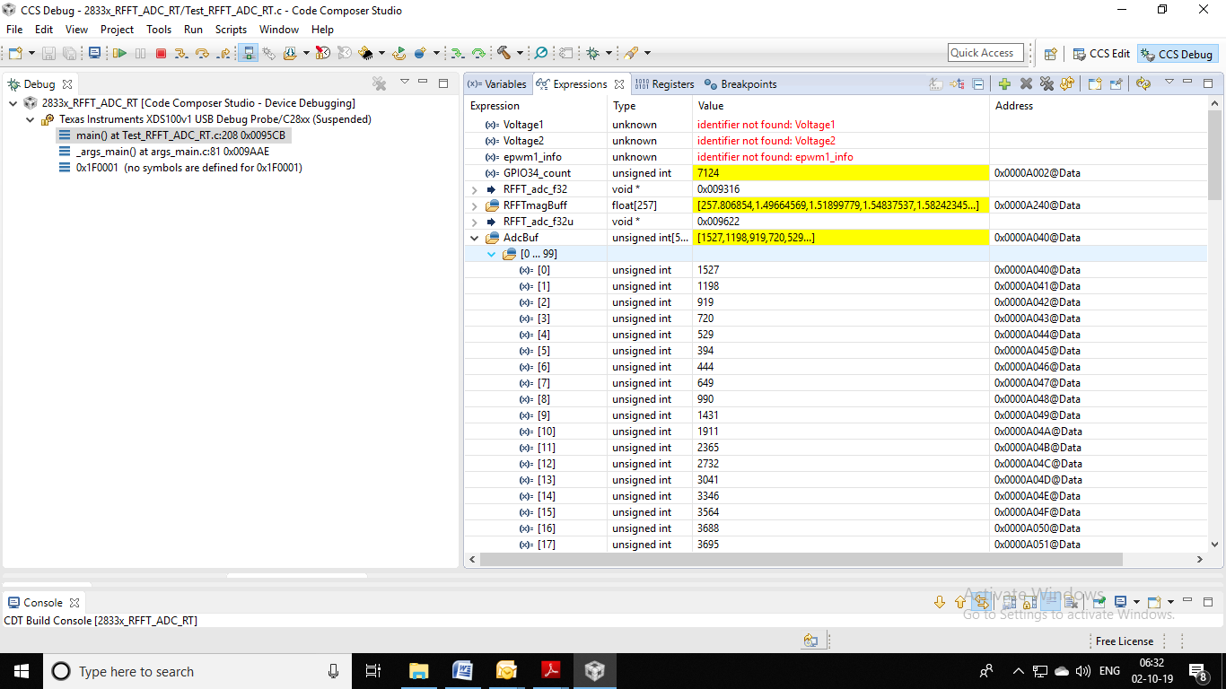

Result After giving break point on conversion flag =1;
X[0] bin we are getting max value .But should be 0 as it is a DC bias(please correct me if I am wrong)
