Here is the Setup File

This Window Opens up after Double click on the Setup File
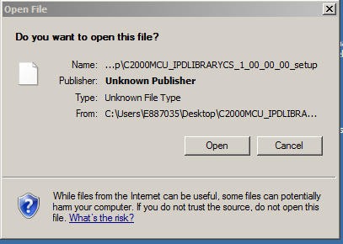
Pointed to “Control Suite” to open
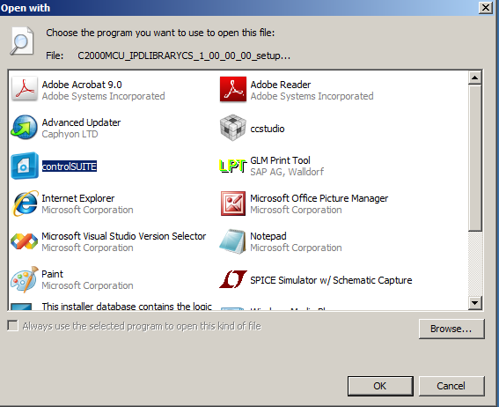

One more window opens asking to open the requested file

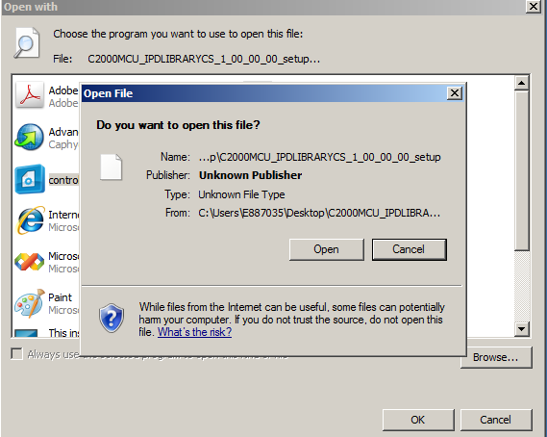
Control Suite Opens up. Now , I am not sure Where I can see the HFI Library??
