How to jump from Bootloader to Application

We have used TMS320F28377D in our product. I tried to divide internal Flash(1Mbyte) in 16 blocks(Block0~Block15)， as picture 1. My bootloader code is stored in Block0和Block1，Others in my application code. Here is my sample code. When bootloader is working, I program to jump to application code, to control LED. The corresponding CMD are shown as picture 3 and picture 4.
But I meet problems. When CPU is working, my bootloader can work. But it can’t jump to application code.
I guess:
(1)、My program makes some wrong.
(2)、CMD files makes some wrong.
I hope TI professors could give me advices help to solve this problem. Thanks a lot.

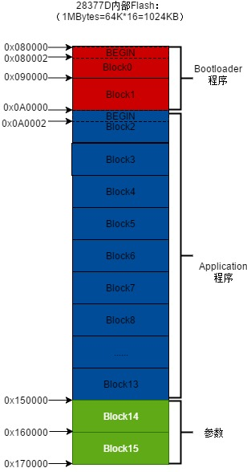
Picture 2 Flash division

Bootloader & CMD File

Bootloader
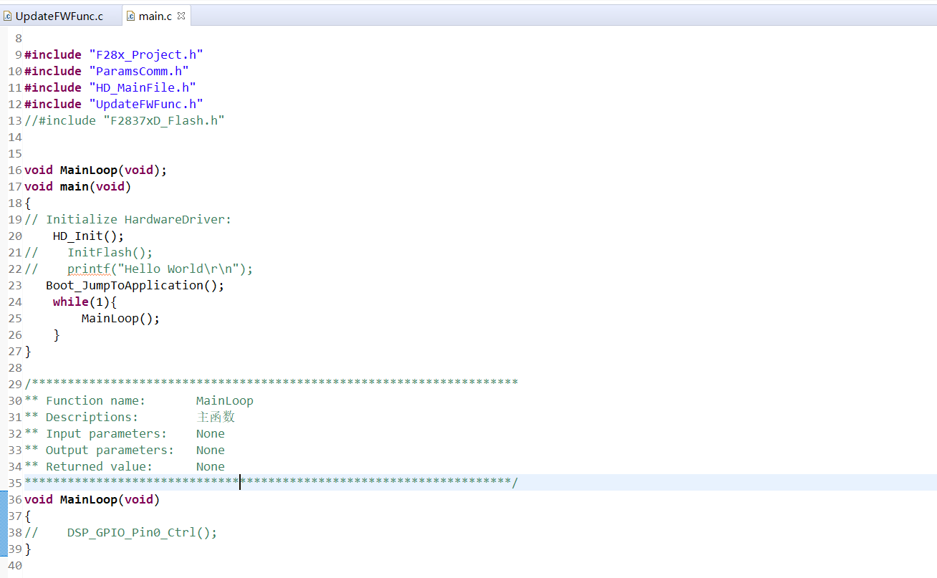
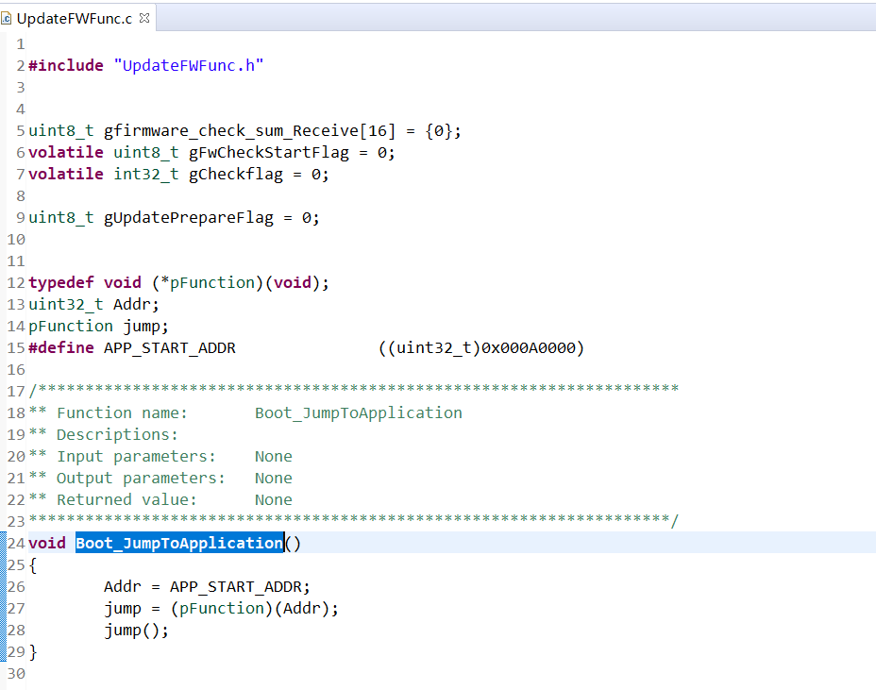

CMD file
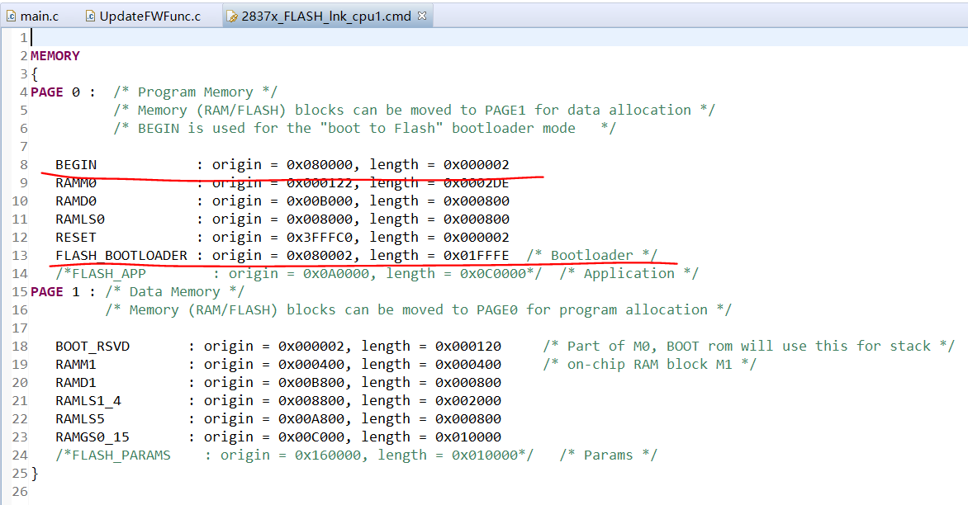
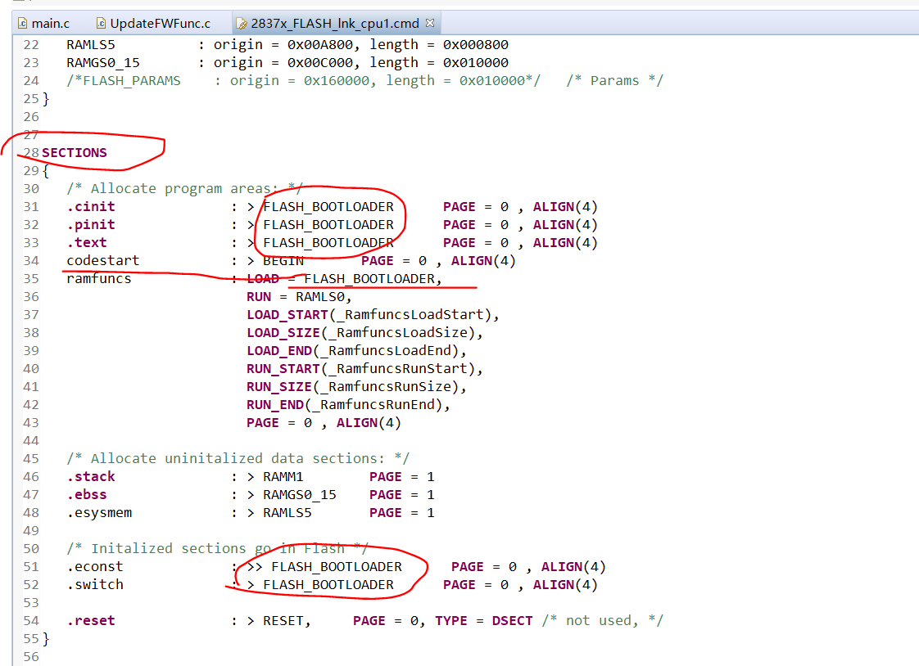

Application & CMD File

Application
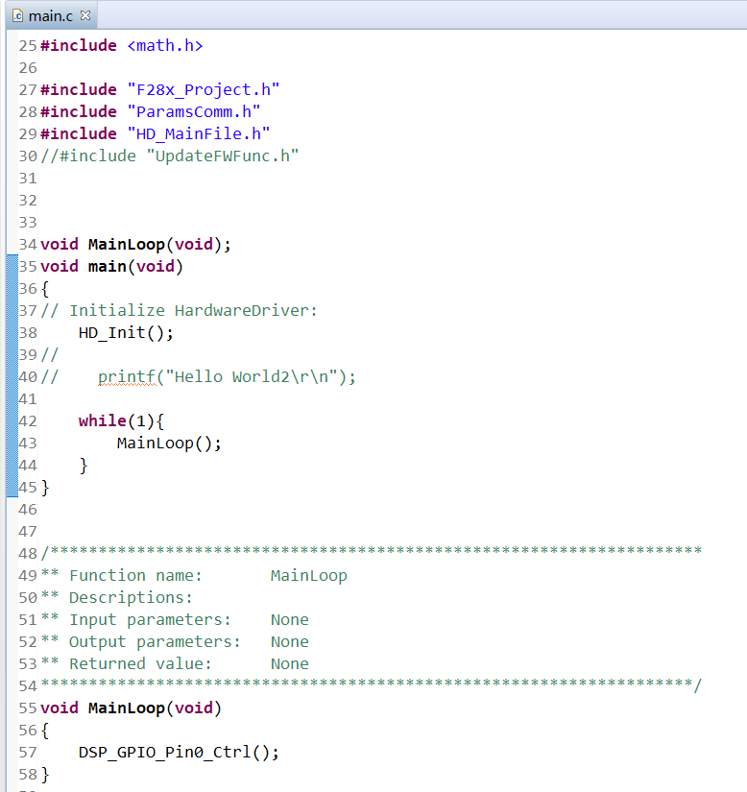

CMD File
