IPC settings is here , setting flag onn CPU1 :

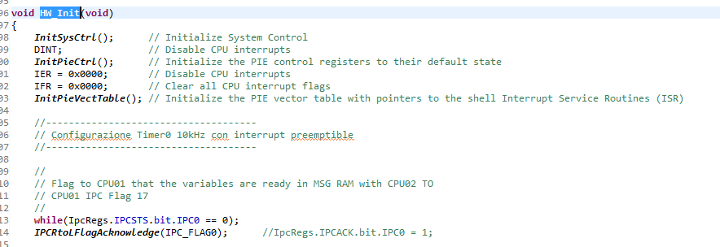

GSRAM used for segments ebss & esysmem:

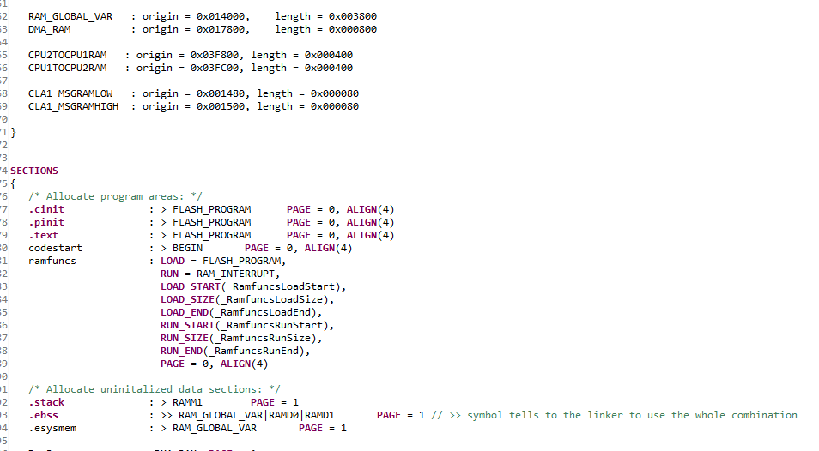

WAIT states as Initflash default function F2837xD_SysCtrl.c

