To everybody ,
I successfully program the password on the TMS320F28374D, and I have also LOCK the password. but I have 2 issues which I would like to clarify.
ISSUE 1
To program the OTP, with the right password and the right resources allocation in Z1 secure zone, I create in the C program 3 const struct, initialized to some default values (the correct ones).
Basically, my cmd file is the following
/* Z1 OTP. LinkPointers */
DCSM_OTP_Z1_LINKPOINTER : origin = 0x78000, length = 0x00000C
/* Z1 OTP. PSWDLOCK/RESERVED */
DCSM_OTP_Z1_PSWDLOCK : origin = 0x78010, length = 0x000004
/* Z1 OTP. CRCLOCK/RESERVED */
DCSM_OTP_Z1_CRCLOCK : origin = 0x78014, length = 0x000004
/* Z1 OTP. RESERVED/BOOTCTRL */
DCSM_OTP_Z1_BOOTCTRL : origin = 0x7801C, length = 0x000004
/* DCSM Z1 Zone Select Contents (!!Movable!!) */
/* Z1 OTP. Z1 password locations, Flash and RAM partitioning */
DCSM_ZSEL_Z1_P0 : origin = 0x78030, length = 0x000010

/* Z2 OTP. LinkPointers */
DCSM_OTP_Z2_LINKPOINTER : origin = 0x78200, length = 0x00000C
/* Z2 OTP. PSWDLOCK/RESERVED */
DCSM_OTP_Z2_PSWDLOCK : origin = 0x78210, length = 0x000004
/* Z2 OTP. CRCLOCK/RESERVED */
DCSM_OTP_Z2_CRCLOCK : origin = 0x78214, length = 0x000004
/* Z2 OTP. GPREG3/BOOTCTRL */
DCSM_OTP_Z2_BOOTCTRL : origin = 0x7821C, length = 0x000004
/* DCSM Z2 Zone Select Contents (!!Movable!!) */
/* Z2 OTP. Z2 password locations, Flash and RAM partitioning */
DCSM_ZSEL_Z2_P0 : origin = 0x78220, length = 0x000010

DcsmZ1OtpLinkPointers : > DCSM_OTP_Z1_LINKPOINTER, PAGE = 1 /*, type = NOLOAD */
DcsmZ1OtpPswLock : > DCSM_OTP_Z1_PSWDLOCK, PAGE = 1 /*, type = NOLOAD */
DcsmZ1OtpCrcLock : > DCSM_OTP_Z1_CRCLOCK, PAGE = 1, type = NOLOAD
DcsmZ1OtpBootCtrl : > DCSM_OTP_Z1_BOOTCTRL, PAGE = 1, type = NOLOAD

DcsmZselZ1File : > DCSM_ZSEL_Z1_P0 PAGE = 1/*, type = NOLOAD */

DcsmZ2OtpLinkPointers : > DCSM_OTP_Z2_LINKPOINTER, PAGE = 1, type = NOLOAD
DcsmZ2OtpPswLock : > DCSM_OTP_Z2_PSWDLOCK, PAGE = 1, type = NOLOAD
DcsmZ2OtpCrcLock : > DCSM_OTP_Z2_CRCLOCK, PAGE = 1, type = NOLOAD
DcsmZ2OtpBootCtrl : > DCSM_OTP_Z2_BOOTCTRL, PAGE = 1, type = NOLOAD

DcsmZselZ2File : > DCSM_ZSEL_Z2_P0 PAGE = 1, type = NOLOAD

And then I would like to allocate the OTP with the right value with this declaration
#ifdef __cplusplus
#pragma DATA_SECTION("DcsmZ1OtpLinkPointers")
#else
#pragma DATA_SECTION(DcsmZ1OtpLnkPnt,"DcsmZ1OtpLinkPointers");
#endif
const struct DCSM_Z1_OTP_LINKPOINTERS DcsmZ1OtpLnkPnt = DCSM_Z1_OTP_LINKPOINTERS_DEFAULTS;
//----------------------------------------
#ifdef __cplusplus
#pragma DATA_SECTION("DcsmZ1OtpPswLock")
#else
#pragma DATA_SECTION(DcsmZ1OtpPswLk,"DcsmZ1OtpPswLock");
#endif
const struct DCSM_Z1_OTP_PSWLOCK DcsmZ1OtpPswLk = DCSM_Z1_OTP_PSWLOCK_DEFAULTS;
//----------------------------------------
#ifdef __cplusplus
#pragma DATA_SECTION("DcsmZselZ1File")
#else
#pragma DATA_SECTION(DcsmZselZ1Otp,"DcsmZselZ1File");
#endif
const struct DCSM_ZSEL_Z1_OTP DcsmZselZ1Otp = DCSM_ZSEL_Z1_OTP_DEFAULT;

I made this for both CPU1 and CPU2.
In this way I though to insert the password programming on my program.
CCS compilation output is the *.out files, but to use C2PROG programmer, I made also the .hex files.
I the following there are my settings for the Hex file generation in CCS
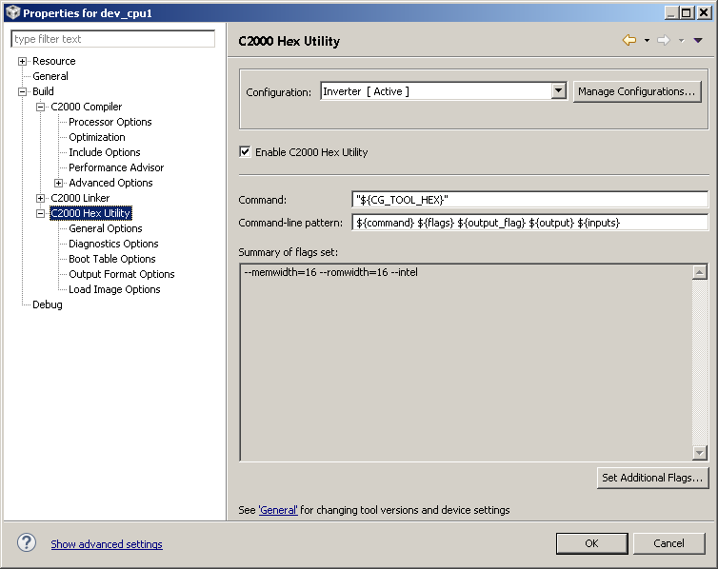
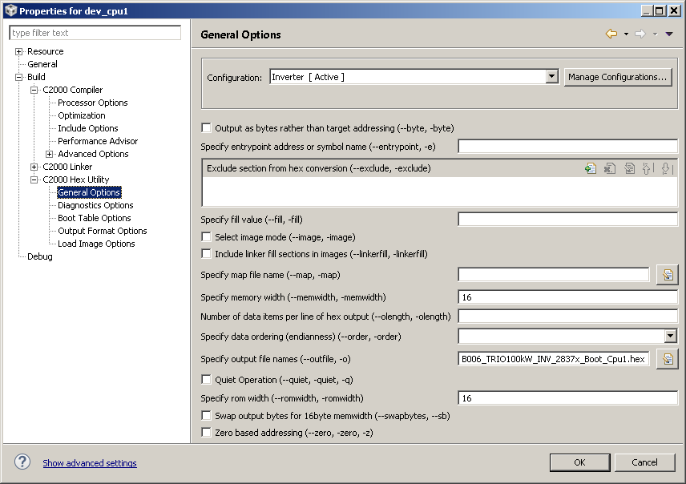
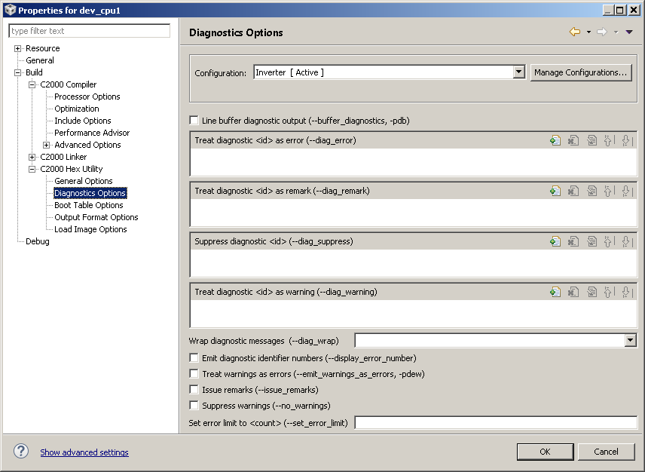
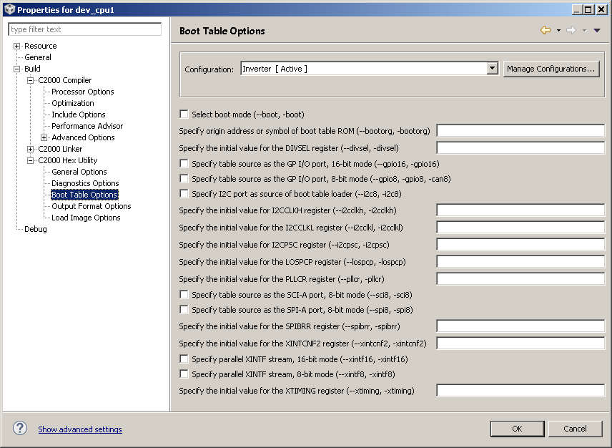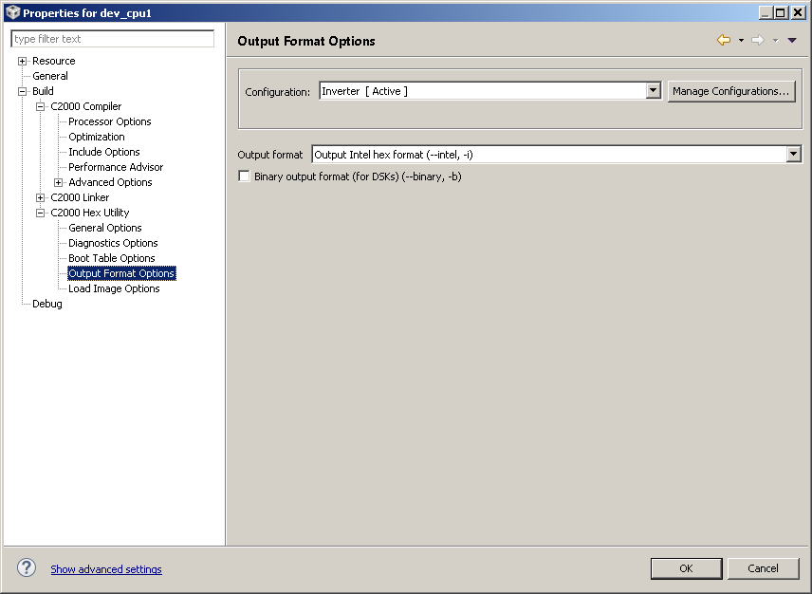
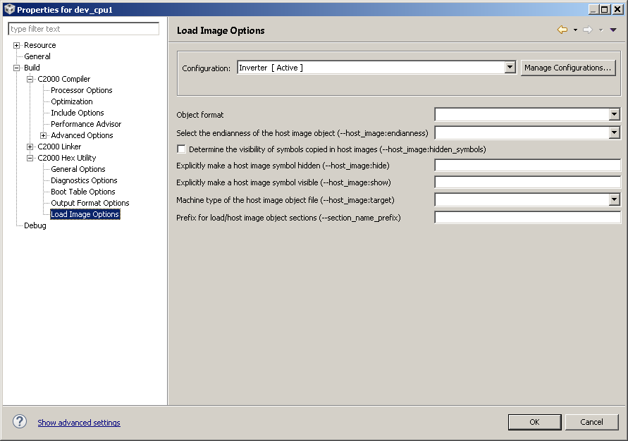
The .hex files generated with these settings are not able to program the OTP in a blank DSP, both with UNIFLASH and C2PROG. It was like the const struct are not allocated in OTP.
While programming bhe blank DSP using the .out files with UNIFLASH (C2PROG work only with hex file), program correctly the OTP.
What is the reason for that? Is there a way to have the OTP programmed also using .hex files?

ISSUE 2
Another question concern the settings we have to provide in debug tab, once the password has been programmed in the DSP to debug the DSP with Blackhawk programmer: More exactly, what is the difference between this tab
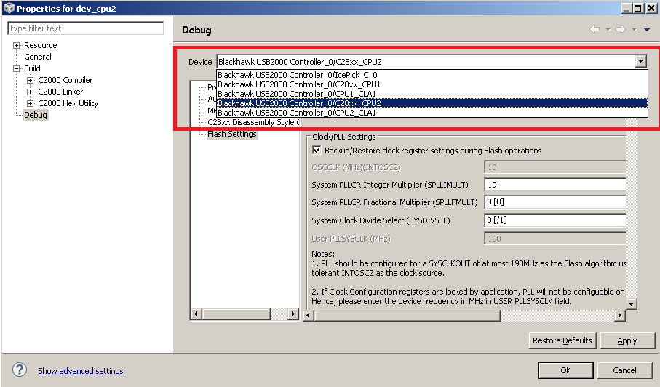
And this tab
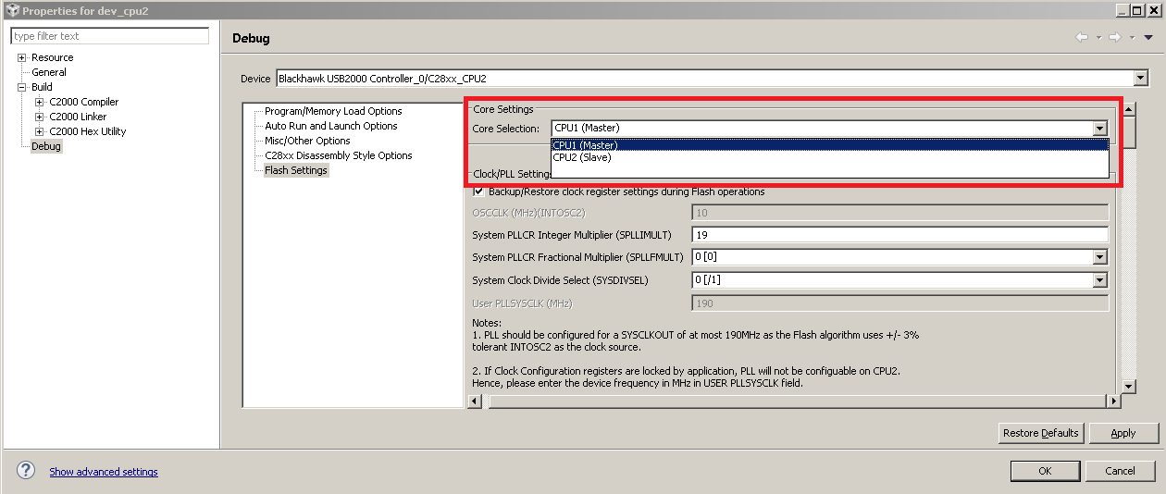
I’m asking this because settings the passwords for CPU2 (Slave) doesn’t unlock the CPU2, “while setting the right password choosing BlackHawk USB200 Controller 0/C28xx_CPU1, works.”

