Initially when I am trying to generate gate pulse from simple phase shifted shoot through program in CCstudio 10.2.0 version fallowing error is showing.
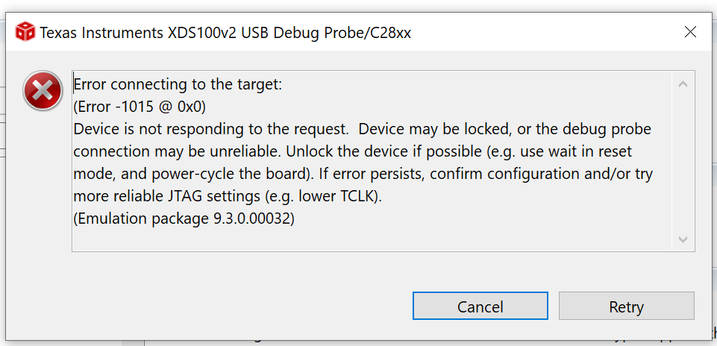
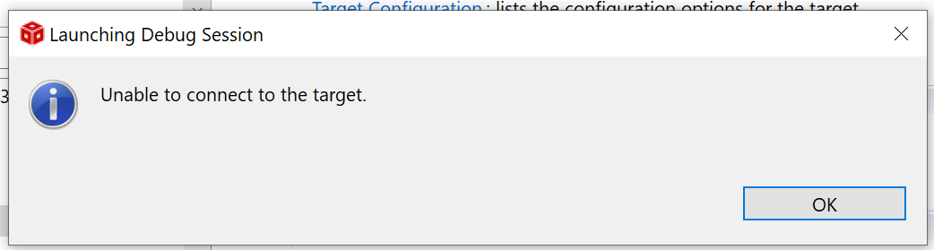

After your suggestion, I went through a JTAG integrity test in CCS -> Target Configuration -> Test Connection.
It is shown as fallowing.
