Model in Simulink
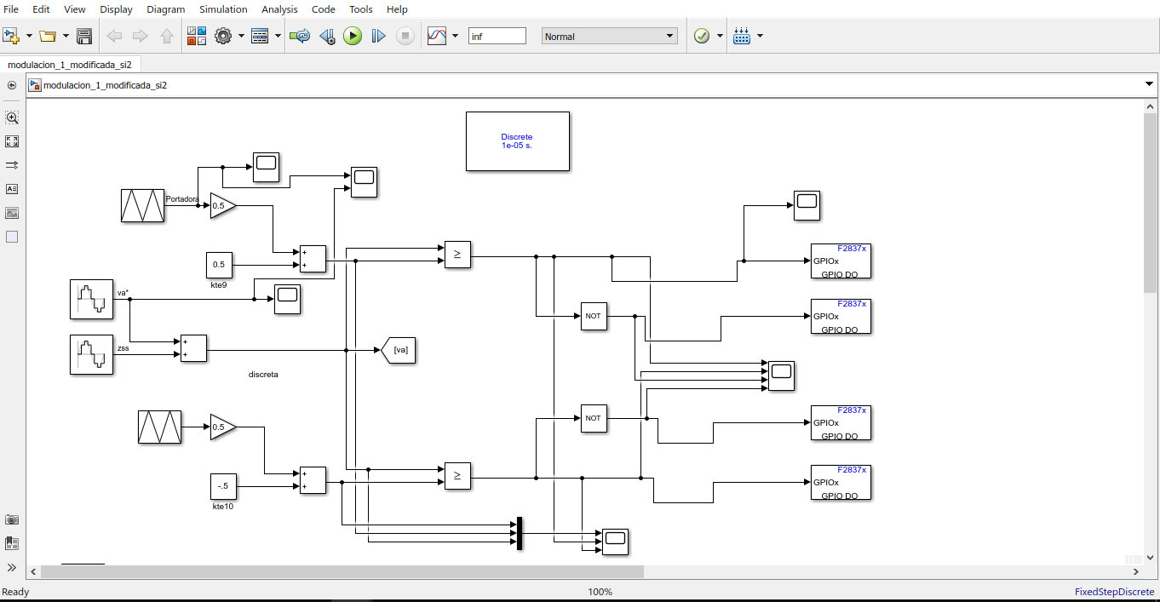
Configuration parameters
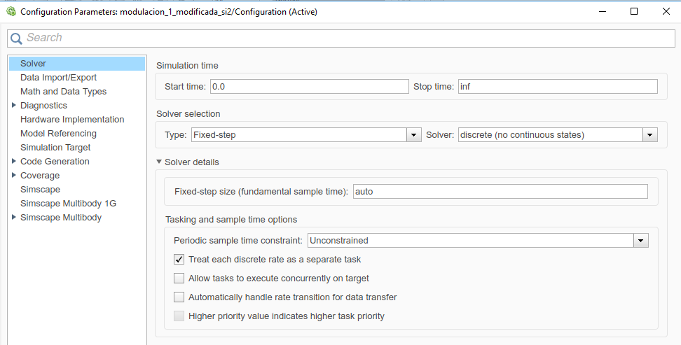
Fixed-step
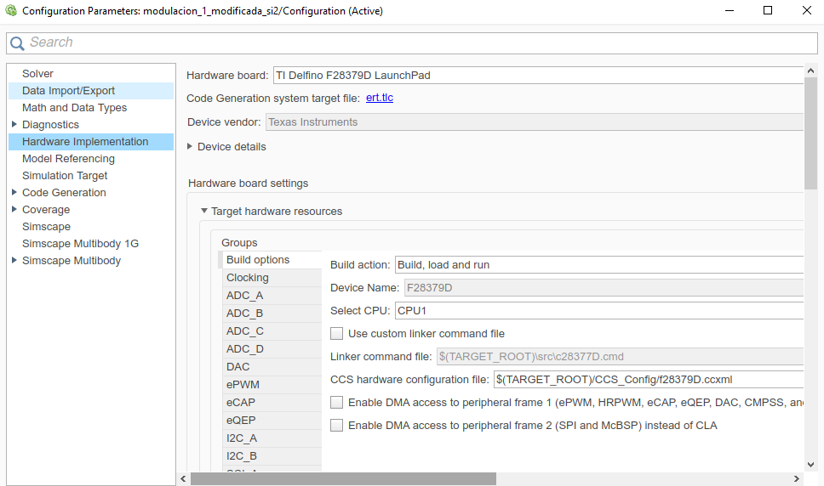
F28379d
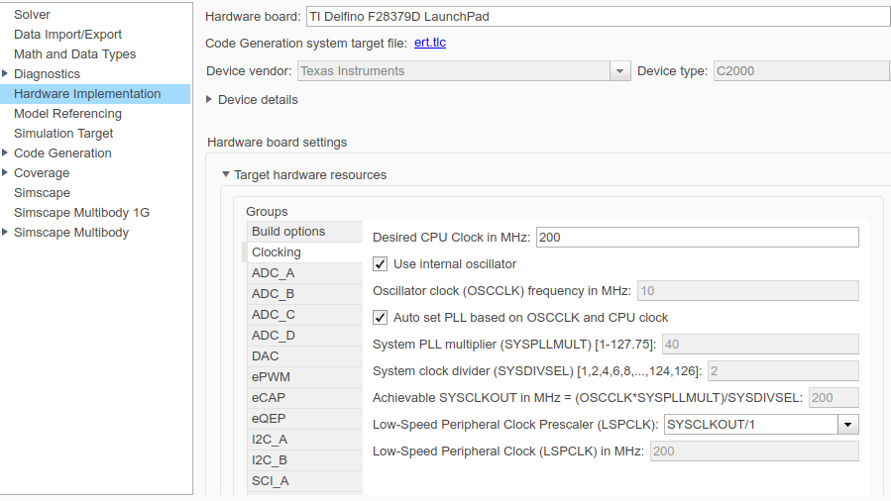
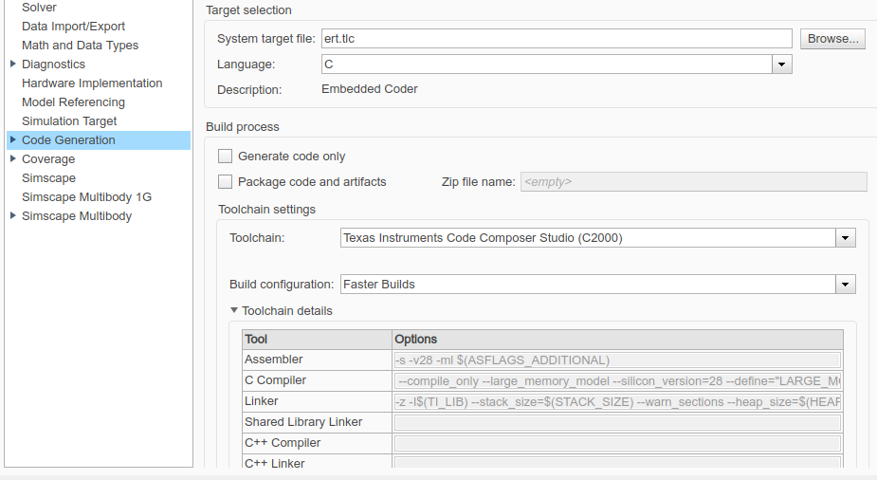

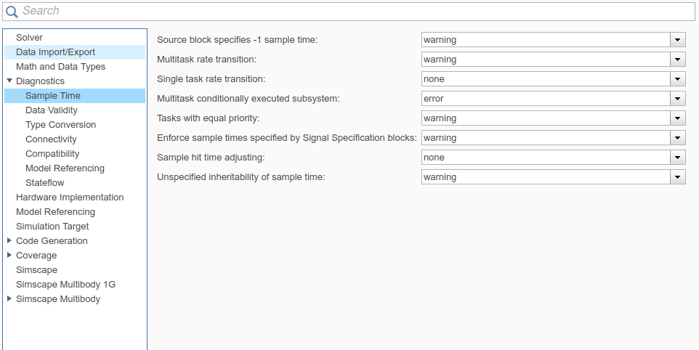

I can build the model and load it to the microcontroller without problema
Carrier frecuency 10khz
Reference signal frecuency 60hz
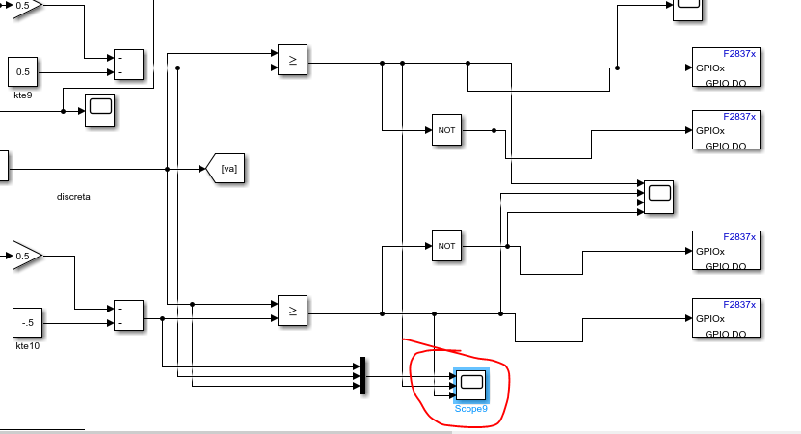
(Simulink)
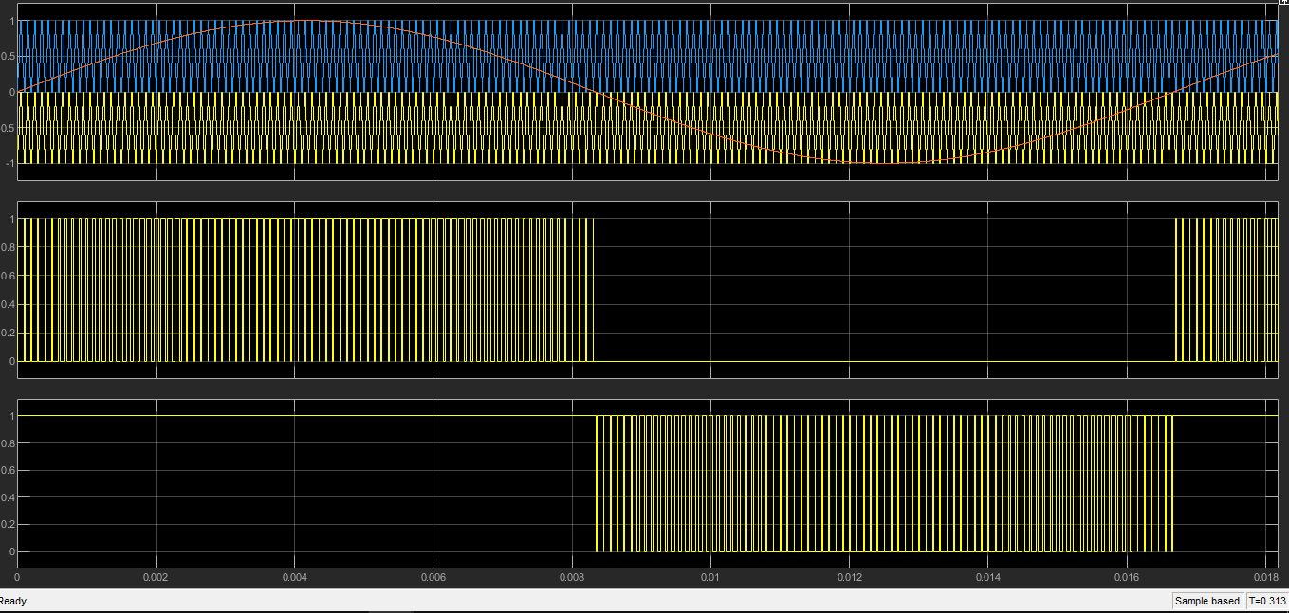
Zoom(Simulink)
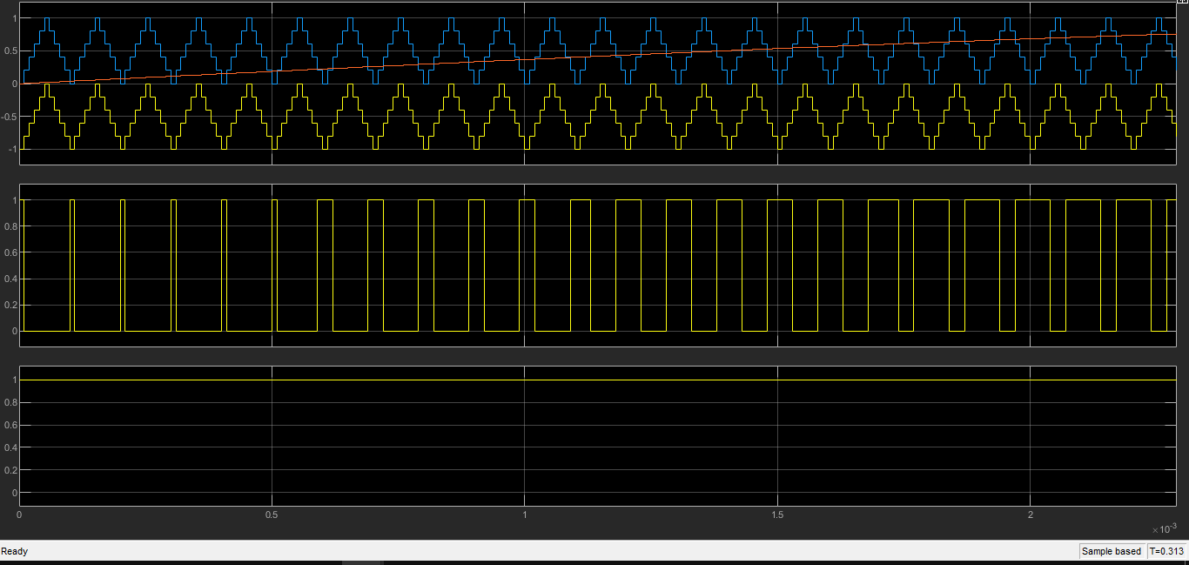
Buil model

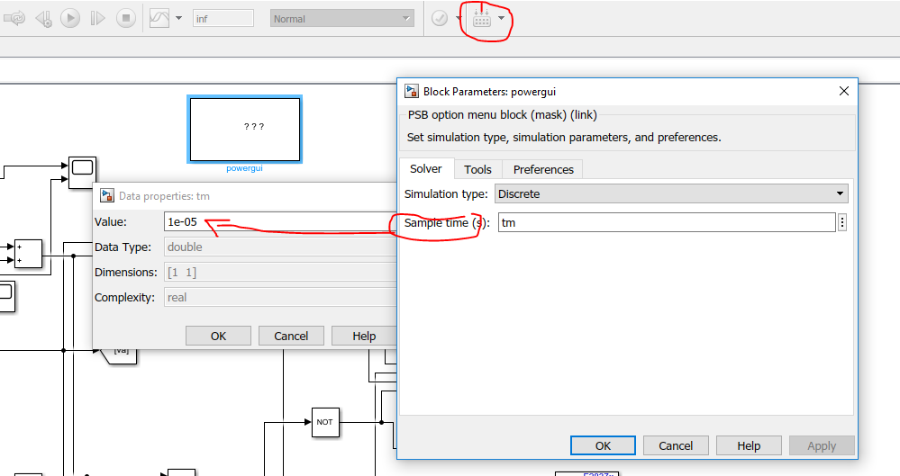

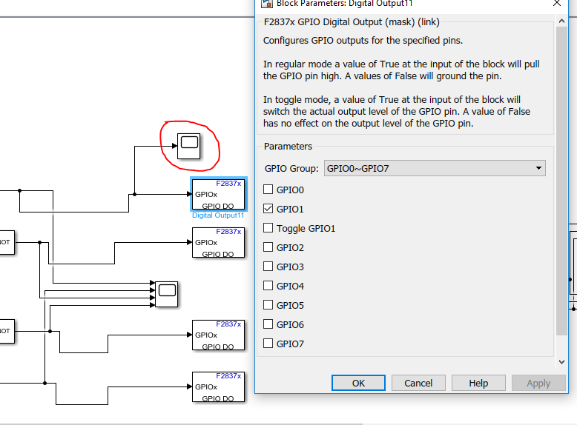

Pulsesin gpio1(Simulink)
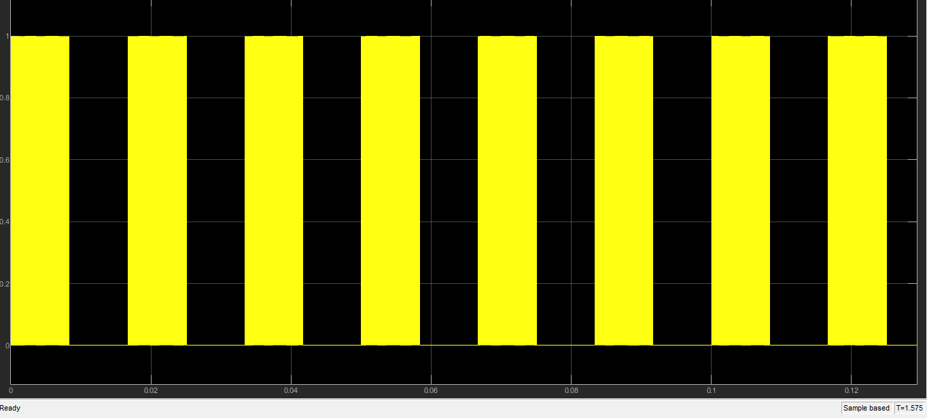
Zoom(simulink)
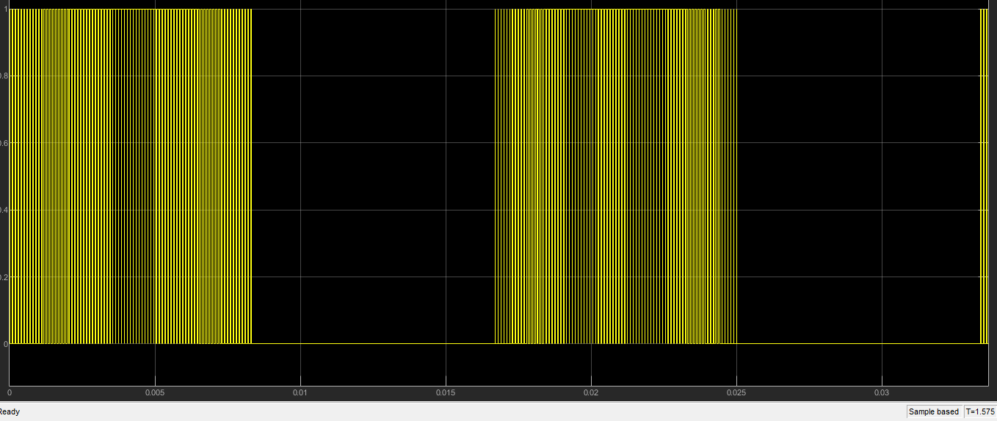
Zoom
It is evidente that the frecuency of the pulse is 10 khz (simulink)
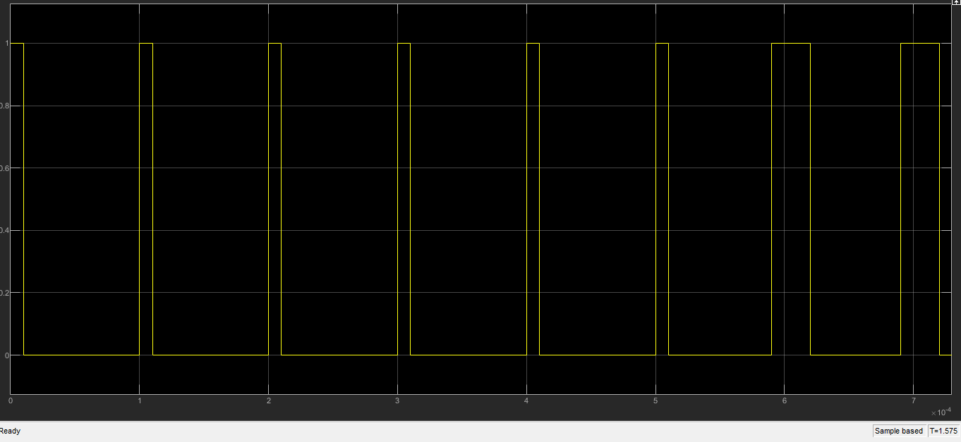

Howevwe the frequency on the 39 gpio1 is of the order of the hz(1667hz) when it should be 10 khz

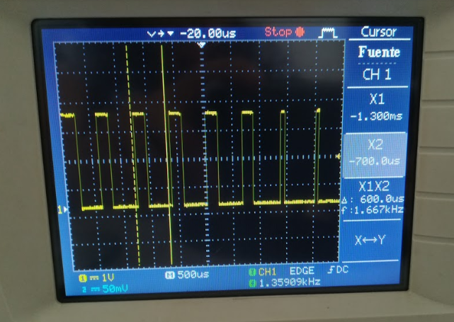
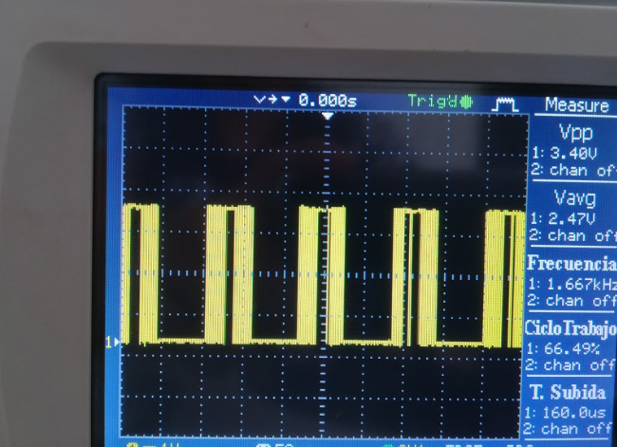
the only way I could find is to change the frequency of the carrier by 4 khz and the sampling time by 16 kHz or 1/16000 s with which the pulses at the output if they have the expected frequency which is 4 khz which leads me to think that the frequency limit of the microcontroller sample is 16khz or how it works for 4khz frequencies downwards but for 10khz which is the one that I need to sample with 60 khz does not work
please wait for help.

