NVM – NO Response
I am currently interfacing an SPI NOR flash with a MCU TMS320F28P650 microcontroller.
MCU - TMS320F28P650
SPI NOR flash - S25FL128LAGMFI013.
Pins used
- MOSI / PICO - GPIO 58
- MISO / POCI – GPIO 59
- CLK - GPIO 60
- CS - GPIO 61
Configuration :-
- Peripheral - SPIA
- Transfer Protocol ( Mode) – Mode 0.
- Mode – SPI controller ( As MCU is the master used as SPI controller ) .
- Bit Rate – 10 Mhz
- Data Width - 8.
- CS is manually controlled via GPIO .
- Clk, mosi, miso are configured as Push-pull output/floating input.

Current observations:
- SCLK is active and stable
- MOSI correctly transmits the JEDEC ID command (0x9F).
- CS# timing appears correct based on oscilloscope observation.
- RESET# and WP# are held HIGH (~2.7 V).
- VCC is stable at 3.26 V.
- SPI configured in Mode 0, 10 MHz clock.
- MISO (SO) pin never drives any response.
- SPI receive buffer (SPIRXBUF) always reads 0x0000.

Current Waveforms
1. SClk vs CS

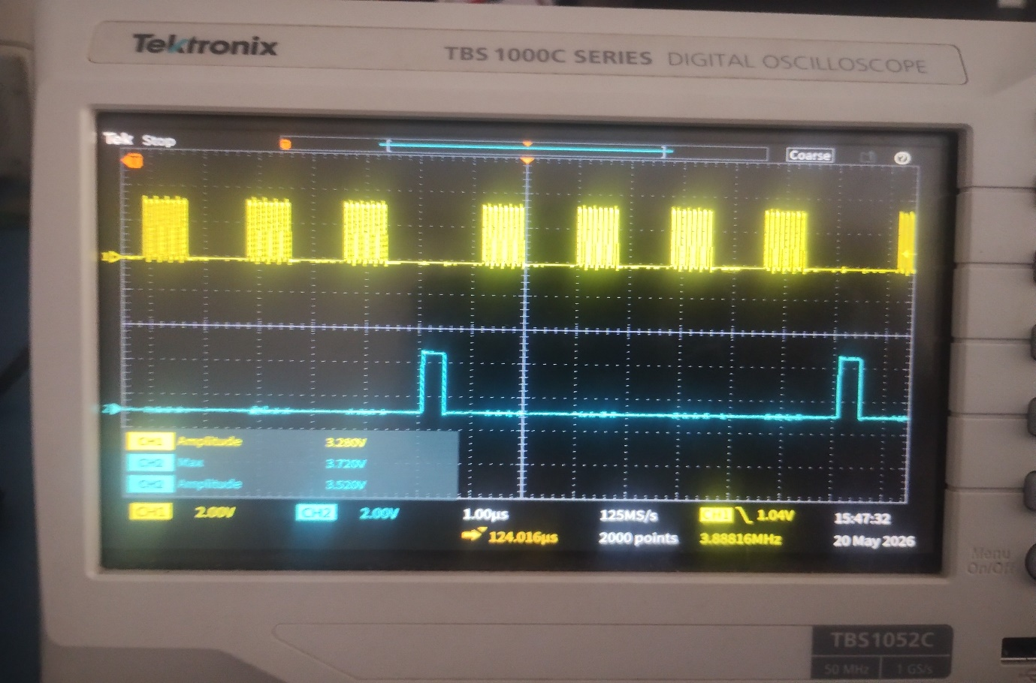
2. SClk vs MOSI
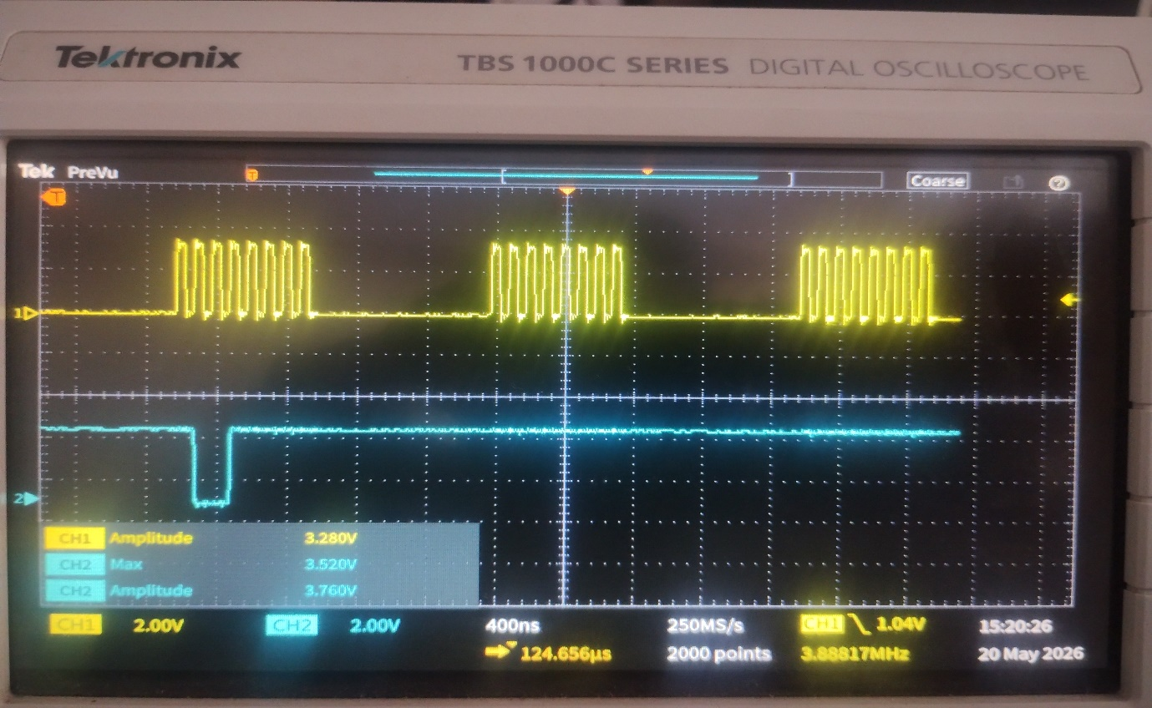
3. Clk vs MISO
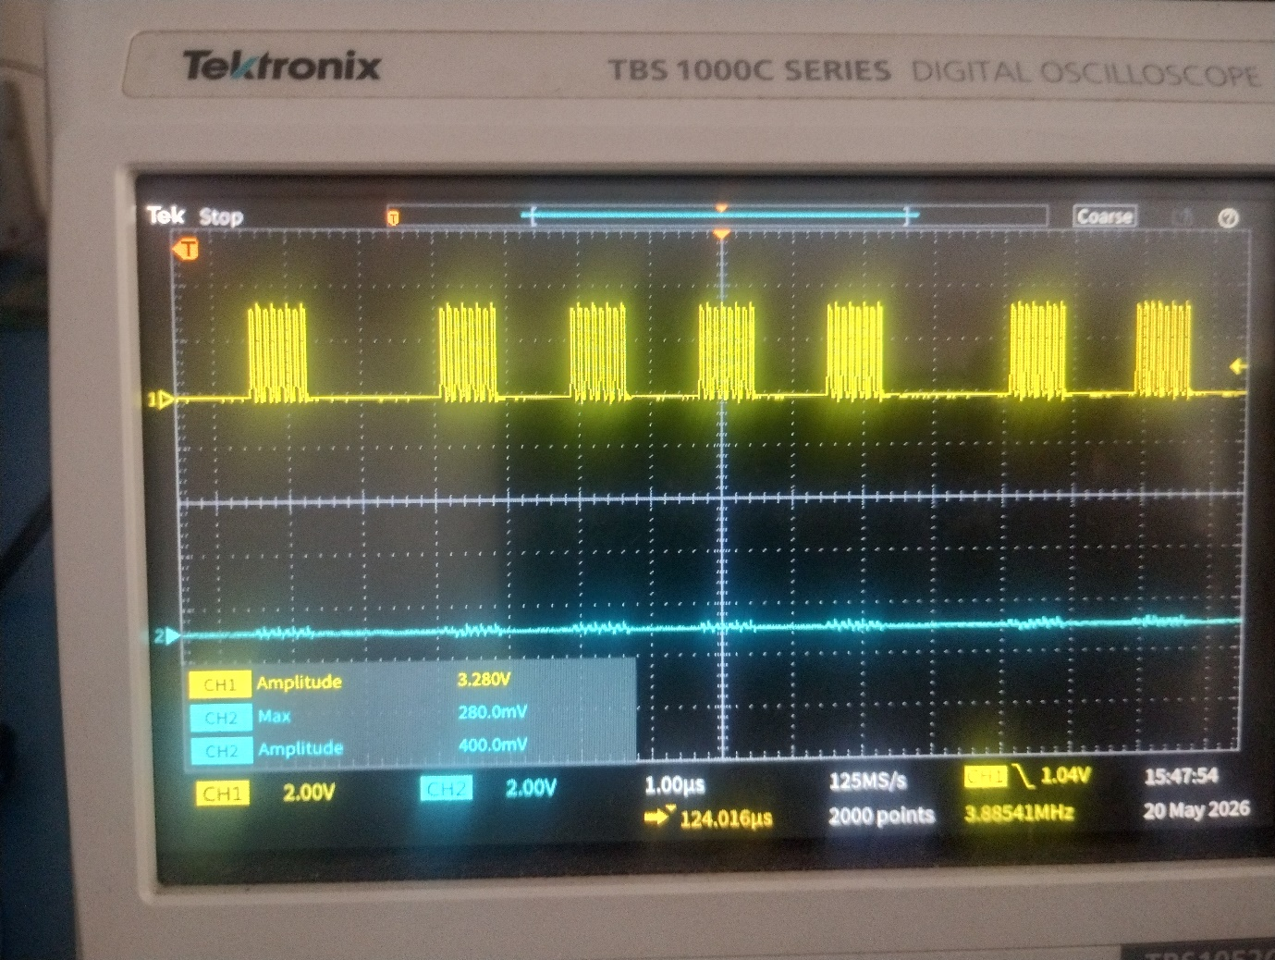

code Snippet:-
As not got a response in the case of normal write and read.Used JEDEC ID for getting the response because JEDEC ID does not require write enable. So used that for Testing . if that don’t work no other things ok .
while(1){
uint8_t cmd = 0x9F;
uint8_t id1 = 0, id2 = 0, id3 = 0;
uint8_t dummy = 0xFF;
uint8_t dummy1;
//SS2OUT_SetLow();
GPIO_writePin(GPIO_PIN_SPIA_PTE, 0);
//DEVICE_DELAY_US(1);
SPI2_Exchange1(&cmd, &dummy1, 1000);
SPI2_Exchange1(&dummy, &id1, 1000);
SPI2_Exchange1(&dummy, &id2, 1000);
SPI2_Exchange1(&dummy, &id3, 1000);
//SS2OUT_SetHigh();
GPIO_writePin(GPIO_PIN_SPIA_PTE, 1);
}

Inside the pinMux_init().
// GPIO61 -> GPIO_PIN_SPIA_PTE Pinmux
GPIO_setPinConfig(GPIO_61_GPIO61);
// SPIA -> mySPI0 Pinmux
//
GPIO_setPinConfig(mySPI0_SPIPICO_PIN_CONFIG);
GPIO_setPadConfig(mySPI0_SPIPICO_GPIO, GPIO_PIN_TYPE_STD);
GPIO_setQualificationMode(mySPI0_SPIPICO_GPIO, GPIO_QUAL_ASYNC);

GPIO_setPinConfig(mySPI0_SPIPOCI_PIN_CONFIG);
GPIO_setPadConfig(mySPI0_SPIPOCI_GPIO, GPIO_PIN_TYPE_STD);
GPIO_setQualificationMode(mySPI0_SPIPOCI_GPIO, GPIO_QUAL_ASYNC);

GPIO_setPinConfig(mySPI0_SPICLK_PIN_CONFIG);
GPIO_setPadConfig(mySPI0_SPICLK_GPIO, GPIO_PIN_TYPE_STD);
GPIO_setQualificationMode(mySPI0_SPICLK_GPIO, GPIO_QUAL_ASYNC);

Spi configuration .
void mySPI0_init(){
SPI_disableModule(mySPI0_BASE);
SPI_setConfig(mySPI0_BASE, DEVICE_LSPCLK_FREQ, SPI_PROT_POL0PHA0,
SPI_MODE_CONTROLLER, mySPI0_BITRATE, mySPI0_DATAWIDTH);
SPI_setPTESignalPolarity(mySPI0_BASE, SPI_PTE_ACTIVE_LOW);
SPI_disableFIFO(mySPI0_BASE);
SPI_disableLoopback(mySPI0_BASE);
SPI_setEmulationMode(mySPI0_BASE, SPI_EMULATION_STOP_MIDWAY);
SPI_enableModule(mySPI0_BASE);
}
void GPIO_PIN_SPIA_PTE_init(){
GPIO_setPadConfig(GPIO_PIN_SPIA_PTE, GPIO_PIN_TYPE_STD);
GPIO_setQualificationMode(GPIO_PIN_SPIA_PTE, GPIO_QUAL_SYNC);
GPIO_setDirectionMode(GPIO_PIN_SPIA_PTE, GPIO_DIR_MODE_OUT);
GPIO_setControllerCore(GPIO_PIN_SPIA_PTE, GPIO_CORE_CPU1);
}

Spi function

SPI2_Status_TypeDef SPI2_Exchange1(uint8_t *pTransmitData,
uint8_t *pReceiveData,
uint16_t timeout)
{
uint32_t tick = 0;
uint16_t txData = (uint16_t)(*pTransmitData)<< 8;
uint16_t rxData = 0;
uint16_t time_out =0;
uint32_t base =SPIA_BASE;
while((HWREGH(base + SPI_O_STS) & SPI_STS_BUFFULL_FLAG) != 0U)
{
}
// // Send data
SPI_writeDataNonBlocking(mySPI0_BASE, txData);

while((HWREGH(base + SPI_O_STS) & SPI_STS_INT_FLAG) == 0U)
{
}
rxData = SPI_readDataNonBlocking(mySPI0_BASE);

// Store only 8-bit
*pReceiveData = (uint8_t)(rxData & 0xFF);

return SPI2_OK;
}

What I Did (Steps Tried)
1. Normal read and Write
I already had an existing application code in which the NVM communication was working correctly with the previous MCU, TI TMS320F28P550SJ9PNA. Since both the previous MCU and the current MCU (TI TMS320F28P650) belong to the same MCU family, the SPI peripheral architecture and configuration are similar. Therefore, only GPIO pin configuration changes were made for the new hardware design, while the remaining SPI communication logic was reused. changes are made through the sysconfig in CCStudio.
During testing, oscilloscope waveforms were checked for SPI communication verification. It was observed that:
- Clock (SCLK) was active
- MOSI was transmitting data
- CS# was toggling correctly
- However, no response was observed from the NVM on the MISO line
As a result, normal read and write operations were not successful. Therefore, I started checking each part of the SPI communication functions individually and observed that the Write Enable operation was not working as expected. After sending the Write Enable command, the MCU reads the Status Register to verify whether the Write Enable Latch (WEL) bit is set. However, the expected response was not observed. To further isolate the issue, I decided to test the JEDEC ID read (0x9F), since JEDEC ID can be read without requiring Write Enable or any modification of protection settings.
2. JEDEC ID
The JEDEC ID test was performed as a secondary debugging step after normal read and write operations failed. This test was chosen because JEDEC ID does not require Write Enable or any memory access permissions and should return device identification data directly.
During this test, SPI communication signals (CLK, MOSI, CS#) were observed on the oscilloscope and appeared to be functioning correctly. However, no valid response was observed on the MISO line.
Command is 0x9F. Waveforms are same as like mentioned above.
3. Timeout Handling Removed
The timeout mechanism used in the SPI transfer function was temporarily removed for debugging purposes.
// while ((HWREGH(base + SPI_O_STS) & SPI_STS_INT_FLAG) != 0) {
// if (++time_out >= SPI_TIMEOUT_COUNT) {
// return SPI2_ERROR;
// }
// }
// while ((HWREGH(base + SPI_O_STS) & SPI_STS_INT_FLAG) == 0) {
// if (++time_out >= SPI_TIMEOUT_COUNT) {
// //return SPI_ERROR_TIMEOUT;
// return SPI2_ERROR;
// }
// }
This was done to simplify the SPI transaction and eliminate the possibility of timeout-related issues during data transmission and reception.
Even After that not got a response from the NVM.
4. Buffull_flag
During code review, it was observed that the SPI example drivers and driverlib files use the Buffer Full Flag (SPI_STS_BUFFULL_FLAG) to ensure safe data transmission.
This flag is used to check whether the SPI transmit buffer is full before writing new data.
while((HWREGH(base + SPI_O_STS) & SPI_STS_BUFFULL_FLAG) != 0U)
{
}
This ensures that:
- No new data is written when the transmit buffer is full
- SPI transmission is not corrupted due to buffer overflow
Even after that no response from the NVM.
5. Poci pin pulled up internally.
The SPI POCI (MISO) pin changed as internally pulled up during testing.
//
// SPIA -> mySPI0 Pinmux
//
GPIO_setPinConfig(mySPI0_SPIPICO_PIN_CONFIG);
GPIO_setPadConfig(mySPI0_SPIPICO_GPIO, GPIO_PIN_TYPE_STD);
GPIO_setQualificationMode(mySPI0_SPIPICO_GPIO, GPIO_QUAL_ASYNC);

GPIO_setPinConfig(mySPI0_SPIPOCI_PIN_CONFIG);
GPIO_setPadConfig(mySPI0_SPIPOCI_GPIO, GPIO_PIN_TYPE_STD | GPIO_PIN_TYPE_PULLUP);
GPIO_setQualificationMode(mySPI0_SPIPOCI_GPIO, GPIO_QUAL_ASYNC);

GPIO_setPinConfig(mySPI0_SPICLK_PIN_CONFIG);
GPIO_setPadConfig(mySPI0_SPICLK_GPIO, GPIO_PIN_TYPE_STD);
GPIO_setQualificationMode(mySPI0_SPICLK_GPIO, GPIO_QUAL_ASYNC);
After enabling the internal pull-up, the MISO waveform remained at a steady HIGH level; so found that no issues in the pin wise. however, no valid data transitions were observed from the flash device.
6. Mode
SPI communication was tested across all SPI modes (Mode 0, Mode 1, Mode 2, and Mode 3). Mode 0. Polarity 0, phase 0. Rising edge without delay.
Checked this to verify whether mode issue or not.
Although the S25FL128L datasheet specifies SPI Mode 0, no response was observed from
the device in any of the modes tested.
7. loopback mode
Internal SPI loopback mode was enabled for verification of MCU SPI functionality. In this mode, transmitted data was correctly received back by the MCU, confirming that the SPI peripheral is functioning as expected. So internal of Si just checked to verify the issue is not internal peripherals.
8.Bandwidth
SPI data width was tested with both 8-bit and 16-bit configurations.
Since the flash operates in 8-bit mode, 8-bit data transmission is required.
But this Ti series transmit first 8 msb bits . so need to shift the txdata. Checked the waveform before shifting and after shifting. After shifting only the data 0x9F is found in the waveform. However, due to the MCU SPI data register behavior, the transmitted data was aligned as:
uint16_t txData = (uint16_t)(*pTransmitData) << 8;
This ensures that the MSB is transmitted first as per SPI shift register behaviour.
Despite correct configuration, no response was observed from the NVM.
9. Bit rate
SPI communication was tested at multiple bit rates, including 10 MHz and 1 MHz.
In both configurations, no response was observed from the flash device on the MISO line.

