- Parts I currently have
  - Motor
  - Driver board
  - Current sensors
  - PGA411 resolver to digital converter
  - LaunchXL-F28069M
  - TMDSDOCK28027
  - ControlCARD for 28069
  - And then all of the car controls and CAN messages
- Characteristics
    - Designing a controller to replace a logic board for an inverter in order to be compatible with the motor
    - Motor is used as a P1 motor in a hybrid electric vehicle architecture
      - Main function is to replace the 12V starter and alternator
  - Controls needed
    - Capable of starting an engine
    - Only torque control required
    - Later goals
      - Apply reliable torque to drivetrain
      - Charge 340V nom battery pack
  - IPM
    - Integrated starter generator used for automotive purposes
    - Will be ran at 340 V nom
    - Up to around 100 A
  - Driver Board
    - Controlled with 3 phase pwm signals
    - Reset input available
    - Temperature and fault outputs available

- Sensor Data
  - Motor resolver
  - Current sensors
  - Driver board temperature
  - Driver board fault pin
  - Angle or velocity data from PGA411 chip if needed
- User inputs
  - CAN
    - Torque requests
    - Bus voltage
    - Other things

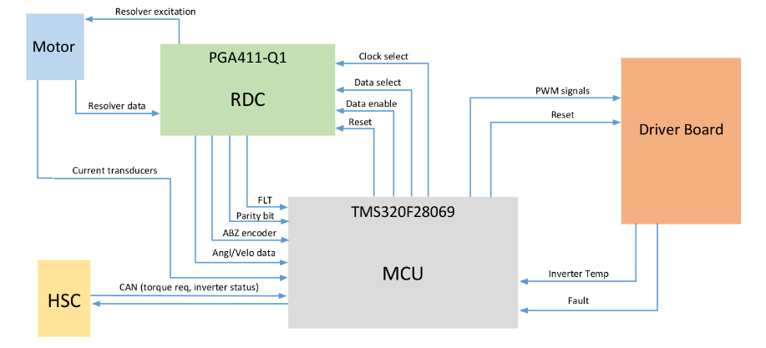
Preliminary box and wire diagram prior to getting deep into InstaSPIN

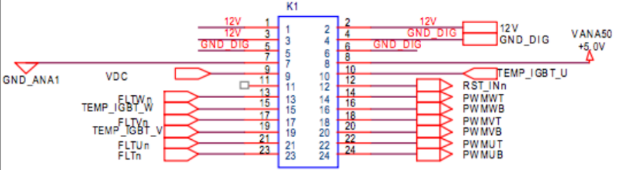
Driver board interface

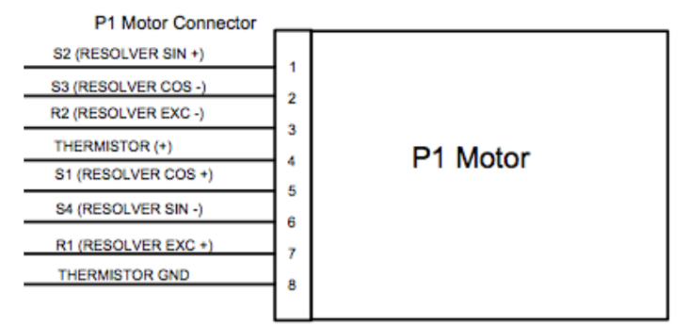
Resolver pins

