Hi Experts,
I am working on implementation of the peak current mode control algorithm on DC-DC (own designed, can be work as step down as well as step up configuration) converter with TMS320F28379D C2000 microcontroller. I have used the inbuilt analog comparator module (without ramp compensation) and epwm module of the mcu to implement the peak current mode concept with outer voltage loop open. With the help of the technical reference manual of the TMS320F2837xD Dual-Core Microcontrollers, I have tried to implement the algorithm.
As per my observation from hardware results (attached below), once the inductor current is reaching the reference set value the tripping event gets initiated and current starts to decrease but on the completion of TBCTR = TBPRD the pwm should go to high state (as per the instruction: EPwm6Regs.AQCTLA.bit.ZRO = AQ_SET;) and inductor current (shown in channel 2) should start increasing. Instead of this the pwm is remaining in low state as a result the current is decreasing to zero value and after reaching to zero the current again starts increasing and due to this type of action, the required operating range of frequency (around 30kHz) as well as duty ratio (25%) is unable to achieve. The parameters are designed to operate the circuit in CCM.
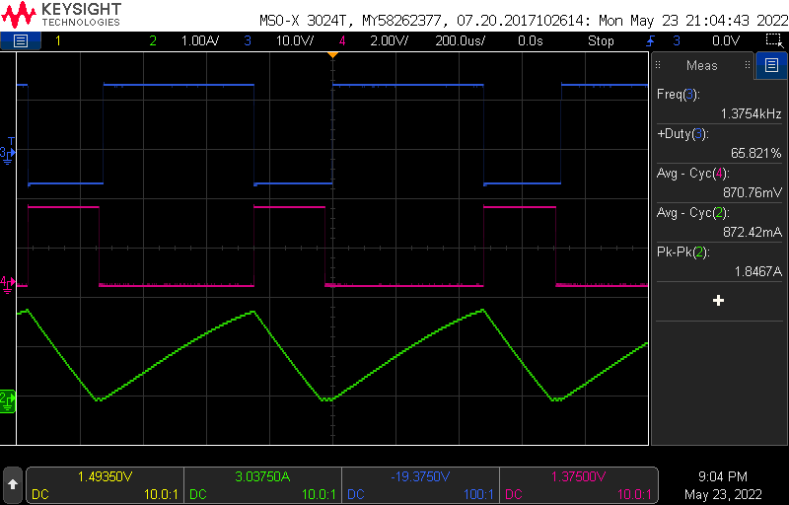
Channel 2: Inductor current
Channel 3: Gate to source voltage across switch
Channel 4 : Analog comparator output through gpio pin

I have also tried to implement the blanking window logic. For that case also I am getting same response along with it there is some narrow pulse observed in the gate to source voltage (shown in channel 3) of the switch, which width is seeming to relate with magnitude of blanking time.

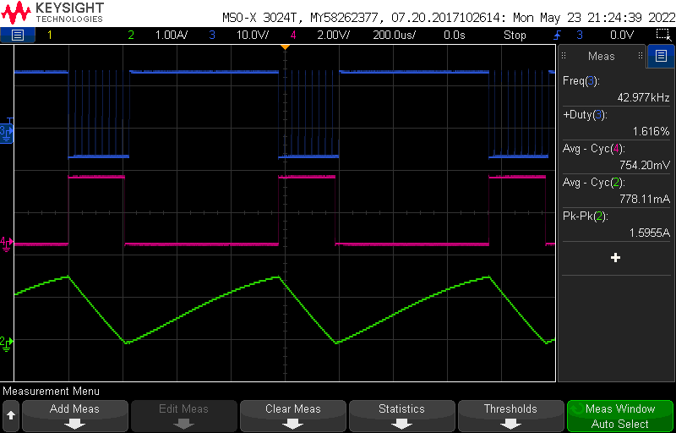
Channel 2: Inductor current
Channel 3: Gate to source voltage across switch
Channel 4 : Analog comparator output through gpio pin

As per my understanding the comparator module part is working fine as the output of comparator module (shown in channel 4) able to initiate the trip event.
I have following doubts
- Why the action “EPwm6Regs.AQCTLA.bit.ZRO = AQ_SET” is not getting initiated once counter is starting from zero.
- As the epwm module functionality is showing issues, what other syntax I need to corporate in this module. I have attached my full running code here with. Please have a look on it once and help to find out the required modifications.
Please share your valuable suggestions.
Please find the running code:
////////
#include "F28x_Project.h"
///////////////////////////////////////////
// Defines
//
//definitions for selecting DACH reference
#define REFERENCE_VDDA 0
#define REFERENCE_VDAC 1
//definitions for COMPH input selection
#define NEGIN_DAC 0
#define NEGIN_PIN 1
//definitions for CTRIPH/CTRIPOUTH output selection
#define CTRIP_ASYNCH 0
#define CTRIP_SYNCH 1
#define CTRIP_FILTER 2
#define CTRIP_LATCH 3
//definitions for selecting output pin
#define GPIO_CTRIP_PIN_NUM 10
#define GPIO_CTRIP_PER_NUM 1
///////////////
#define GPIO_CTRIPOUT_PIN_NUM 2
#define GPIO_CTRIPOUT_PER_NUM 5
/////////////////////////////////////////////////
#define DACA 1
#define DACB 2
#define DACC 3
#define DAC_NUM DACB
///////////////////////////////////////////////////////////////////
#define EPWM6_TIMER_TBPRD 4999
#define EPWM6_TIMER_CMPA 1999
////////////////////////////////////////////
#define EPWM6_BLANK_WND_OFFSET 4996
#define EPWM6_BLANK_WND 80
////////////////////////////////////
float ic_ref = 1000;
////////////////////////
void InitEPwm6Example(void);
void InitCMPSS(void);
/////////////////////
__interrupt void epwm6_isr(void);
////////////////////////////
void main(void)
{
InitSysCtrl();
///////////////////
CpuSysRegs.PCLKCR2.bit.EPWM6=1;
///////////////////
InitEPwm6Gpio();
//////////////
DINT;
///////////////////////////////
InitPieCtrl();
///////////////////////
IER = 0x0000;
IFR = 0x0000;
/////////////////////////////////
InitPieVectTable();
//////////////////////////////////
InitCMPSS();
///////////////////////
EALLOW;
PieVectTable.EPWM6_INT = &epwm6_isr;
EDIS;
////////////////////////////////
EALLOW;
CpuSysRegs.PCLKCR0.bit.TBCLKSYNC = 0;
EDIS;
/////////////////////////////////
InitEPwm6Example();
////////////////////////////////////
EALLOW;
CpuSysRegs.PCLKCR0.bit.TBCLKSYNC = 1;
EDIS;
///////////////////////////////////
EALLOW;
ClkCfgRegs.PERCLKDIVSEL.bit.EPWMCLKDIV =0;
EDIS;
////////////////////////////////////
IER |= M_INT3;
///////////////////////////////////
PieCtrlRegs.PIEIER3.bit.INTx6 = 1;
//////////////////////////////////
EINT;
ERTM;
/////////////////////////////////
GPIO_SetupPinMux(GPIO_CTRIP_PIN_NUM, GPIO_MUX_CPU1,GPIO_CTRIP_PER_NUM);
GPIO_SetupPinMux(GPIO_CTRIPOUT_PIN_NUM, GPIO_MUX_CPU1,GPIO_CTRIPOUT_PER_NUM);
while(1)
{

}

}
/////////////////////////////////////////////////////////////////////////
// InitCMPSS - Initialize CMPSS1 and configure settings
/////////////////////////////////
void InitCMPSS(void)
{
EALLOW;
Cmpss1Regs.COMPCTL.bit.COMPDACE = 1;
Cmpss1Regs.COMPCTL.bit.COMPHSOURCE = NEGIN_DAC;
Cmpss1Regs.COMPDACCTL.bit.SELREF = REFERENCE_VDDA;
Cmpss1Regs.COMPDACCTL.bit.SWLOADSEL = 0;
Cmpss1Regs.COMPCTL.bit.COMPHINV = 0;
Cmpss1Regs.CTRIPHFILCTL.bit.SAMPWIN =0x1F;
Cmpss1Regs.CTRIPHFILCTL.bit.THRESH =0x1F;
Cmpss1Regs.CTRIPHFILCLKCTL.bit.CLKPRESCALE =0x3FF;
Cmpss1Regs.CTRIPHFILCTL.bit.FILINIT = 1;
Cmpss1Regs.COMPCTL.bit.CTRIPHSEL = CTRIP_FILTER;
Cmpss1Regs.COMPCTL.bit.CTRIPOUTHSEL = CTRIP_FILTER;
Cmpss1Regs.COMPDACCTL.bit.FREESOFT = 2;
Cmpss1Regs.COMPDACCTL.bit.DACSOURCE =0;
Cmpss1Regs.COMPDACCTL.bit.RAMPSOURCE = 5;
Cmpss1Regs.COMPDACCTL.bit.RAMPLOADSEL = 1;
OutputXbarRegs.OUTPUT1MUX0TO15CFG.bit.MUX0 = 0;
OutputXbarRegs.OUTPUT1MUXENABLE.bit.MUX0 = 1;
EDIS;

}
///////////////////////
void InitEPwm6Example()
{
EALLOW;
EPwm6Regs.TBCTL.bit.PRDLD = TB_SHADOW;
EPwm6Regs.TBCTL.bit.CTRMODE =TB_COUNT_UP;
EPwm6Regs.TBPRD = EPWM6_TIMER_TBPRD;
EPwm6Regs.TBCTL.bit.PHSEN = TB_DISABLE;
EPwm6Regs.TBPHS.bit.TBPHS = 0x0000;
EPwm6Regs.TBCTR = 0x0000;
EPwm6Regs.TBCTL.bit.CLKDIV = TB_DIV1;
EPwm6Regs.TBCTL.bit.HSPCLKDIV = TB_DIV1;
EPwm6Regs.CMPCTL.bit.SHDWAMODE = CC_SHADOW;
EPwm6Regs.CMPCTL.bit.LOADAMODE = CC_CTR_ZERO;
EPwm6Regs.DBCTL.bit.OUT_MODE = DB_FULL_ENABLE;
EPwm6Regs.DBCTL.bit.POLSEL = DB_ACTV_HIC;
EPwm6Regs.DBFED.bit.DBFED = 0;
EPwm6Regs.DBRED.bit.DBRED = 0;
EPwm6Regs.AQCTLA.bit.ZRO = AQ_SET;
EPwm6Regs.TZSEL.bit.DCAEVT2 = 1;
EPwm6Regs.TZCTL.bit.TZA= 2;
EPwm6Regs.TZDCSEL.bit.DCAEVT2 = 2;
EPwm6Regs.DCTRIPSEL.bit.DCAHCOMPSEL =3;
EPwm6Regs.DCACTL.bit.EVT2SRCSEL =1;
EPwm6Regs.DCACTL.bit.EVT2FRCSYNCSEL =1;
EPwm6Regs.DCFCTL.bit.SRCSEL = 1;
EPwm6Regs.DCFCTL.bit.BLANKE = 1;
EPwm6Regs.DCFCTL.bit.BLANKINV = 0;
EPwm6Regs.DCFCTL.bit.PULSESEL = 1;
EPwm6Regs.TZCLR.bit.CBCPULSE=1;
EPwmXbarRegs.TRIP4MUX0TO15CFG.bit.MUX0 = 0;
EPwmXbarRegs.TRIP4MUXENABLE.bit.MUX0 = 1;
EPwm6Regs.ETSEL.bit.INTSEL = 1;//ET_CTR_ZERO;
EPwm6Regs.ETSEL.bit.INTEN = 1;
EPwm6Regs.ETPS.bit.INTPRD = ET_1ST;
EDIS;
}

__interrupt void epwm6_isr(void)
{

EPwm6Regs.CMPA.bit.CMPA =EPWM6_TIMER_CMPA;
Cmpss1Regs.DACHVALS.bit.DACVAL = ic_ref;
EPwm6Regs.DCFOFFSET = EPWM6_BLANK_WND_OFFSET;
EPwm6Regs.DCFWINDOW = EPWM6_BLANK_WND;
EPwm6Regs.ETCLR.bit.INT = 1;
PieCtrlRegs.PIEACK.all = PIEACK_GROUP3;
}

