The red channel – high side PWM1A pin of processor
The blue channel – Low side PWM1B pin of processor
The green waveform is output (mosfet output) PWM going to motor.
The orange channel is motor current seen using curent probe.
Below waveforms are when the processor is in release mode
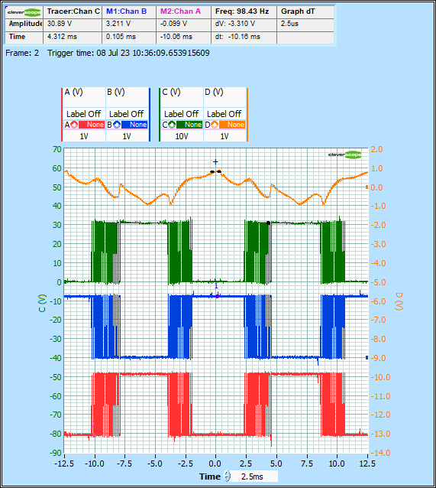

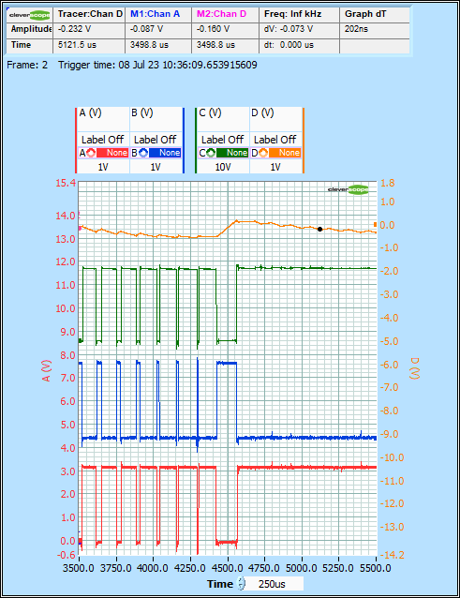
The first graph is expanded in the second graph. The only issue is the last PWM waveform before PWM goes high.

The motor waveforms when processor is in debug mode.

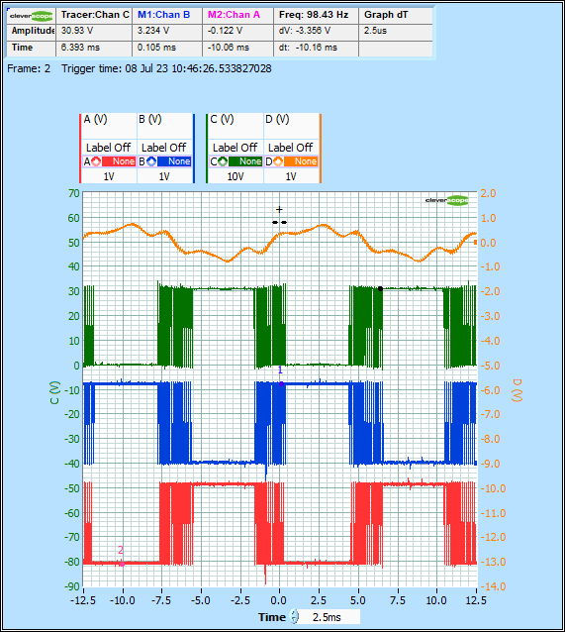

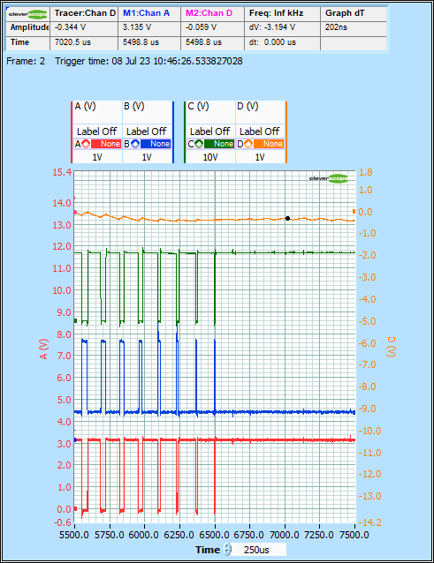
The first graph is expanded in the second graph. The issue of PWM expansion does not arise in the PWM.

