Good morning.
The following is the problem in brief:
We are using open loop control V/F method for induction motor control in our Solar pump inverter.
The block diagram is given below:
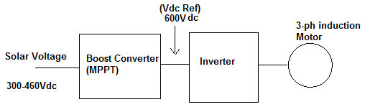
Up to MPPT section there is no problem. In the inverter control, we are using v_hz_profile and svgen_mf modules. Since we are using open loop control there is no speed feed-back in our system.
So, we are giving boost converter output (600Vdc) as input to the v_hz_profile Module and its output (voltage) and frequency are given to the svgen_mf module, as given below:
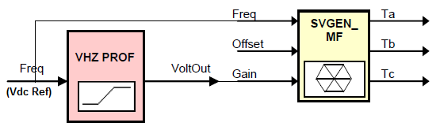

The problem here is, if we try to tune the SVpwm generator o/p to maximum voltage and frequency (i.e. 400Vac and 50Hz), we are getting only 200Vac at the output for the input of 600Vdc. If we observe (Tb-Tc) signal by giving it to DAC and its output will be pure sine wave and amplitude is nearly 3.2V. If we try to increase the output voltage to above 200Vac, by increasing Freq refernce (Vdc Ref) of v_hz_profile module, the waveform at DAC output is getting distorted.
We are unable to increase the inverter output voltage to 400Vac, for the input of 600Vdc, without disturbing the shape of the sine wave. Is there any limitation in the svgen_mf module..? or Is there any problem in tuning the inputs of the control modules..?

