Question/Problem:
- Vertiv (Emerson) needs high-resolution EPWM output on both edges;
- Enabling high-resolution duty mode and setting REP can get rising edges’ high-resolution, and also their power output THDi is good;
- Simply enabling high-resolution duty mode while modifying REP to BEP can not get both edges’ high-resolution;
- Only enabling high-resolution period mode and keeping BEP can get both edges’ high-resolution, but their power output THDi is bad;

Item | CMPxHR | R/B | P/D | THDi Min | THDi Max
1 | √ | R | D | 1.47 | 2.11
2 | √ | R | P | 2.53 | 3.5
3 | √ | B | P | 2.47 | 3.3
4 | √ | B | D | 1.43 | 2.18
5 | × | R | D | 1.4 | 2.4
6 | × | R | P | 2.43 | 3.2
7 | × | B | P | 2.45 | 3.1
8 | × | B | D | 1.47 | 2.3

Note:
CMPxHR: √ means this register is written with calculated value and × means it keeps 0;
R/B: R stands for rising edge and B stands for both edges (EDGMODE = HR_REP/ HR_BEP);
P/D: P is for high-resolution period mode (HRPE=1), and D is for high-resolution duty mode (HRPE=0);
HRLOADA = HR_CTR_ZERO_PRD, HRLOADB = HR_CTR_ZERO_PRD

Below are their test procedure and results (Codes are based on the one you provided):
4 TESTS are completed with incremental modifications and it seems your example code can not output high-resolution, while using high-resolution period mode and BEP does give both edges’ high-resolution, but their power output THDi will turn bad.

TEST1 (Only modify CMPAHR and CMPBHR):
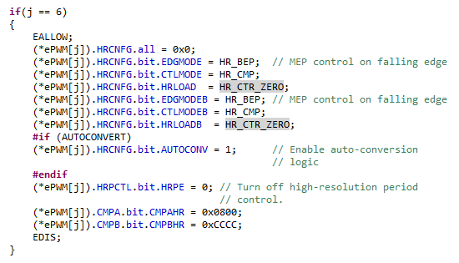

Duty cycle on xA and xB are fully identical although CMPAHR and CMPBHR are different, and Δx = 11.6 ns in picture #2:

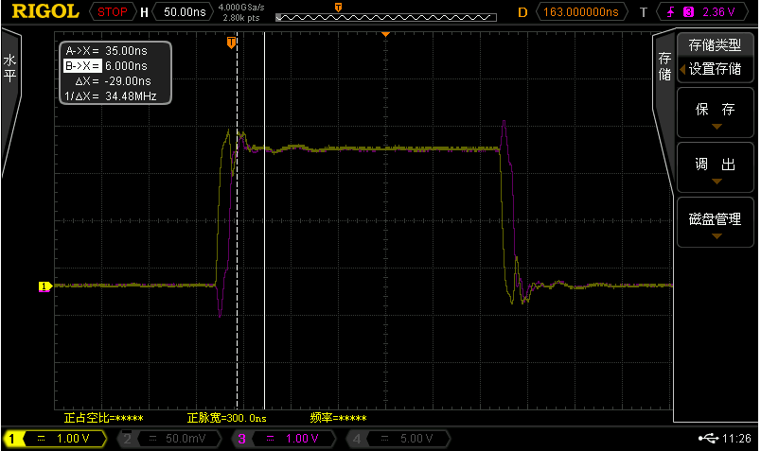

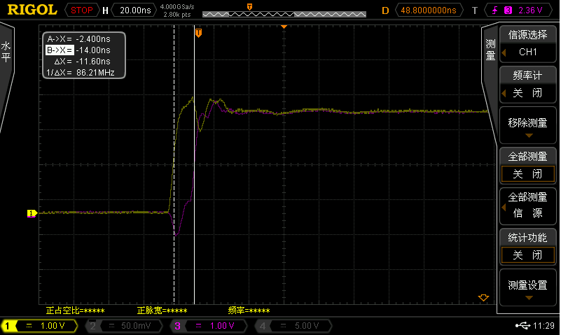

TEST2 (Only modify HRLOAD from HR_CTR_ZERO to HR_CTR_ZERO_PRD based on TEST1):

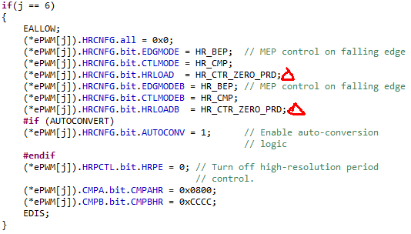

It’s identical to TEST1:
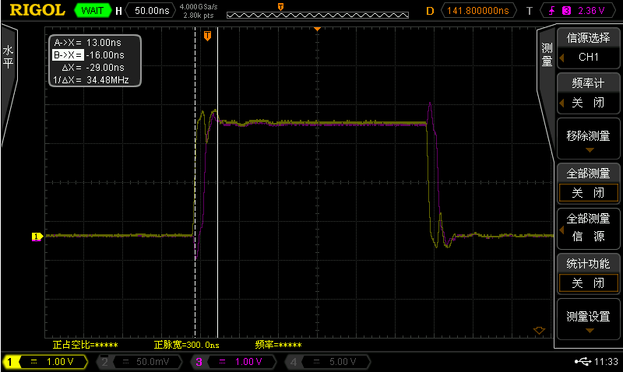

TEST3 (Only enable high-resolution period mode based on TEST2):

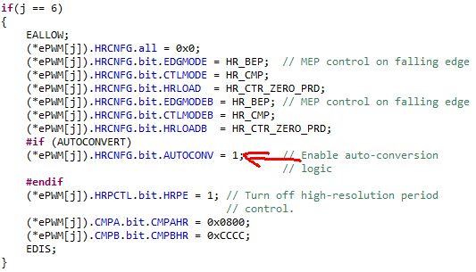

EPWM6B (red) is 12.4ns narrow in both rising and falling edge when compared with EPWM6A (yellow), which can match（0xCC-0x08）/255*16.67=12.8ns:

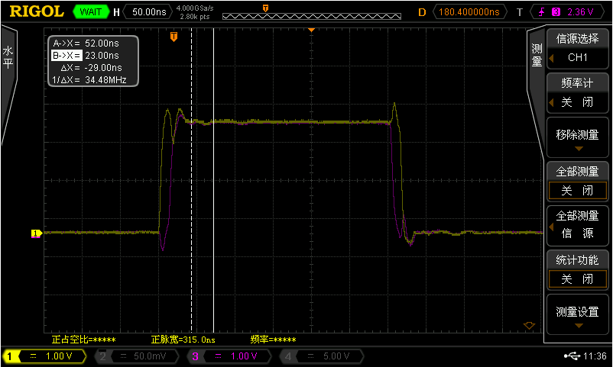

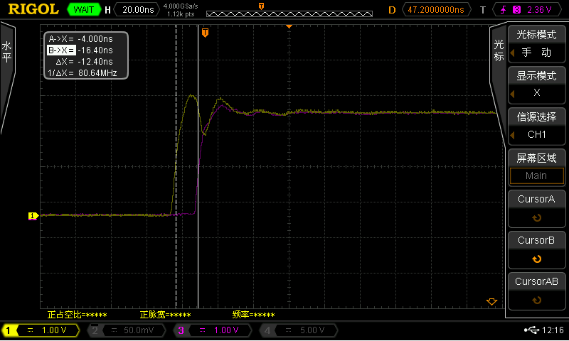

TEST4 (Only modify EDGMODE from BEP to REP based on TEST3):

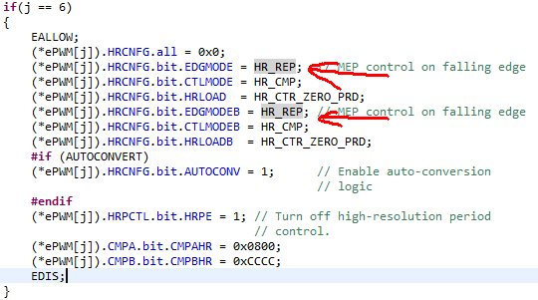

High-resolution is showed only on rising edge while falling edges are override:
