Problem of load code to TMS320F28027

I have code debugged and run well with debugger of CCS6.1.0. Now the code need to be loaded to TMS320F28027 so that TMS320F28027 can run independently without debugger probe.

Uniflash is the software I used to load code to TMS320F28027. However, this software is quite confusing to me. After reading their tutorial, i am still not sure about how to load code to TMS320F28027. Their tutorial is quite different from what I see for TMS320F28027.
When I open the Uniflash 3.4.1, the screen is the following.
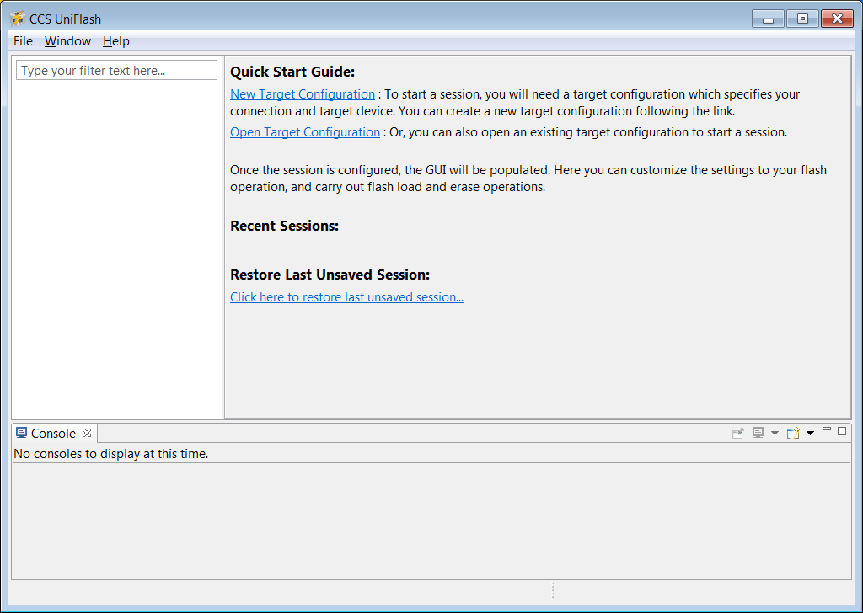
Clicking new target configuration, the new window pop out,
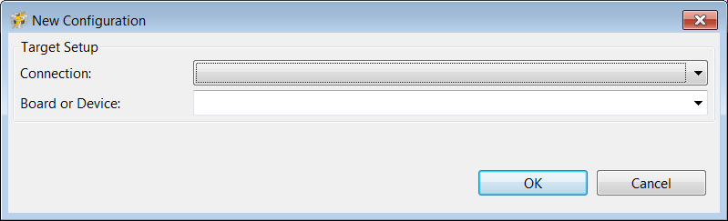
To my system, I select XDS2xx emulator, and TMS320F28027, it is like the following.
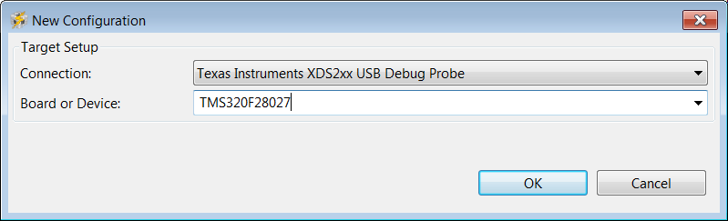
Click “OK”, the GUI main screen will pop out, as the following figure. In the main screen, nothing is allowed to change except code security password.
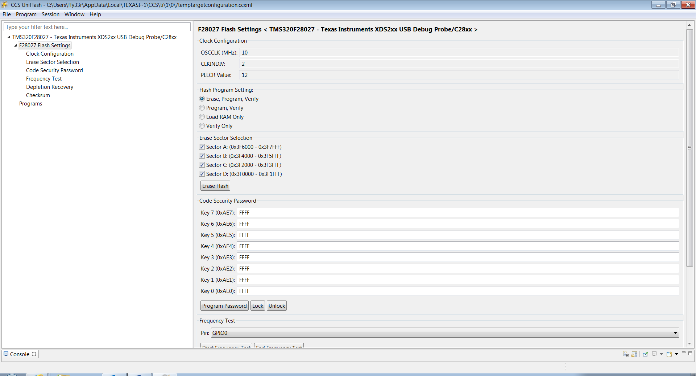
The click “programs” button, the screen for the file shown as the following figure.
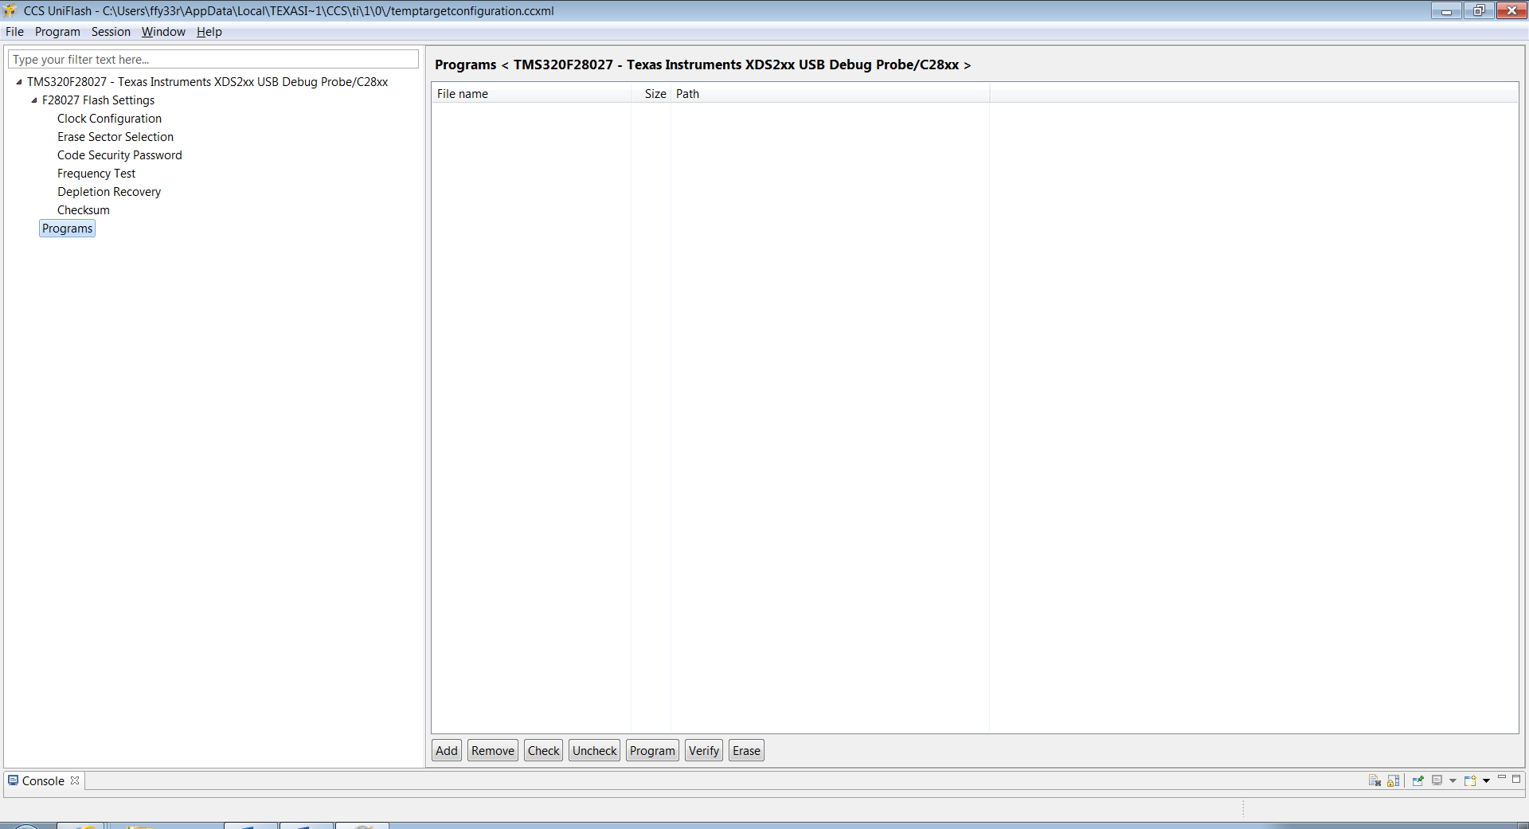
Now click the button “Add”, it means to read in some files.
- What files should be read in here? .out file or .obj file, or something else?
I selected .out file, it does not work.
- Any more detailed tutorial about Uniflash for TMS320F28027?

Thanks.

Z

