Hi, Gautum,

Could you help clarify the following questions? I am not quite clear about them.

Thank you.

Z

- I did “Replace 28027_RAM_lnk.cmd with F28027.cmd”, but the file name of “F28027.cmd” is grayed out automatically by system. It says there is file with the same name. But I do not see the file with the same name.
What causes that?
The roundabout is that I simply rename “F28027.cmd” to “F28027_.cmd”. Then system build fine. Is this method ok?
- How to load compiled “.out” file to TMS320F28027?
Is it through software UNIFALSH? Or through CCS6.1.0?
Can CCS6.1.0 LOAD .out file to flash?
I used “Uniflash” to program “.out” file to chip. It says chip is programed successfully. But when I turn-on power supply of TMS320F28027, TMS320F28027 does not function. The uniflash program screen is shown below.
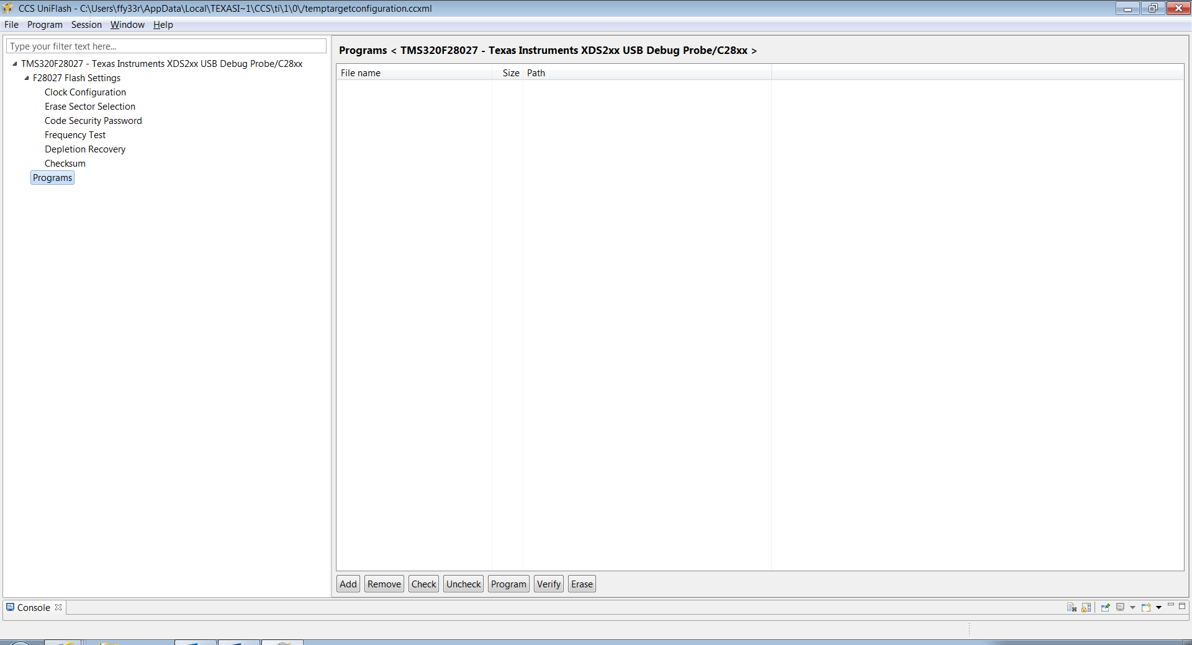
- How to “Configure your GPIO's to boot to flash.”
I set the GPIO37/TDO and GPIO34/COMP2OUT to 3.3V, and TRST to ground.
Is it right?
The result is that there is nothing happened when TMS320F28027 is powered on.
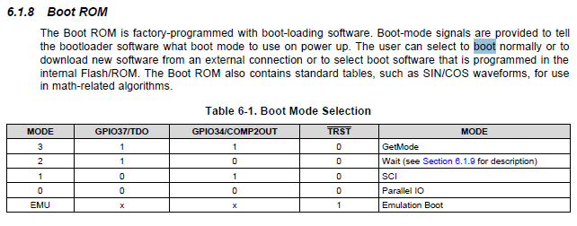
- What is the right way to flash TMS320F28027?
Related documents?
Step by step guidelines?

