QESTION :About PCMC_PSFB Open Loop & Setting and Resetting not doesn't work
Hello,
I am a new student of C2000.I want to use F28004x to make a pcmc control loop. Because of some reasons of supplier ,we don’t have the complete TIDM-02000 now . Our task is to realize the open loop control with mcu before the goods arrive.So we suppose a signal from frequency generator (linked to pin of Q1 and Ihv-fb on controlboard) as primary current . However no matter how i changed the value of PSFB_gui_icommand_Set_Amps , the waveforms maintain as the photo.
Here are my questions:
- The signal I set form generator is a ramp as the photo, is it within the range that the system can handle? If not, what range should it be within?
- In my case , is the valeur of PSFB_gui_icommand_Set_Amps the same as the peak reference current ? Does it need to be converted ?
- I run the package of code PCMC_PSFB_F28004x without extra change, what may be the reason of not working ?
Thanks for your help!
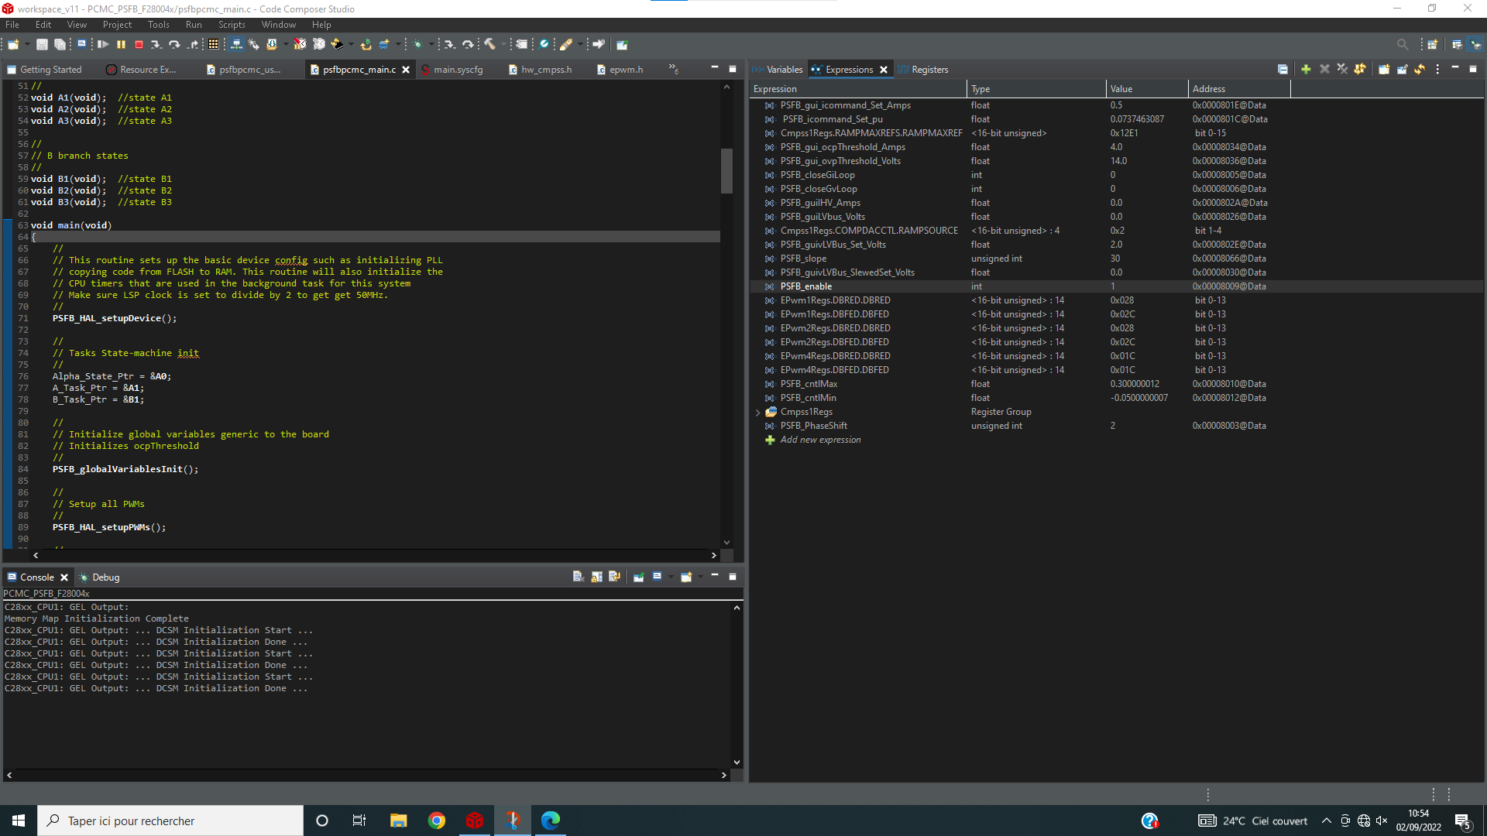
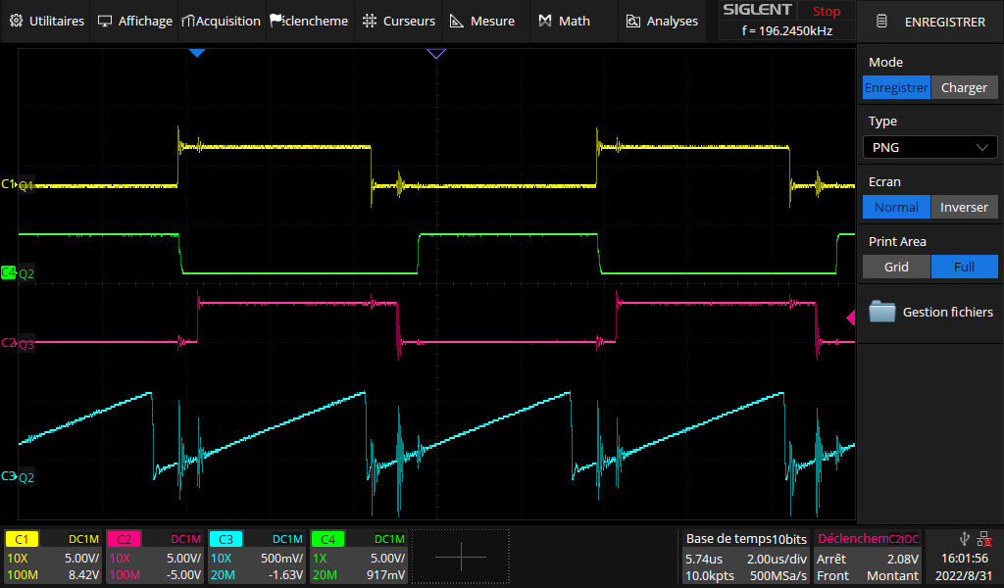
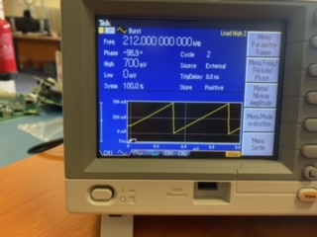 (photo of frequency generator)
