Question on timer interval in CCS v8 with TI-RTOS v6.53

System frequency was set to 80 MHz
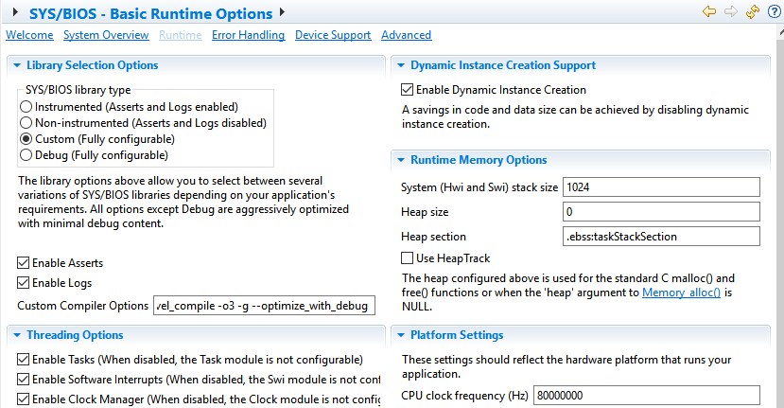
Timer period was set to 2 ms.
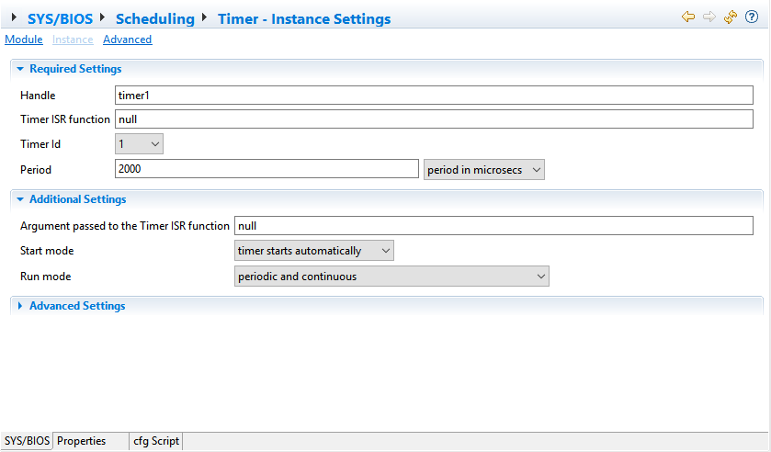
Timer 1 was configured as SOC signal
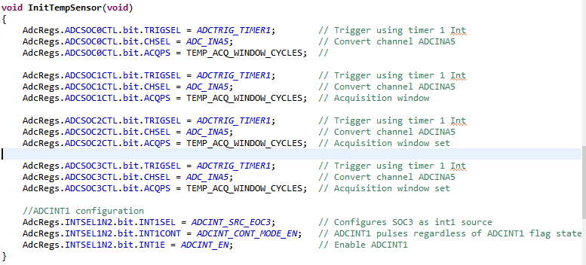
Execution graph shows 160 us ADCINT interval.
