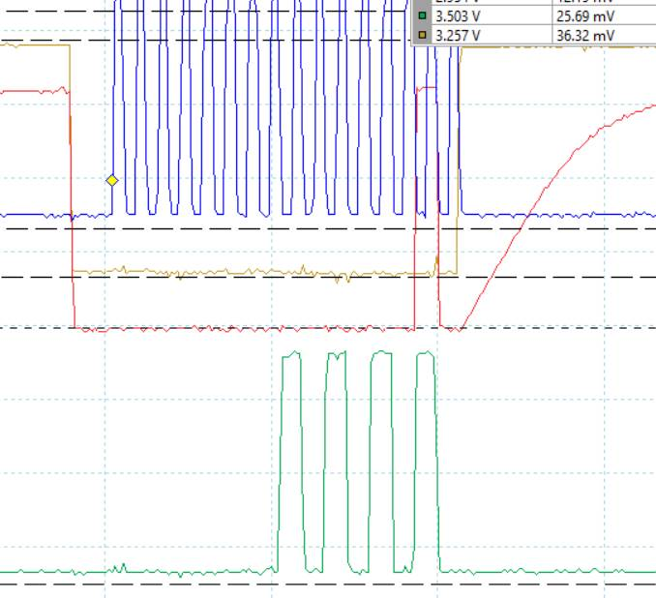
Blue: SPICLK
Gold: SPISTEA
Green: MOSI
RED: SOMI

