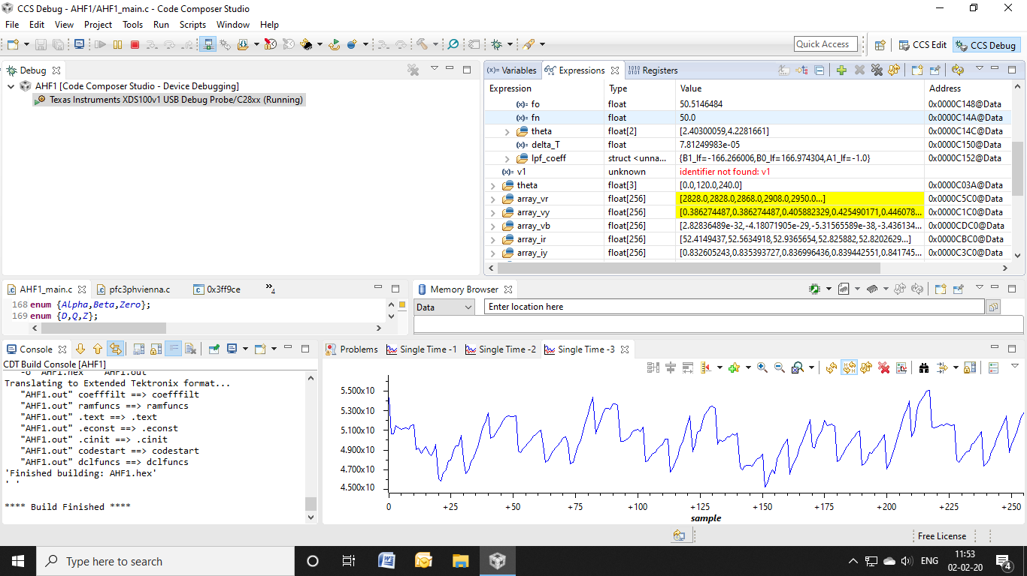

SPLL 3phase f0 output variation

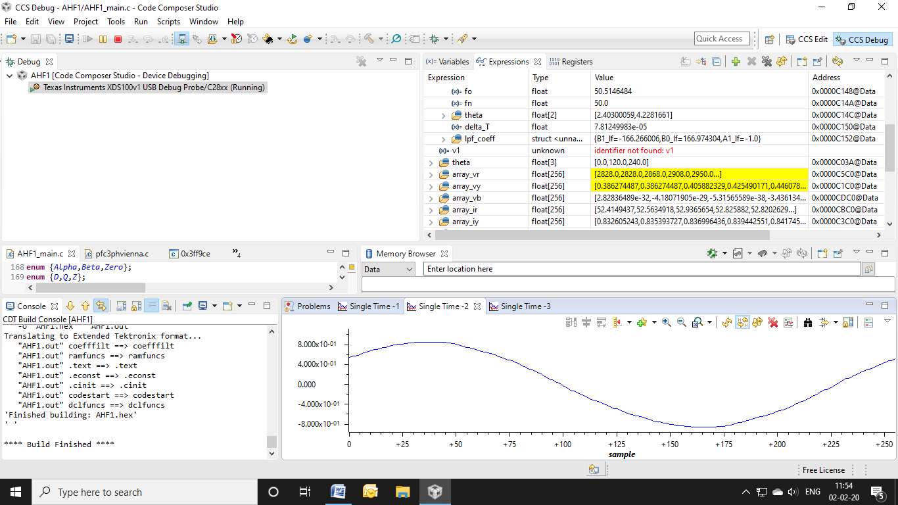

AC input to ADC

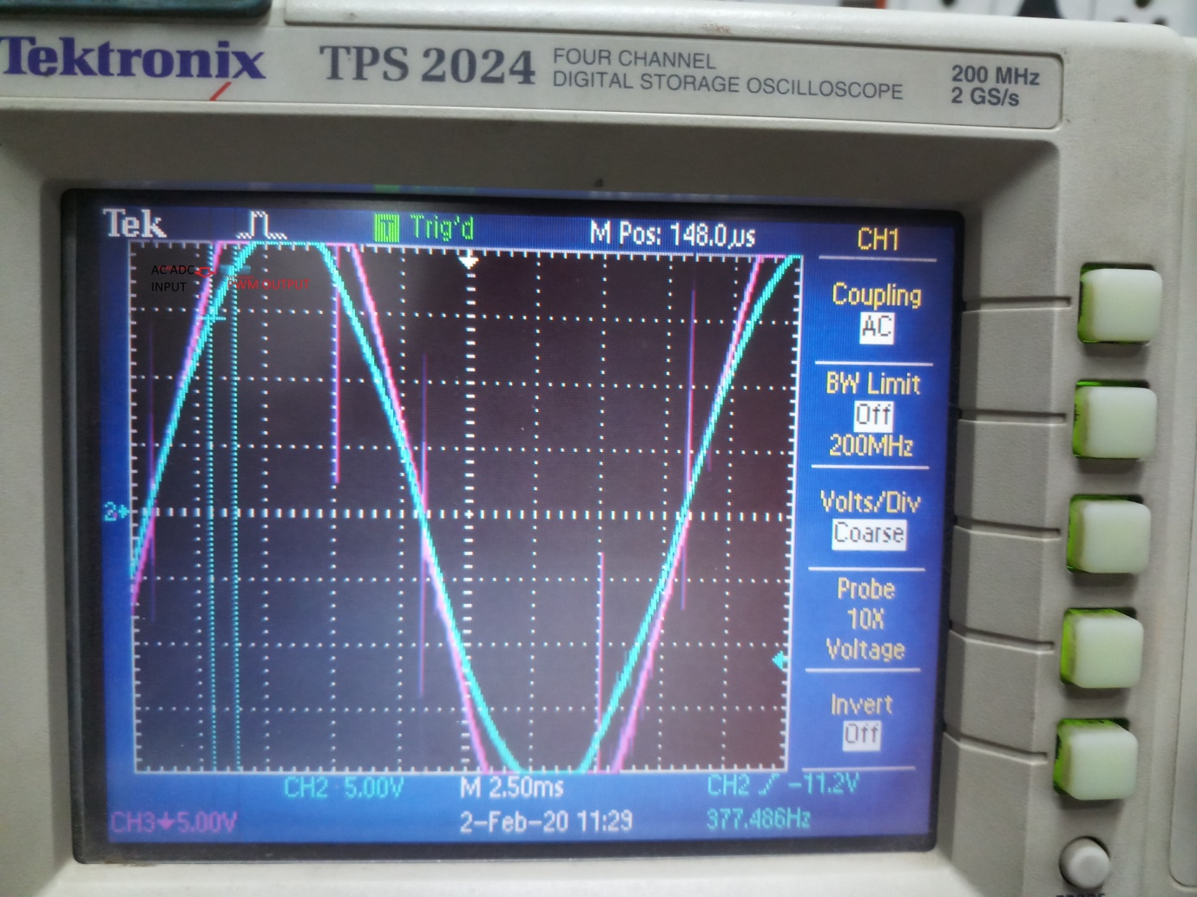

PWM output after SPLL locked (GREEN) and ADC Input(Pink)