Controller: TMS320F28388DZWT
SDRAM: IS42S16320F-7BL
Frequency: 100MHz
IC Corner: Typical
Duty Cycle:50%.

Simulation Observation:
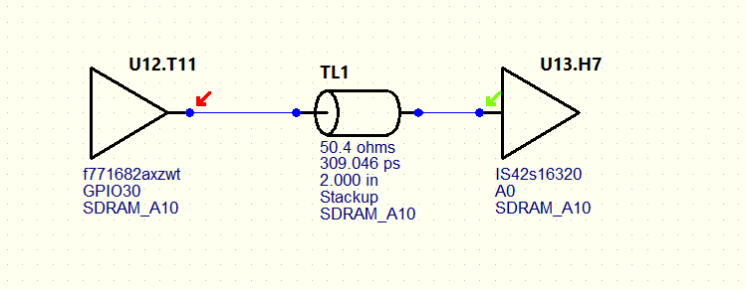

Simulation Observation:
Ringing and non-monotonicity.
- Series Termination near Driver with 18 Ohm. Came up with resistor value using Sweep.
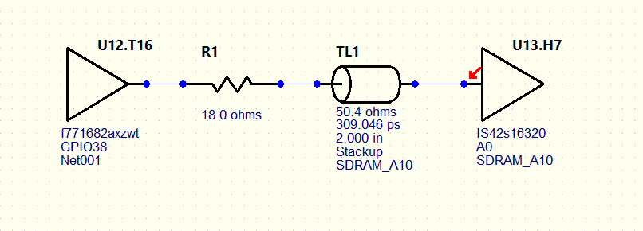
Waveform At Pin:

Simulation Observation:
Still Able to Observe Non- monotonicity at ViL threshold.

Waveform at Die:
Able to Observe non- monotonicity indeterminate region.

- Series Termination near Receiver with 48 Ohm. Came up with resistor value using Sweep.
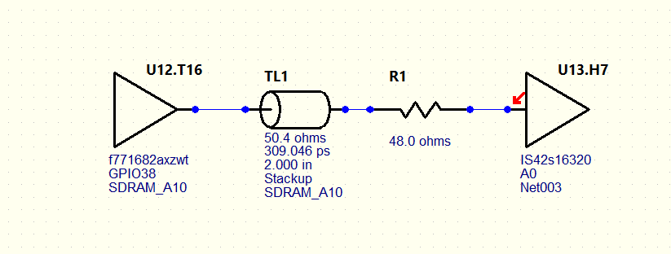
At Pin:
Still Able to Observe non- monotonicity Above ViH.

At die: Signal Are Monotonous.

