Main loop:
ADC initialization in BIT mode:
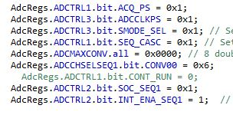
Code in main Execution func:
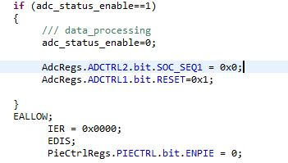
ADC isr func:
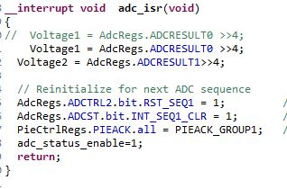
Here in BIT mode after testing the peripherals the opmode function is called

OP mode:
ISR addressing and intialistion 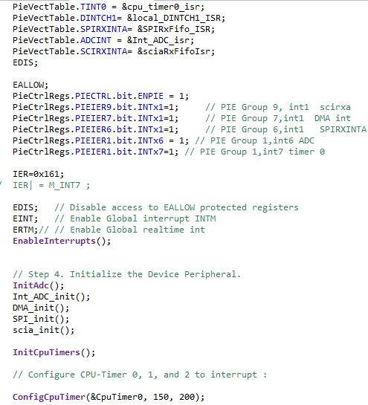
Iteration loop in OPmode
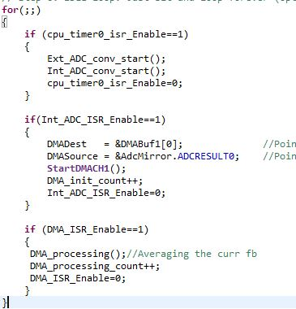

ADC intialisation in OPmode function
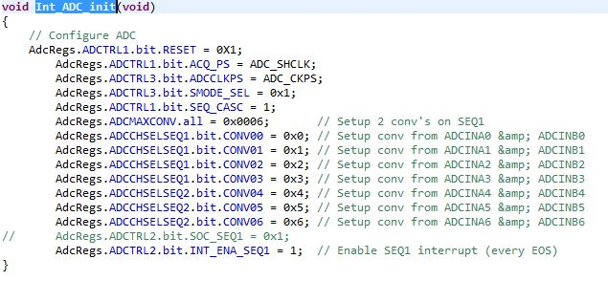
DMA initialisation func
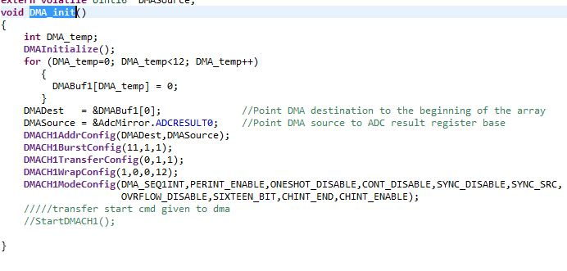
DMA processing function
