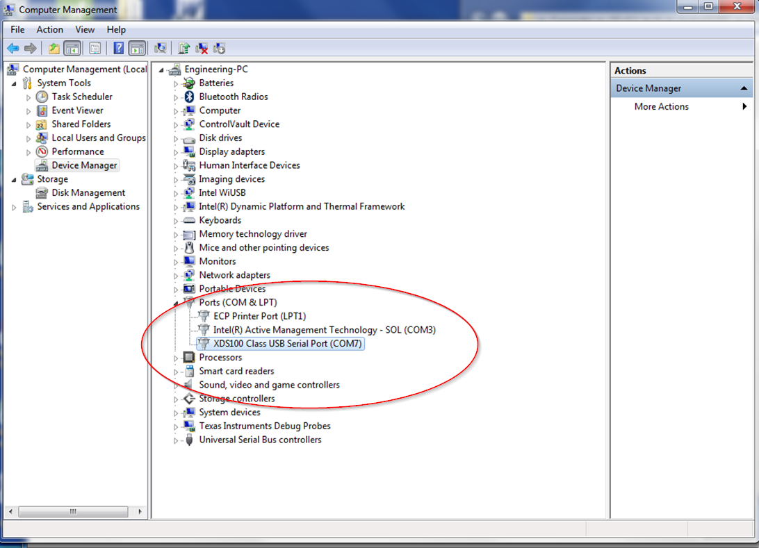

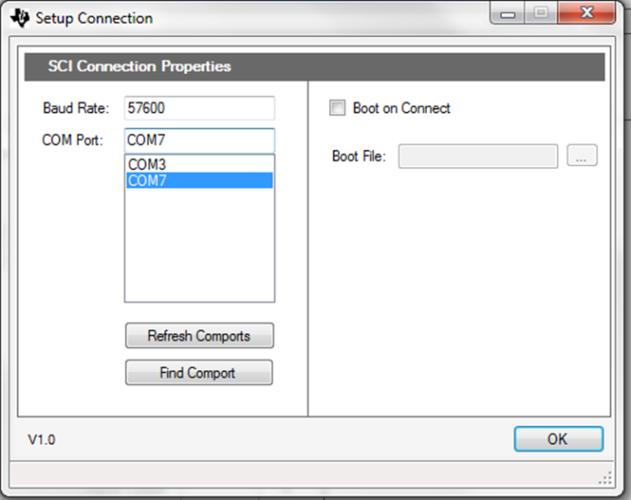

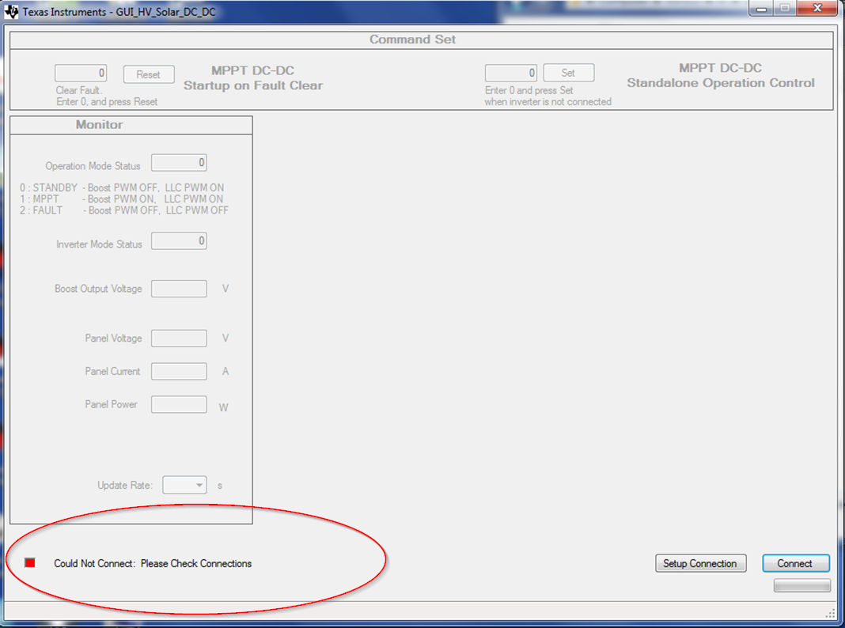

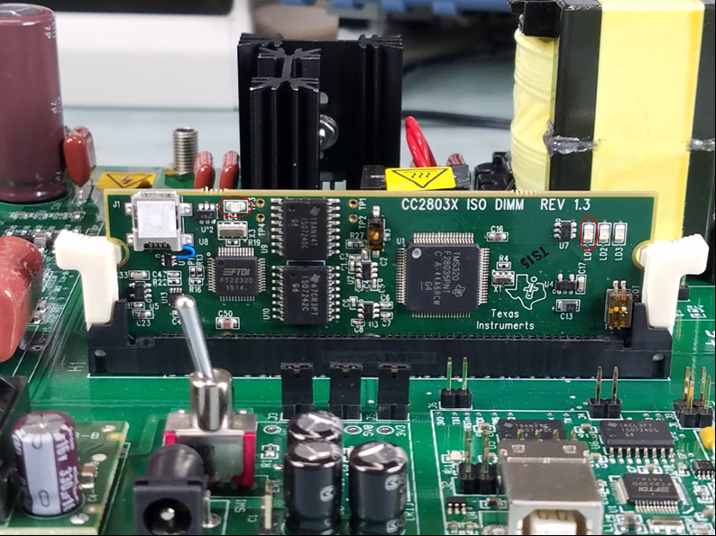
They did not have any LEDs blinking. LED4 on the CC2083X board turned on when the cable was plugged into the CC2803X. LD1 (CC2083X) LD1 (M3 big board) turned on when +12 VDC was plugged in and SW1 (big board) was flipped towards the capacitors nearest to switch SW1.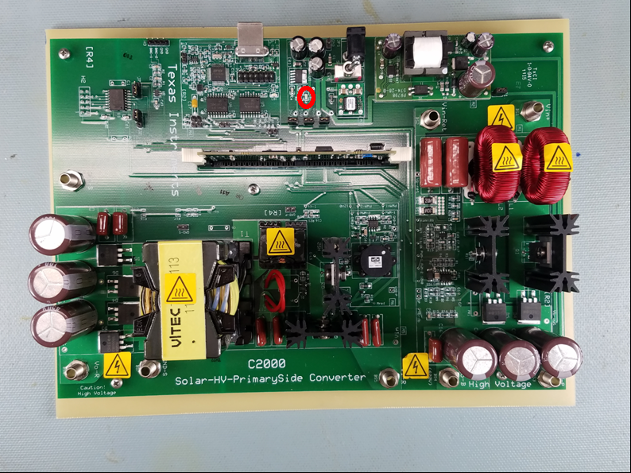

They also have Microsoft.net framework 4.7 installed.