Issue Description:

CLA reported a warning : #70D integer conversion resulted in truncation. Details shown as below figure:

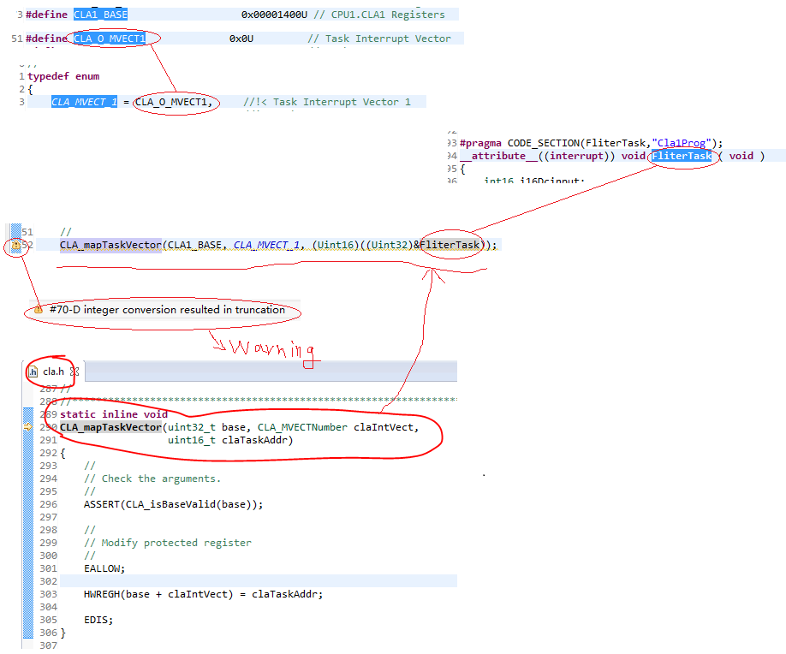

Support Need:

Any comments for how to do the conversion?