Issue description:
The XRS PIN reversed twice within 1ms while customer doing the TMS320F280049PZQ power down test, and the VDDIO(3.3V) is keep falling down, customer used RC filter in XRS pin.

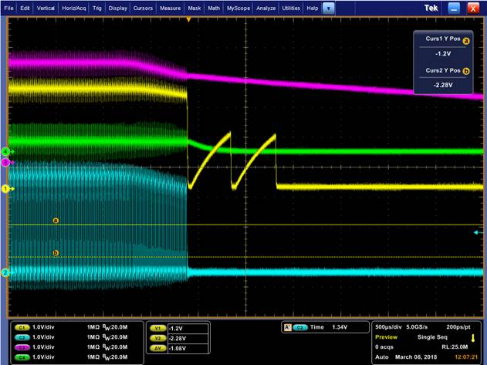
Figure 1 XRS PIN test waveform
CH1: XRS pin CH3: VDDIO（3.3V）

Support Need:
Could you kindly help give comments on the reason the XRS reversed twice during power off within 1ms? And comments for external circuit design of XRS connection?

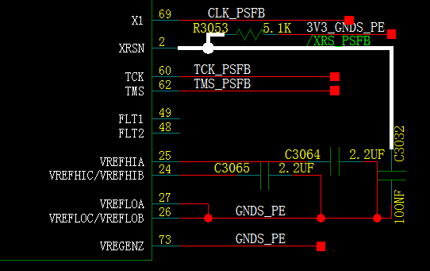
Figure 2： external schematic of XRS pin

