Issues Description：
The IIC SDA/SCL PIN received voltage level of 0 to -0.64V signal which last for 176ns; and for -0.3V to -0.64V, the signal last for 80ns：
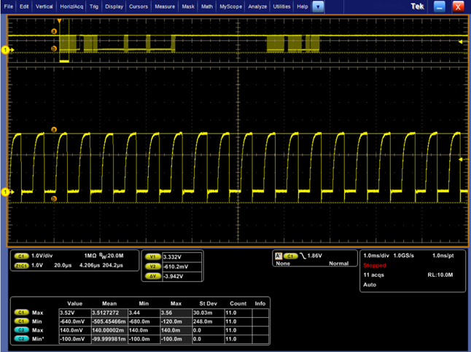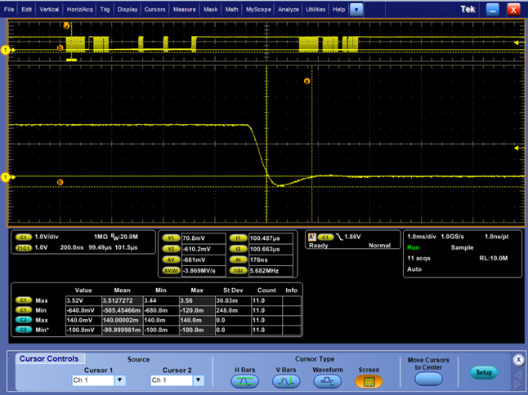
SDA waveform: minimum voltage -0.64V, last for 170ns
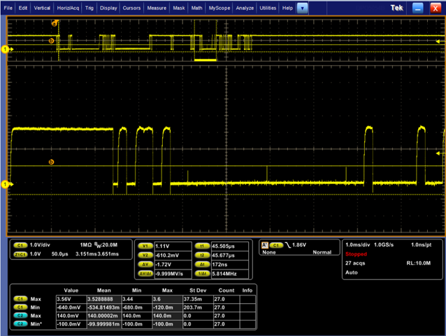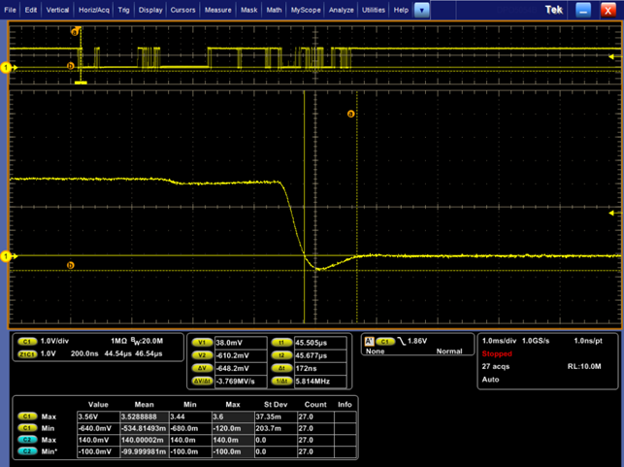

Support Need:
Is it out of datasheet spec definition for -0.64V last for 80ns?
What is the time limitation of 0 to -0.3V which will not broke the device?
What’s the time limitation for F28032 pin input voltage level range is -0.3V to -1V?
What's the comments for the external circuit besides the standard IIC circuit?

