Issue description:
Customer used TMS320F2837s in solar inverter application, and while at night, the power supply of 3.3V(VDDIO/VDD3VFL/VDDA) would be 1V(low than startup), and power supply of 1.2V is 0v, the external monitor device output 0V to XRS pin; but according to the datasheet, which required “The supplies should ramp to full rail within 10ms”. Also while in day time, the 3.3V power supply will be start up from 1V.
Which will affect to the reliability of TMS320F28374s or not at upper situation?
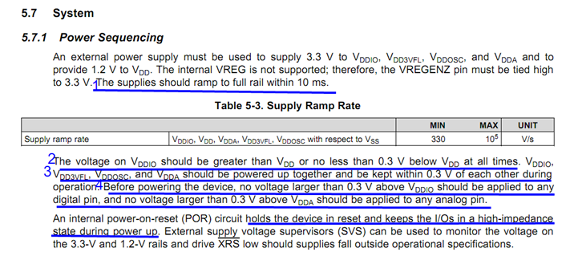
Power up waveform：
pic 28.1: CH1:3.3v_plc CH2:3.3v CH3:1.2v CH4:+12v
