DSP：TMS320F28377DPTPT

CCS：Version: 8.2.0.00007及6.1.3

Application：A published version

Fault phenomenon：

1、The use of CCS8.2.0 failed to write, the error message is shown in the picture below, replace the simulator, replace the computer, replace the board and the results are consistent.

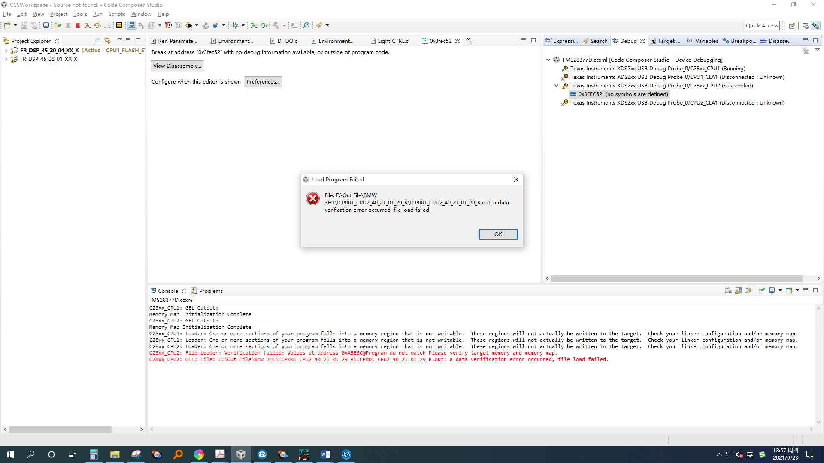

2、If CCS8.2.0 and the same program version are used, no error message is displayed after downloading. The Console output is as follows, and the program cannot run normally.

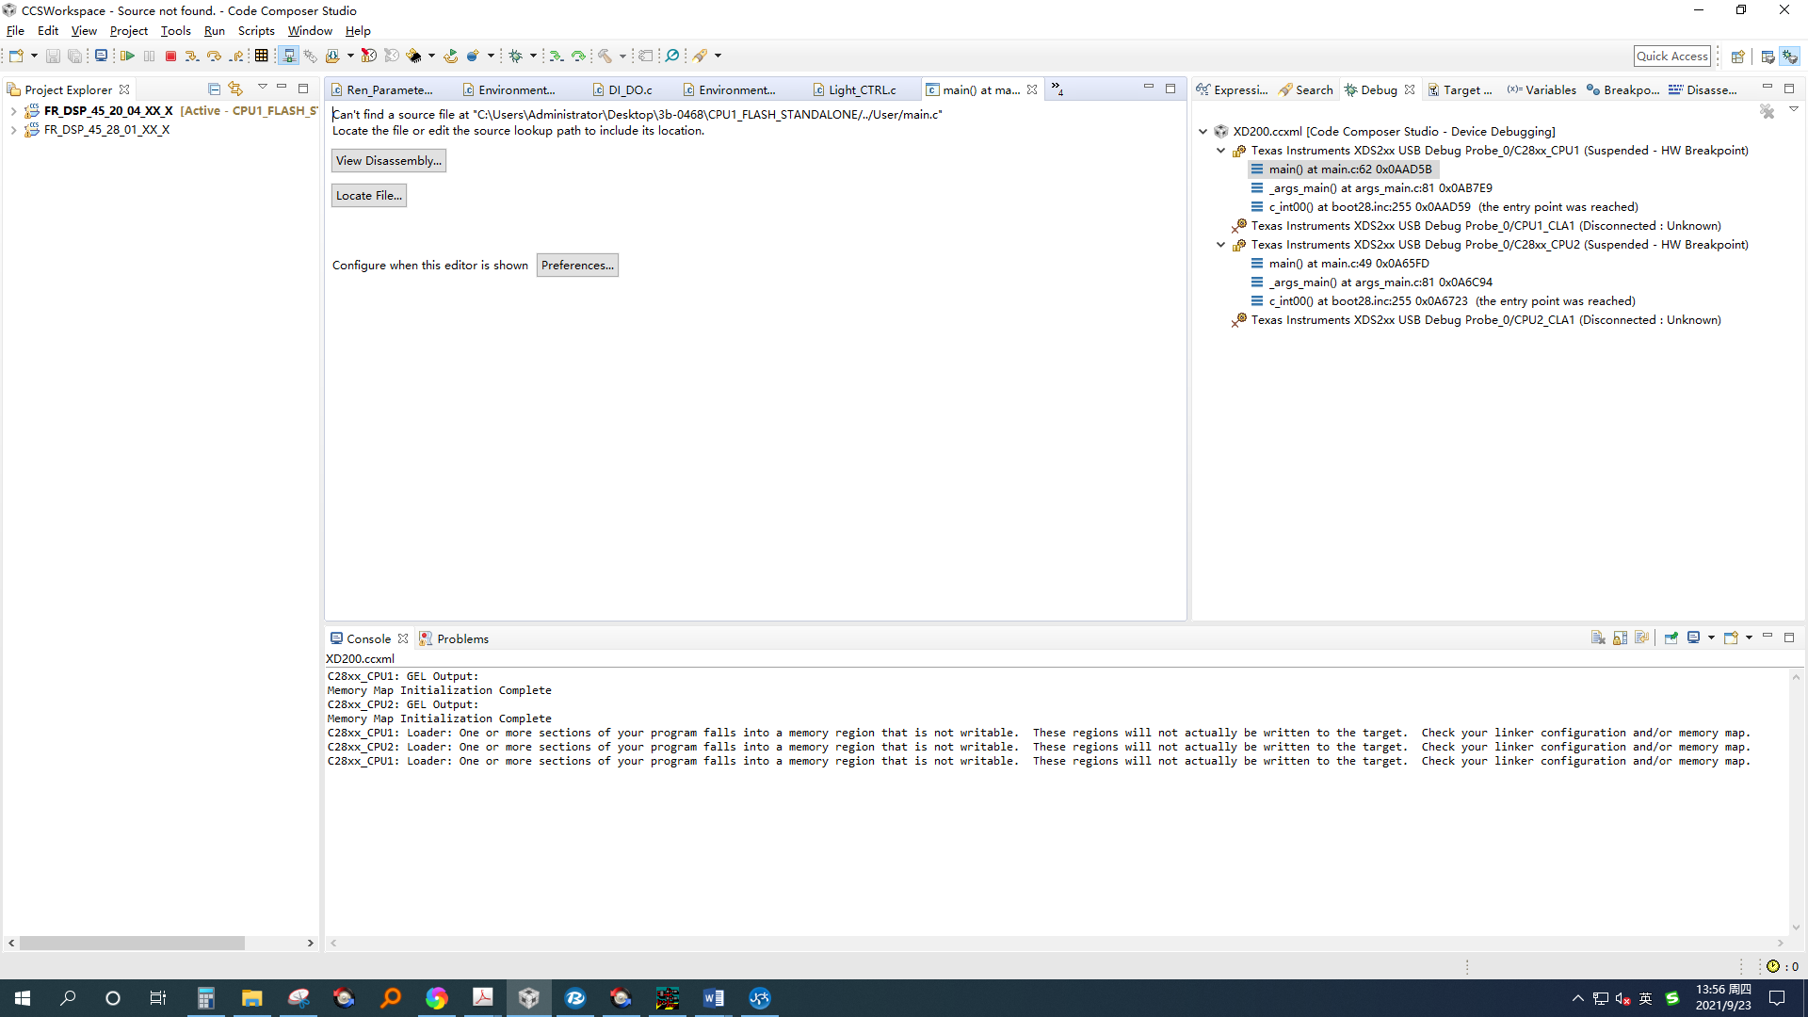

3、3. Change the download tool to UniFlash, use the same program, download successfully, can run normally.But after sending it to the production department, the production department stuck in the LOAD according to the operation steps I sent, and failed to burn and write.

4、Change the CCS Version to Version 10.4.0. Use the same program. The software is downloaded successfully and runs normally.

5、Using CCS8.2.0 and the same program, used in last year's production of the board, downloaded successfully, normal operation. And the same board and application has been used for 2 years.

Issue：

1. Why is the download of this batch of chips using CCS8.2.0 and below versions unsuccessful?

2. Why are the results of different versions of CCS inconsistent when the same board is used?

3. Can this batch of chips be used normally?