We are currently working with TMS320F28388D. Below is the system environment we are using -
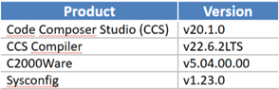
We have developed a project on this environment which compiles and works without any errors, but without any optimization.
However, when we enable optimization and speed v/s size trade off in project properties as shown below -
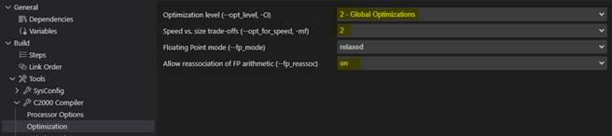
We encounter compilation error with the error message as shown below -
The issue is related to Assembler it seems.
Kindly guide us on what project configurations are required to be updated in order to resolve this issue.

