TMS320F28388D controller issue :
I want the start address to be as per my linker cmd file which is 0x080000 but when compiled with CCS IDE Version: 10.1.0.00010, Compiler version TI v20.2.1.LTS I do not see in the map file which has to be address as required but it generated with a different address as shown in below image.
Because of this Issue I am not able to boot the code from FLASH address 0x080000.
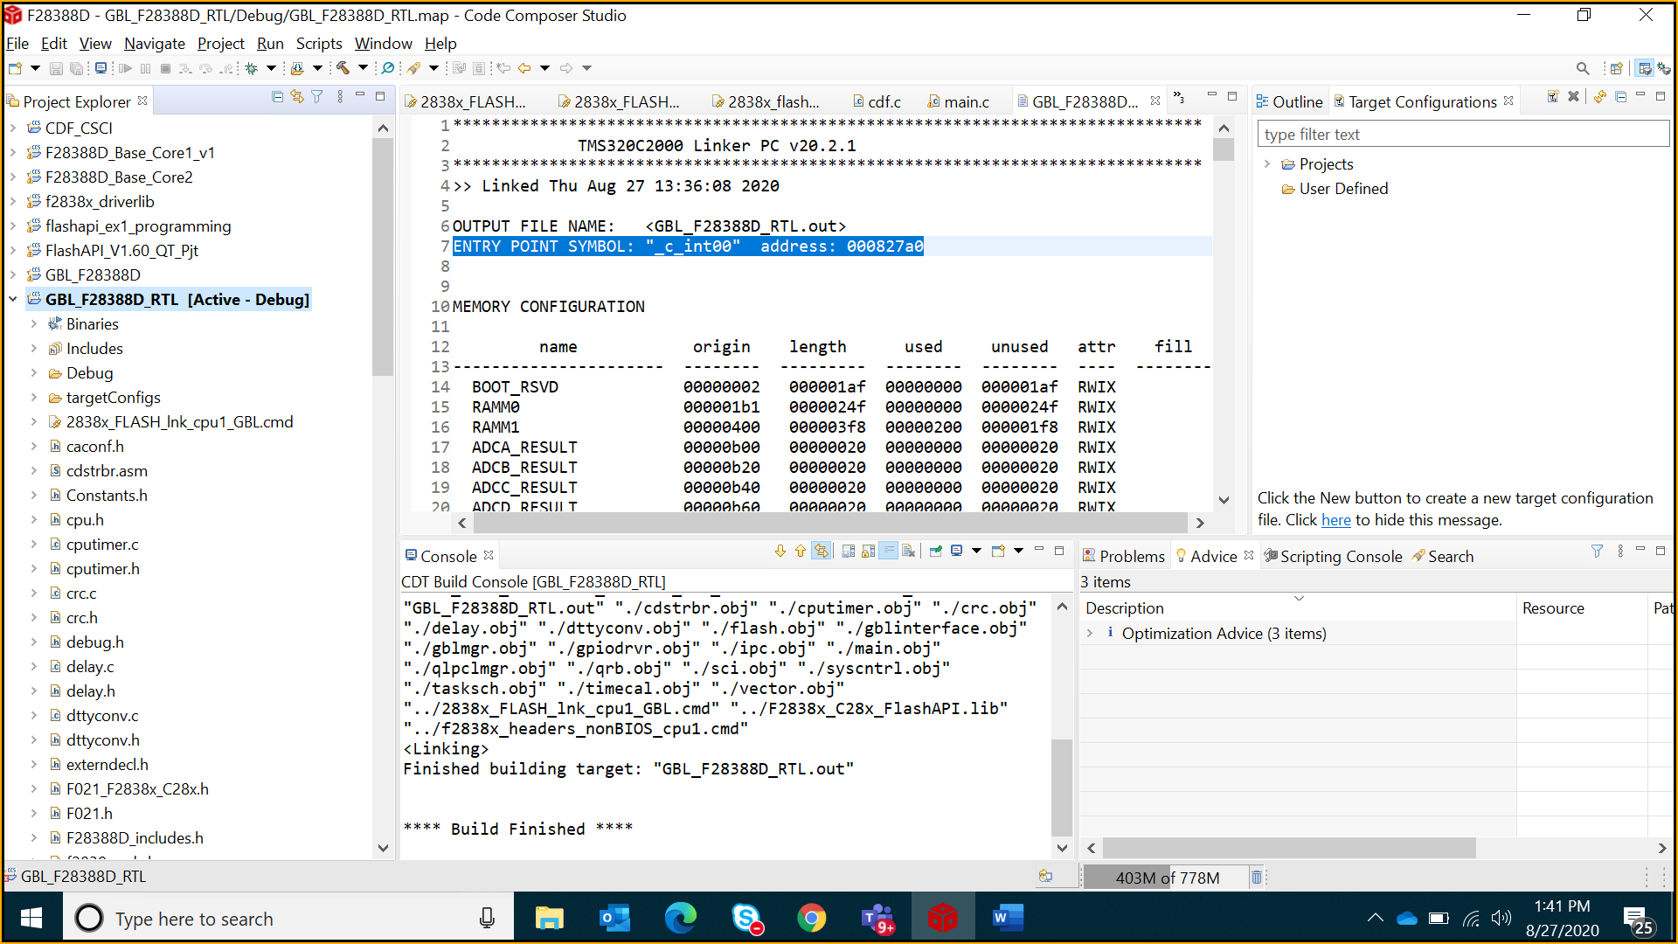

The alternative suggested was to add code_start in ‘Symbol_Management’ by adding this I could see the start address in map file got changed to as required but its not compiling, getting linker issues. Can you please let me know what is the fix for the below linker errors.
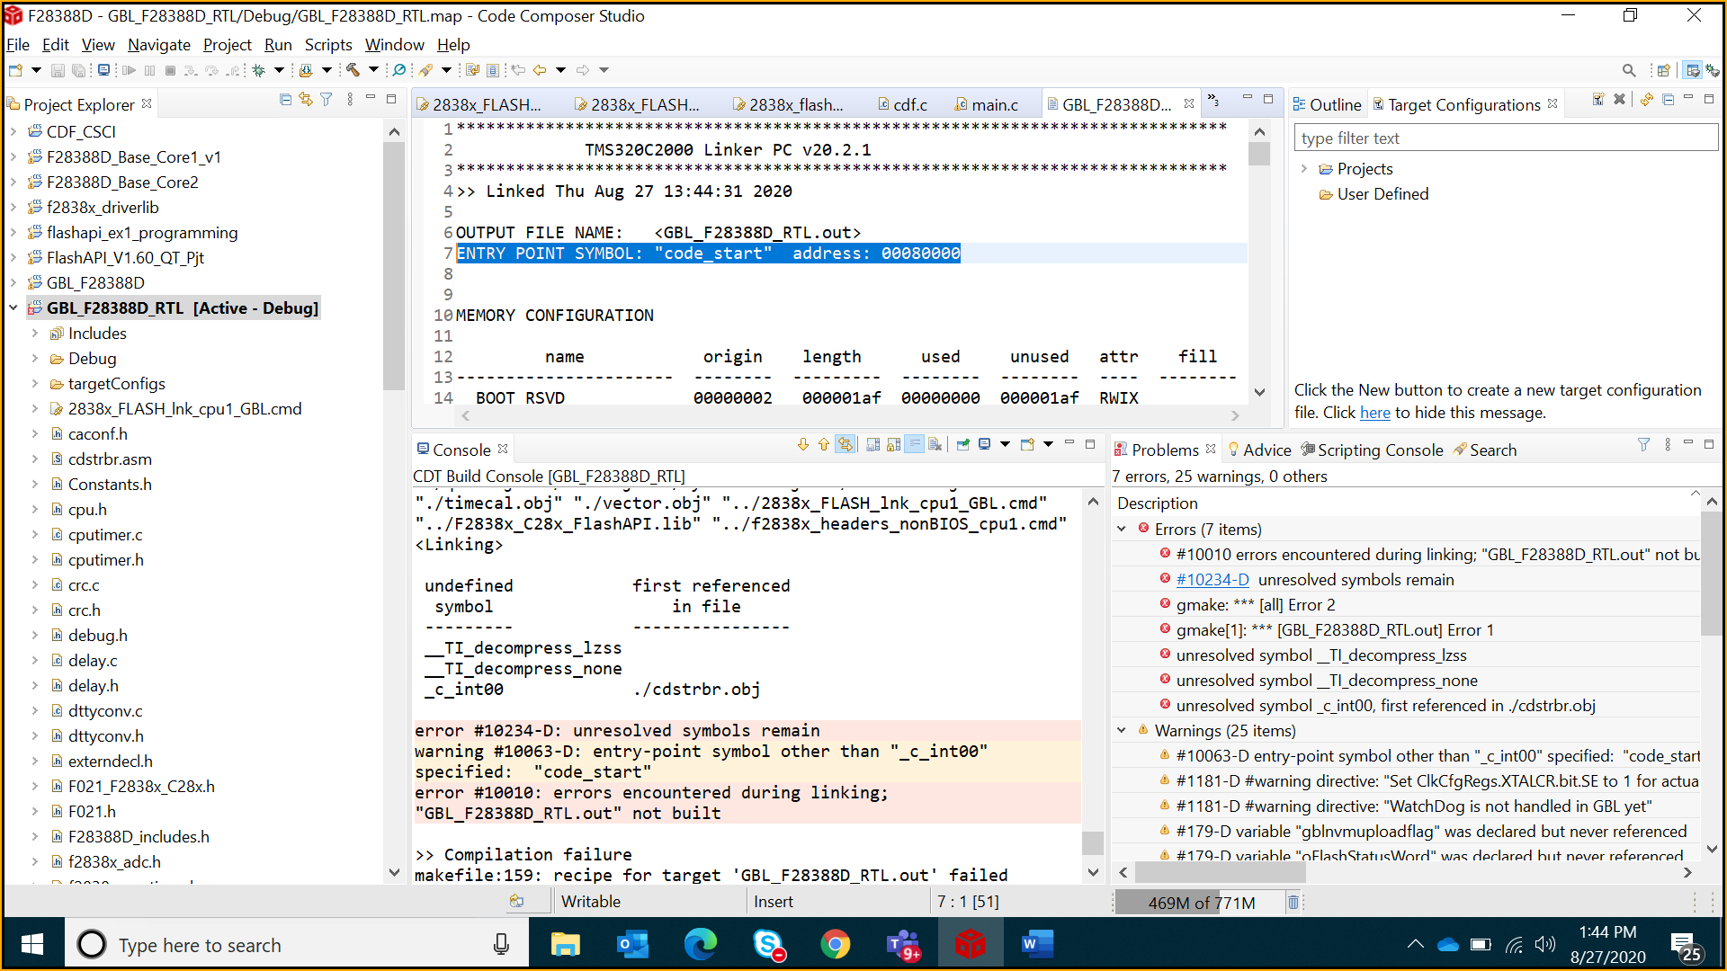

Linking Errors:
undefined first referenced
symbol in file
--------- ----------------
__TI_decompress_lzss
__TI_decompress_none
_c_int00 ./cdstrbr.obj

error #10234-D: unresolved symbols remain
warning #10063-D: entry-point symbol other than "_c_int00" specified: "code_start"
error #10010: errors encountered during linking; "GBL_F28388D_RTL.out" not built

