Dear Tech support,
I am trying to read values from the ADC of a Ti Picollo 280049C launch pad using the scope block in MATLAB Simulink. The Simulink block settings for the ADC are configured for an acquisition window (ACQPS = 8) and sample time 0.00001 s.
If I try to measure a 1 Hz sinusoidal analogue signal, then the ADC shows a perfect sine wave in Simulink, as shown below.
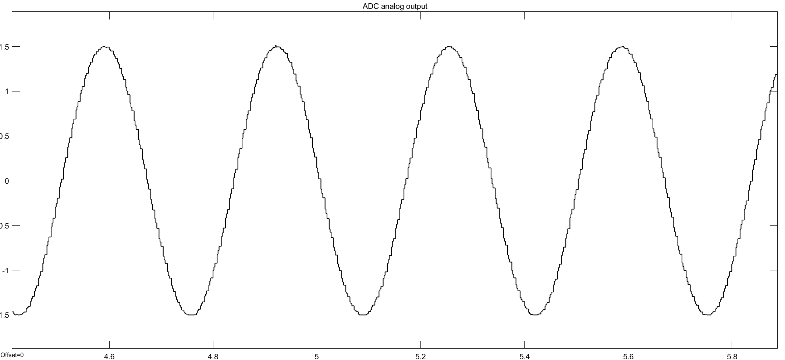
As soon as the frequency of the analogue signal increases, the resolution of the ADC seems to decrease. I'd like to be able to measure signals of 50 Hz frequency. With the current settings, it appears that samples are missing since the sine wave has poor resolution (See image below).
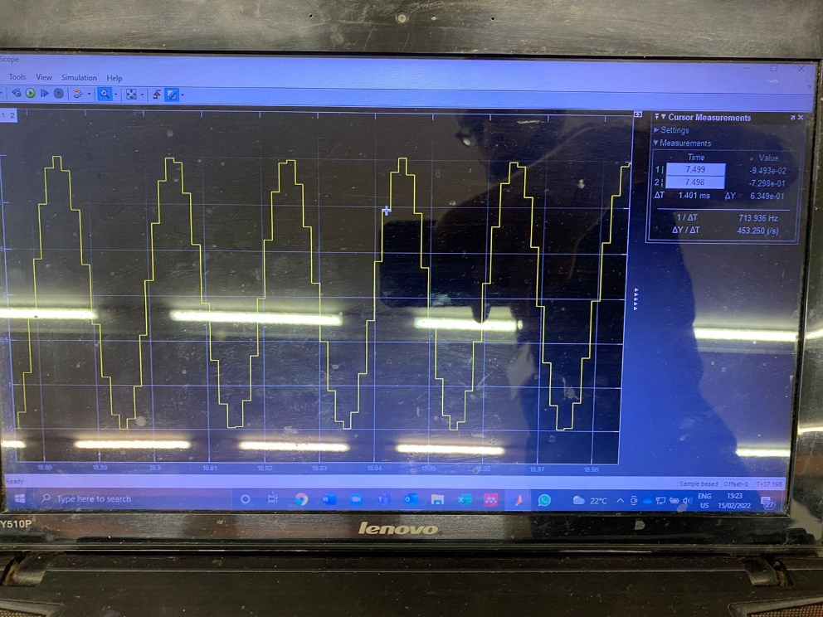
To check if the ADC does the conversion correctly, I have connected a DAC input to the ADC output. Indeed, the DAC output is a perfect sine wave if viewed on an oscilloscope, which means that, internally, the ADC is doing the conversion properly.
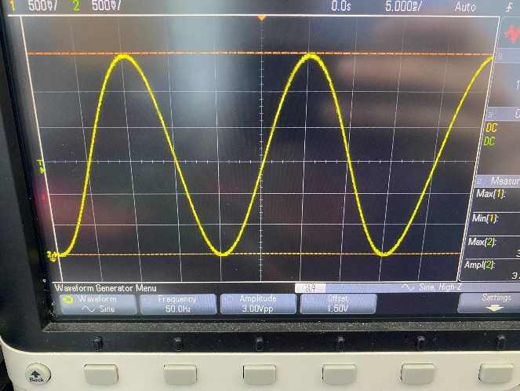
I now suspect that this problem relates to a communication issue between my laptop and the Ti Launchpad.
I use external mode to communicate between the laptop and the Launchpad and the baudrate for the COM port is maxed at 115200.
Please advise what could be the matter.

