Using flash programmer “Prg2xx”
As the flash programmer “Prg2xx” tools mention that for Windows 9x/ Windows NT

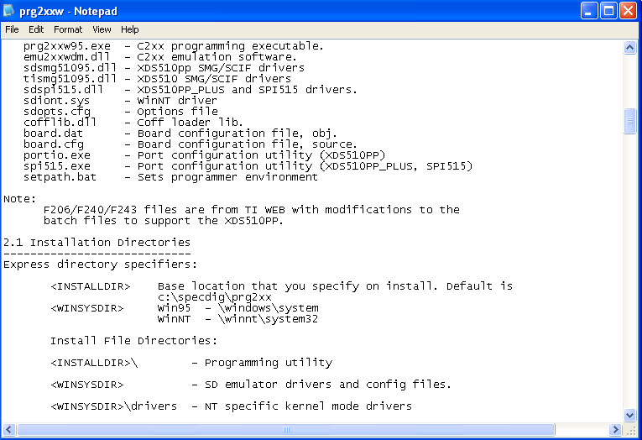
- In the flash programmer “Prg2xx”, the note mention “the F240 files are from TI WEB modifications to the batch file to support the XDS510PP”
- And windows must need Windows 95 or Windows NT.
- And Window 95 or Windows NT can’t support “USB”
- Our model is “XDS510 USB”, only support windows 2000 and above
s

