# Isuues Description:

First there are 3 control boards, and they are Board1, Board2 and Board3.

Board1 can been connected with CCS through XDS510PLSU emulator, however, after connecting the Board1 and dot the FLASH there will happen UNLOCK FLASH. Btw, this is the first to power on the board, and the first time to connect and FLASH the chip. Testing the signal of XCLKOUT is 1.87MHz.

Board2 has the same issue with Boad1, then we weld another F28335 on the Board2. Board2 can not been connected with CCS, and XCLKOUT is changed from 1.87MHz to3.76MHz.

Board3 can been conncted and been flashed successfully. And we check the value of XCOUKOUT is 3.76MHz.

And the three boards’ testing pictures as follows:

## Board1’s testing pictures:

c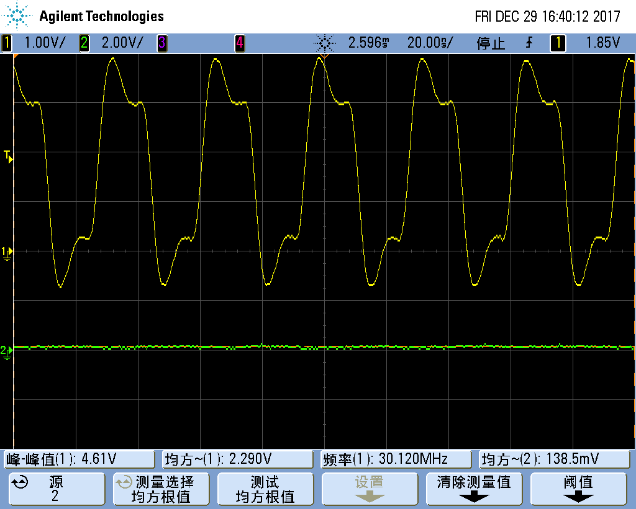

图1 Board1 晶振波形 频率30.120MHz

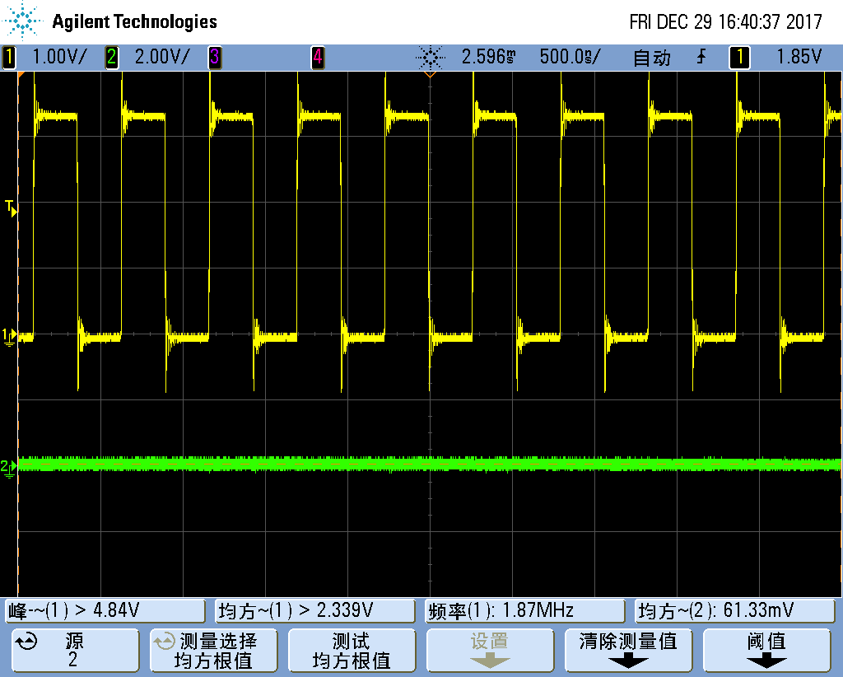

图2 板1 XCLKOUT输出波形 频率1.87MHz

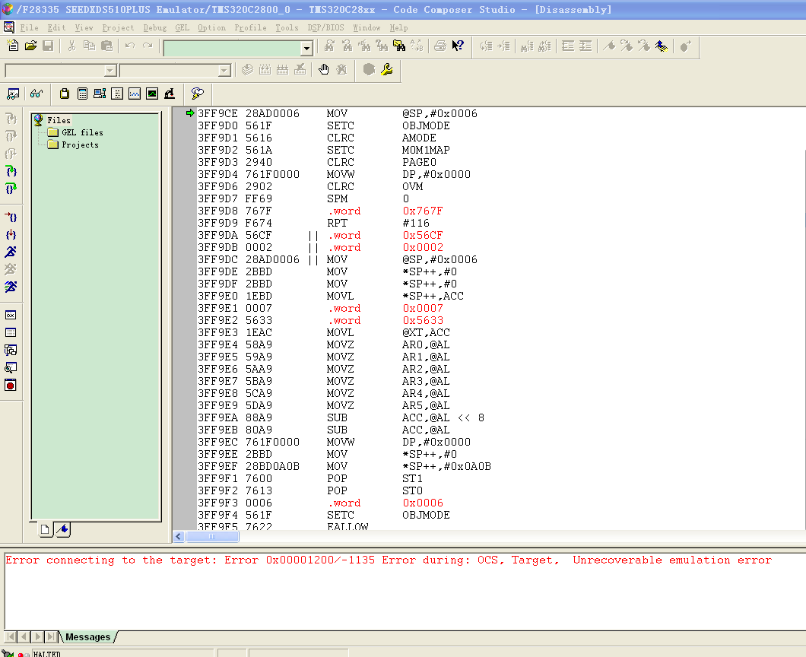

图3 板1通过仿真XDS510PLUS连接电脑后界面

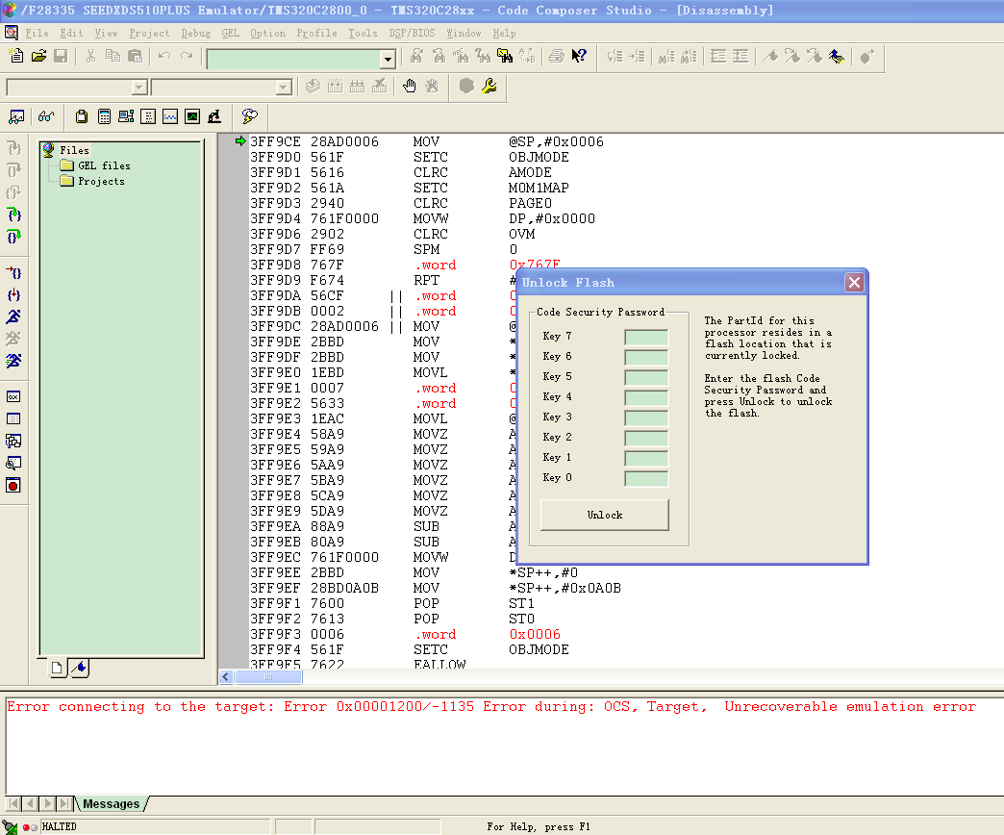

图4 板1点击烧写程序后界面

## Board2’s testing pictures

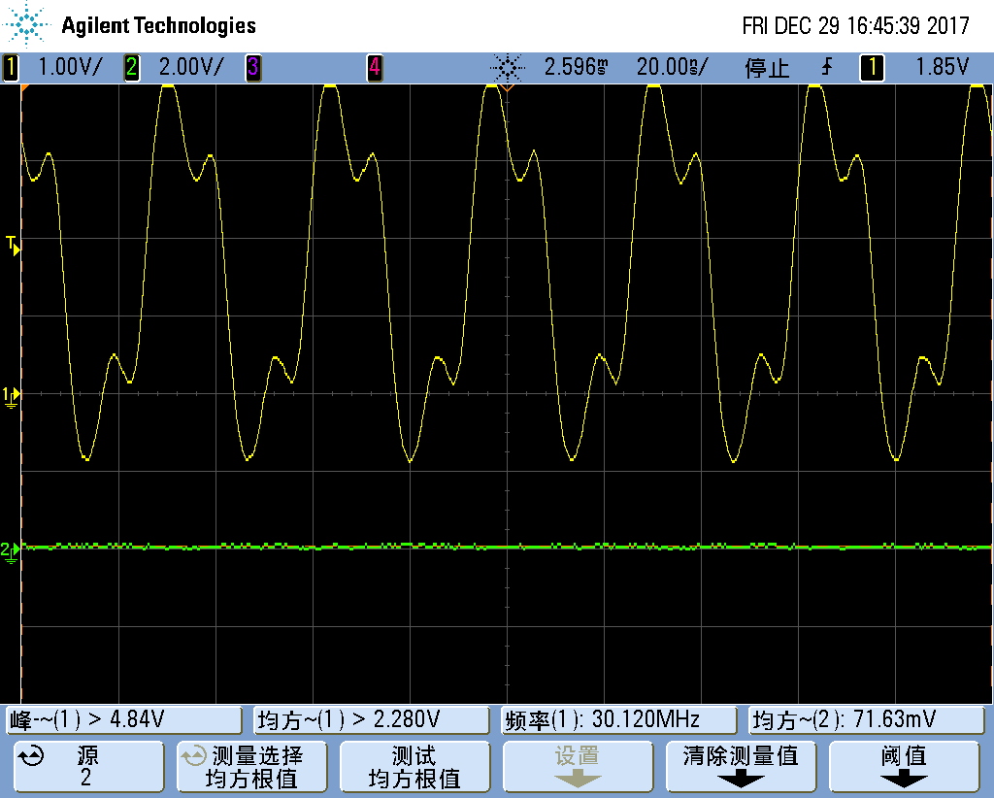

图5 板2输入时钟波形30.120MHz

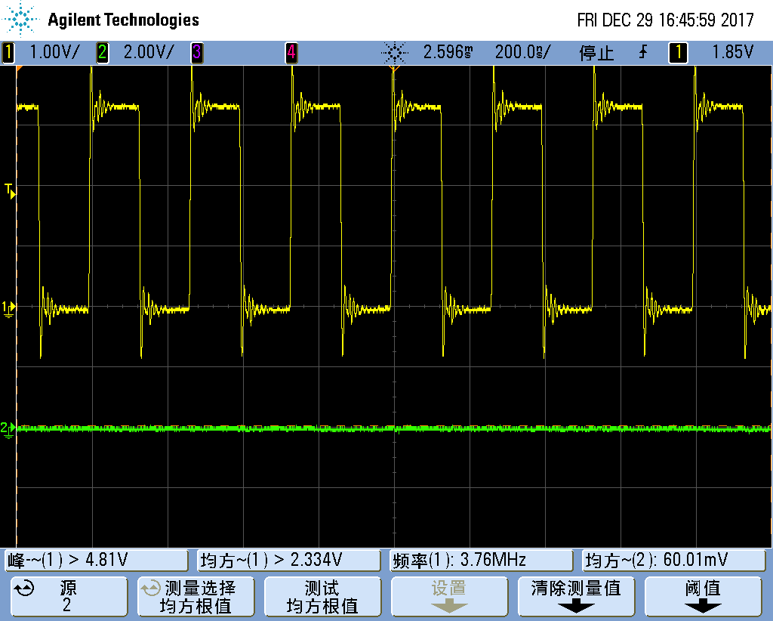

图6 板2 XCLKOOUT输出时钟 3.76MHz

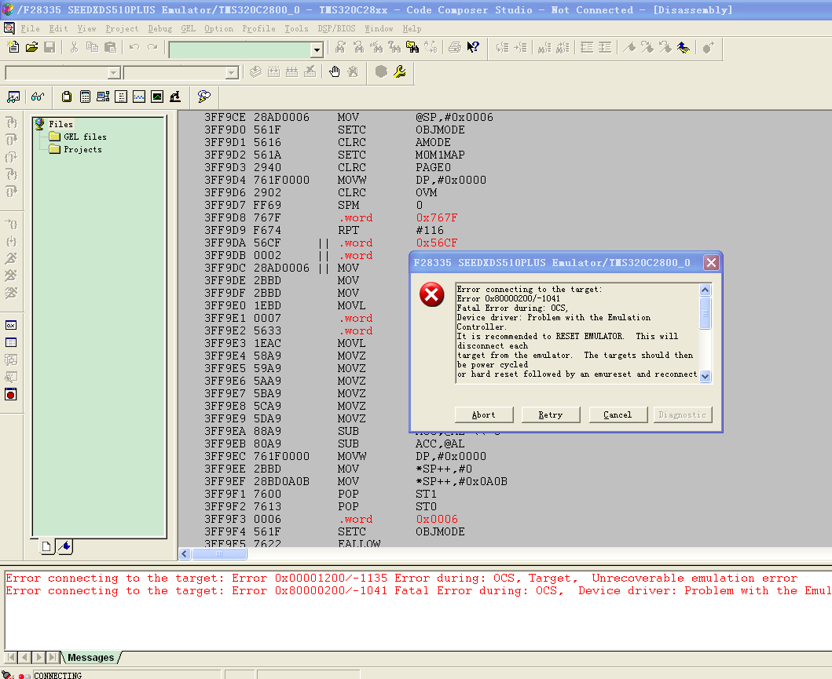

图7 板2通过仿真器连接后ERROR画面

## Board3’s testing pictures

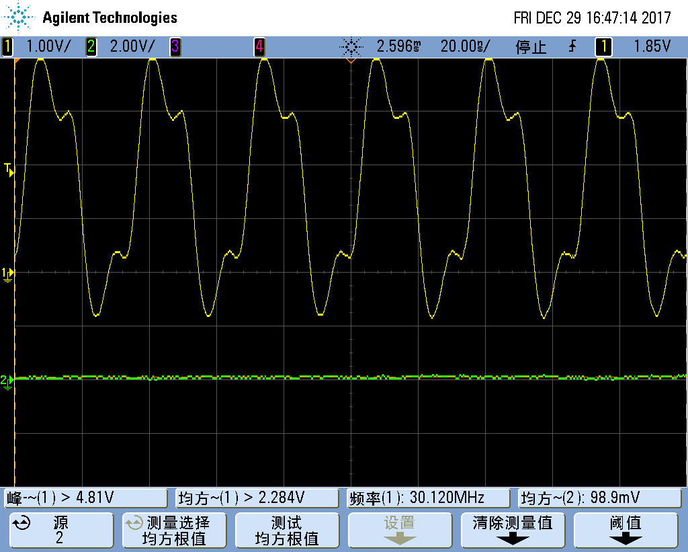

图8 板3时钟输入

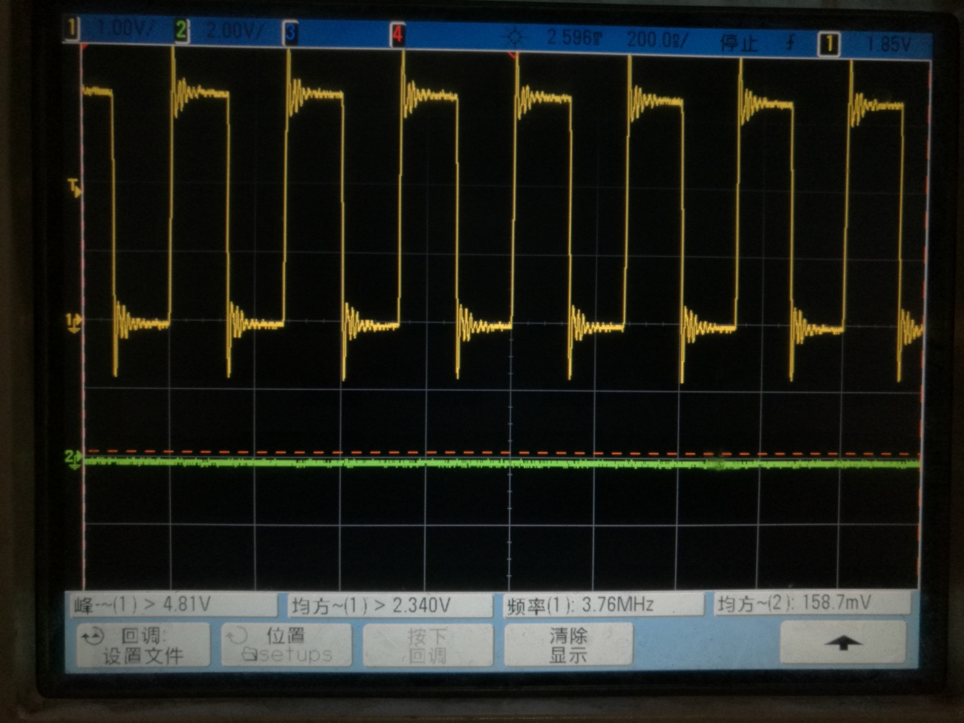

图9 板3 XCLKOUT 输出时钟 3.76MHz

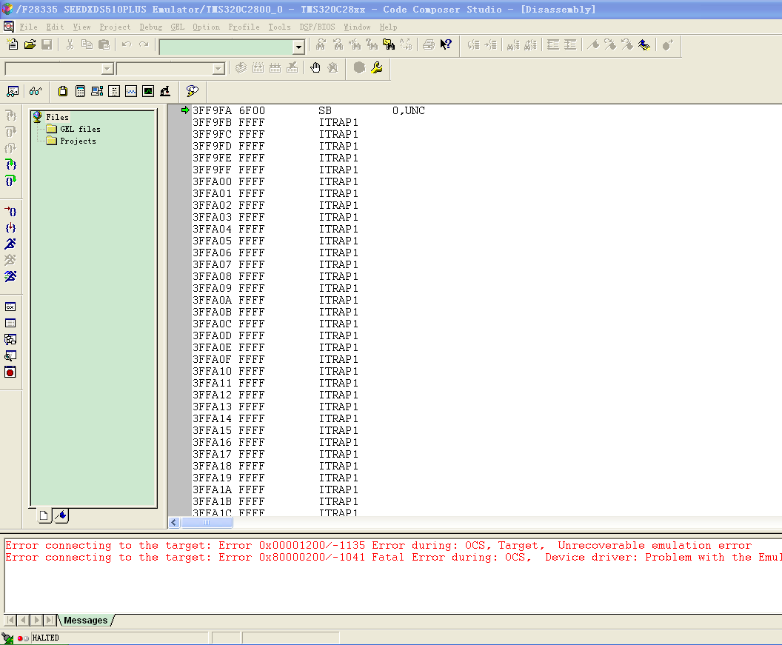

图10 板3连接PC后的界面

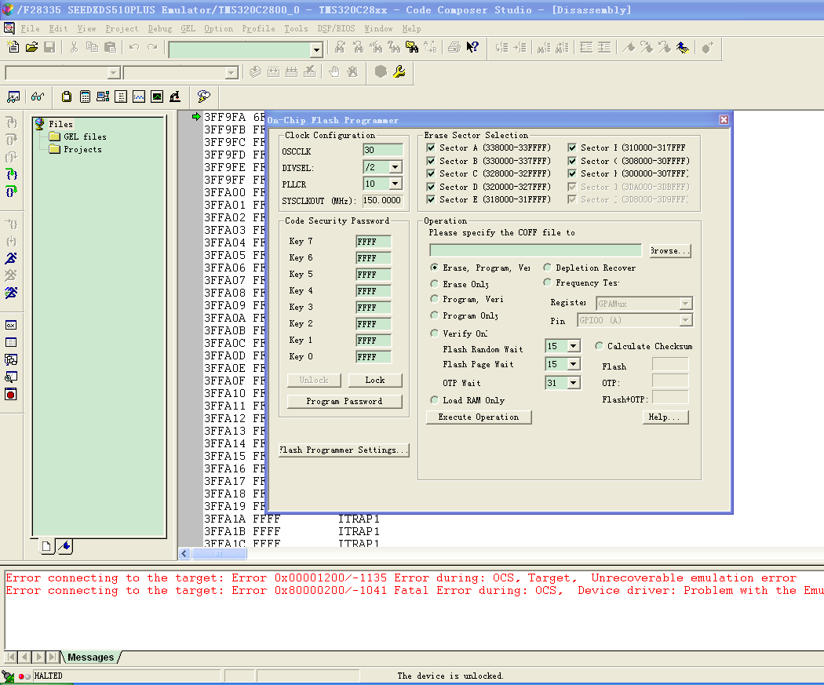

图11 板3点击烧写后的界面