Issue Description:
The #pragma DATA_SECTION operation couldn’t map the symbol to specific memory.

Operation Steps:
- Assign the APP_TYPE memory in .cmd file;
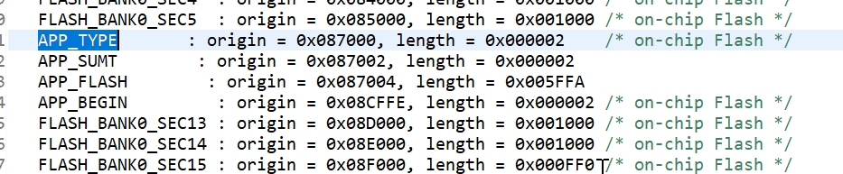

- Allocate the AppSoftType data in .cmd file;
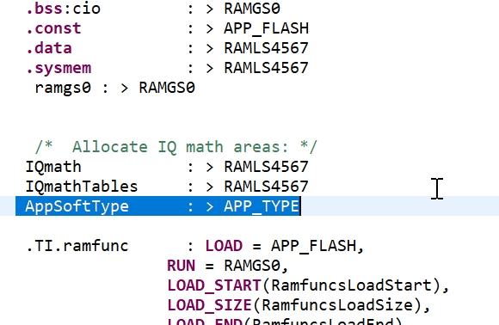

- Using #pragma DATA_SECTION command in main.c file;
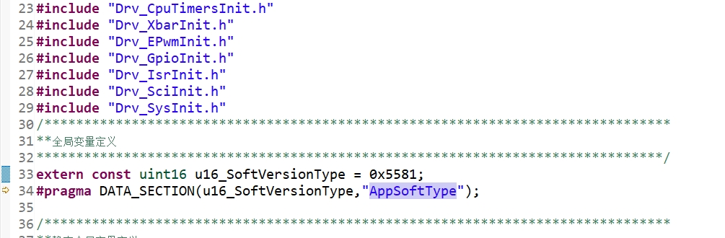

- Build the project, and the .map file shown the APP_TYPE has been created;
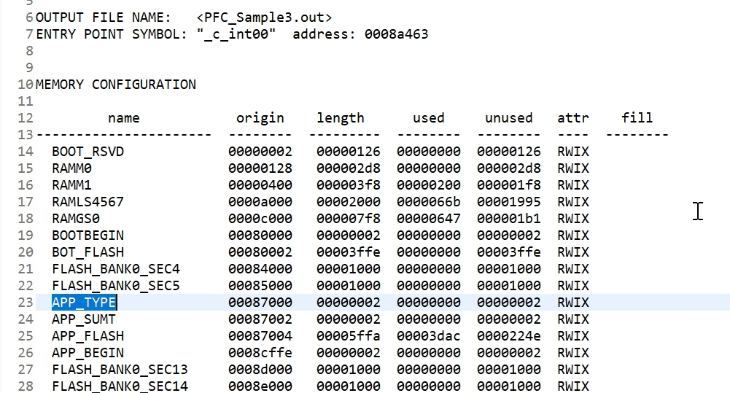

- Read back data of the address of 0x087000, returned 0xffff but not the expected 0x5581;
- Using the EVM do the same operation, which also returned unexpected data;
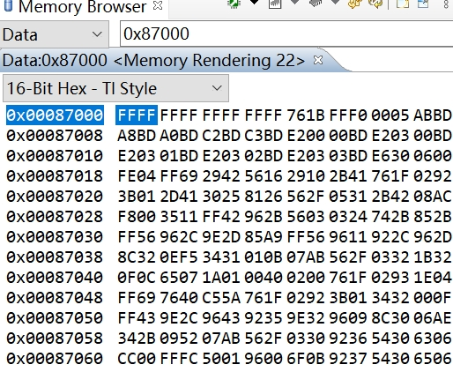

- The same operation worked for F2802x/F2803x;

Support Needs:
- How to do the #pragma DATA_SECTION to assign a fixed FLASH address in F280025;

