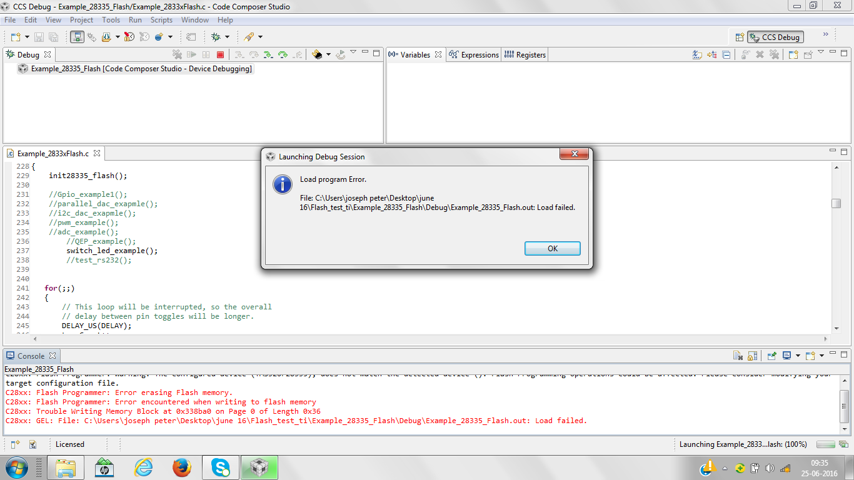
C28xx: Flash Programmer: Warning: The configured device (TMS320F28335), does not match the detected device (). Flash Programming operations could be affected. Please consider modifying your target configuration file.
C28xx: Flash Programmer: Error erasing Flash memory.
C28xx: Flash Programmer: Error encountered when writing to flash memory
C28xx: Trouble Writing Memory Block at 0x338ba0 on Page 0 of Length 0x36
C28xx: GEL: File: C:\Users\joseph peter\Desktop\june 16\Flash_test_ti\Example_28335_Flash\Debug\Example_28335_Flash.out: Load failed.

when trying for making the device as F28334 ,this message appears….
