sineval=1*sin(Rad)+ 0.03*sin(3*Rad)+0.5*sin(5*Rad)+0.2*sin(7*Rad)+0.02*sin(9*Rad)+0.11*sin(11*Rad)+0.1*sin(13*Rad); //Q15

Pspice Output:
Green: Complex Signal
Red : Rejected signal
Blue: Passed 50 Hz signal

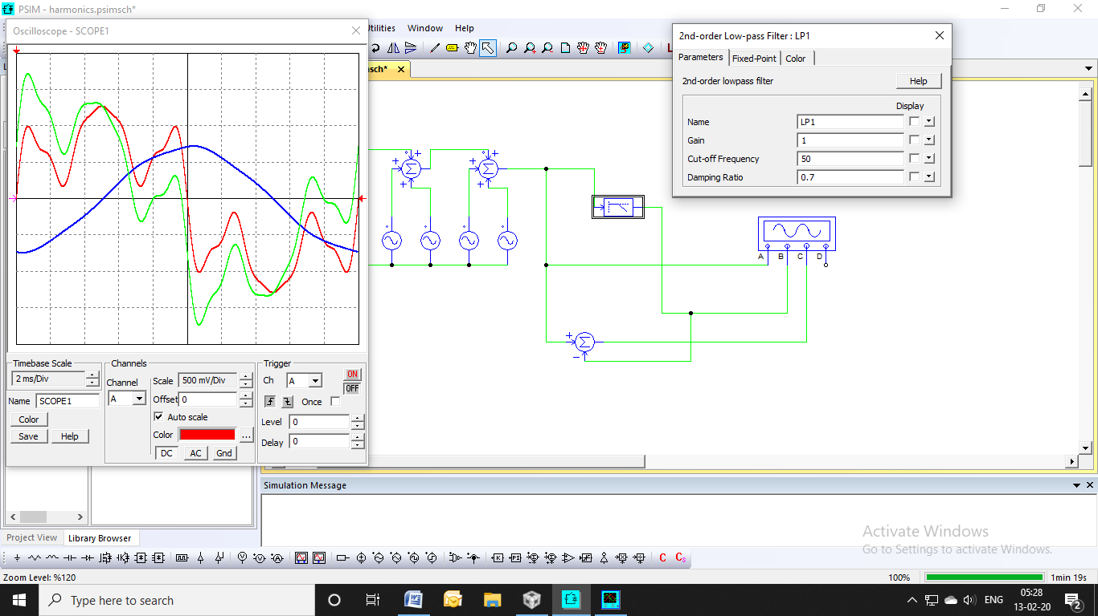

sineval=1*sin(Rad)+ 0.03*sin(3*Rad)+0.5*sin(5*Rad)+0.2*sin(7*Rad)+0.02*sin(9*Rad)+0.11*sin(11*Rad)+0.1*sin(13*Rad); //Q15

CCS6 Output:
Graph: Complex Signal
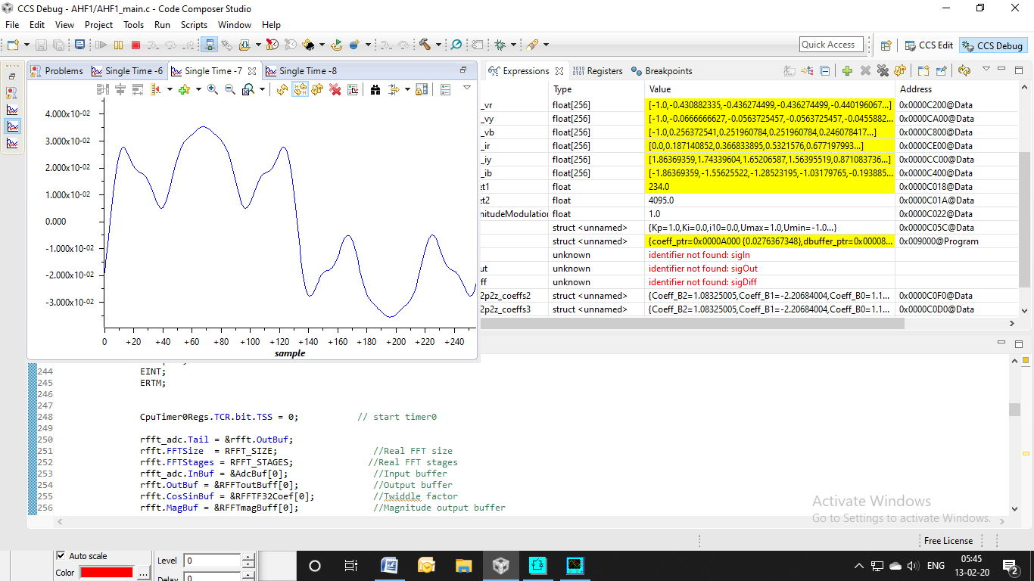
Graph: IIR filter output
