Phase A current waveform at 400 rpm:
7.3 A/div
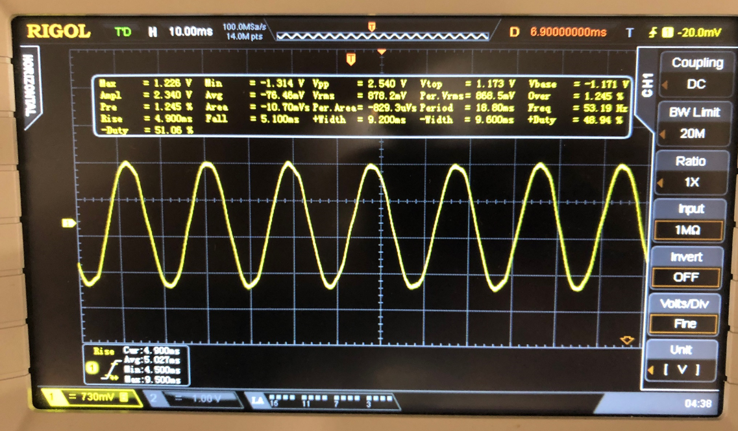
Phase A current waveform at max speed (480 rpm):
9.1 A/div
