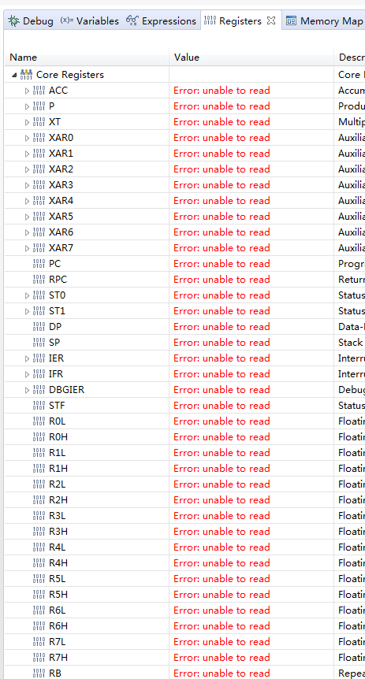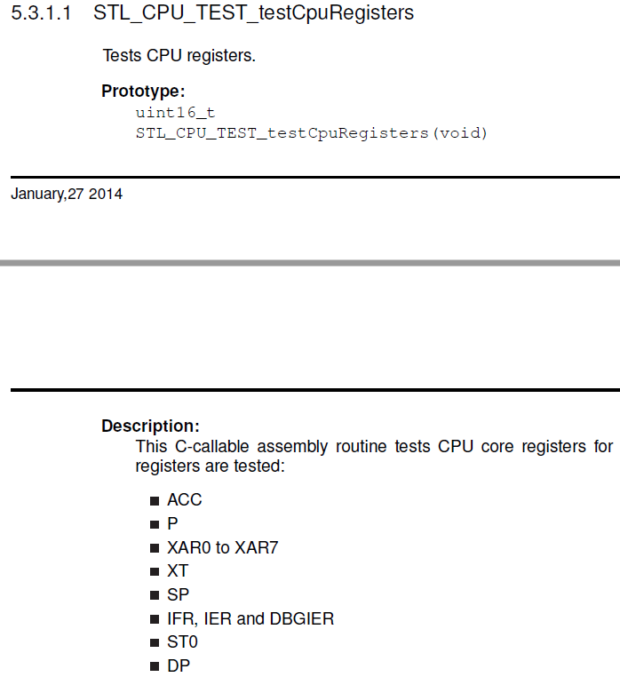
Question 1：there are a lot of Core Registers that from CCS windows？why STL_CPU_TEST only cover part of CPU core register? Any document to talk if these are not safety related ? ？
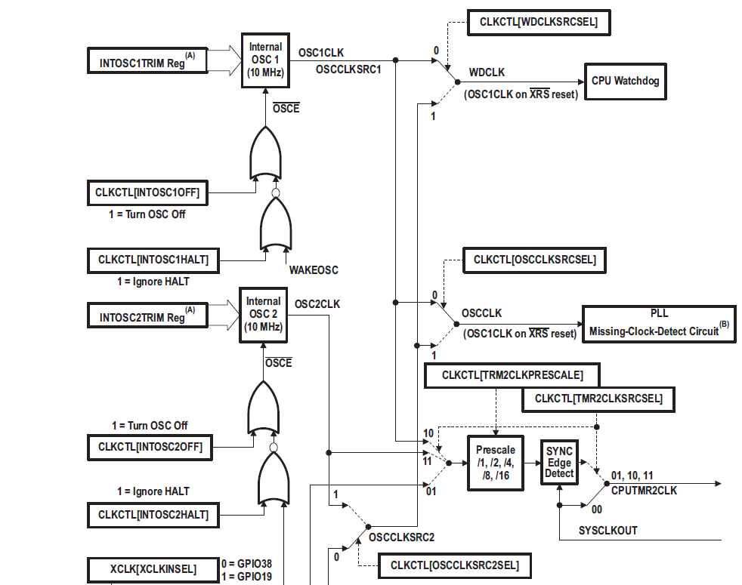
Question 2：there are OSC1 and OSC2 two clock source, is these two clock independent？any document to introduce？
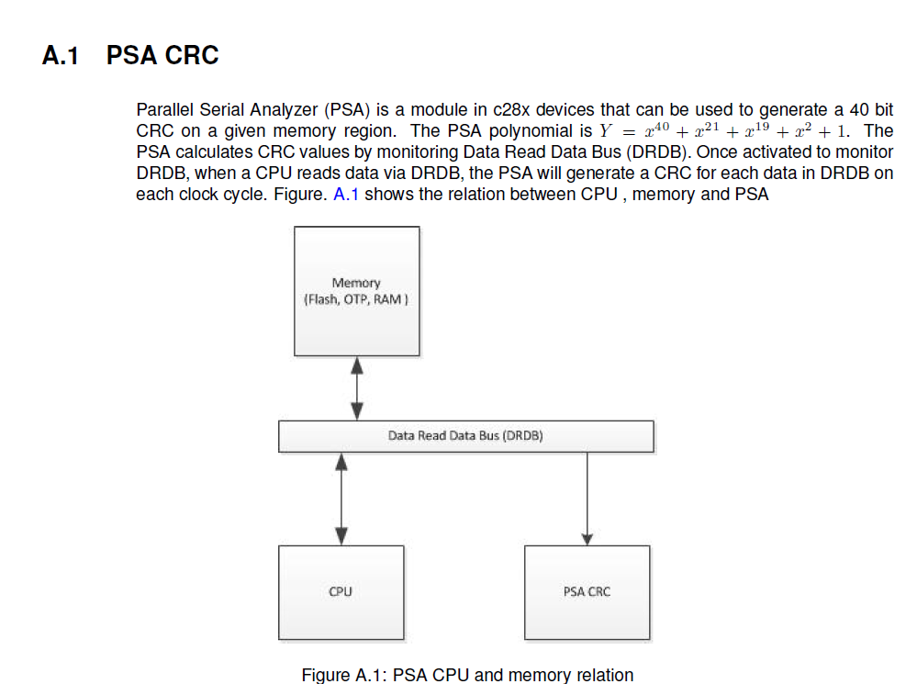
Question 3：PSA CRC is hardware module or software module？

