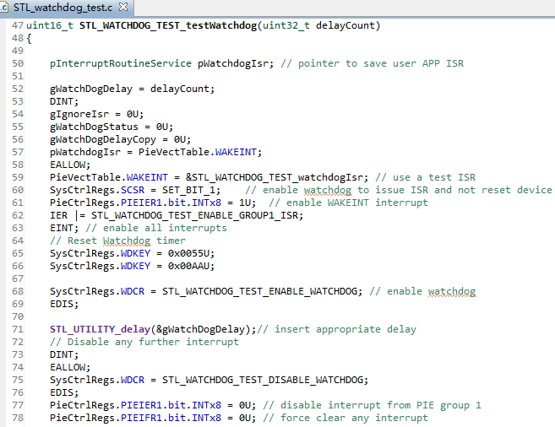
看门狗的检测函数里，这个延时计数变量应怎么配置？In the watchdog detection function, how should this 'delayCount' variable be configured?
In the watchdog detection function, how should this 'delayCount' variable be configured?设置成多少？
疑问1

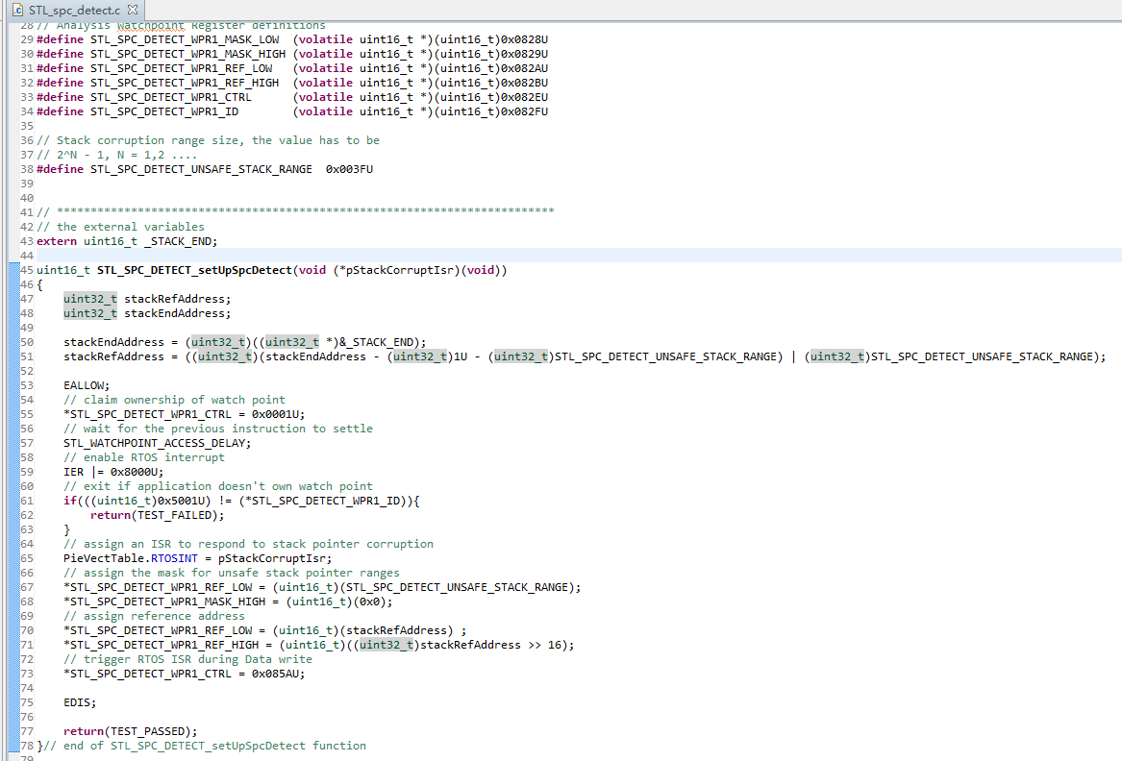
对于堆栈的检测看不明白，请说明一下该函数的检测方法/流程！
I don’t understand the stack detection, please explain the detection method/process of this function!
疑问2
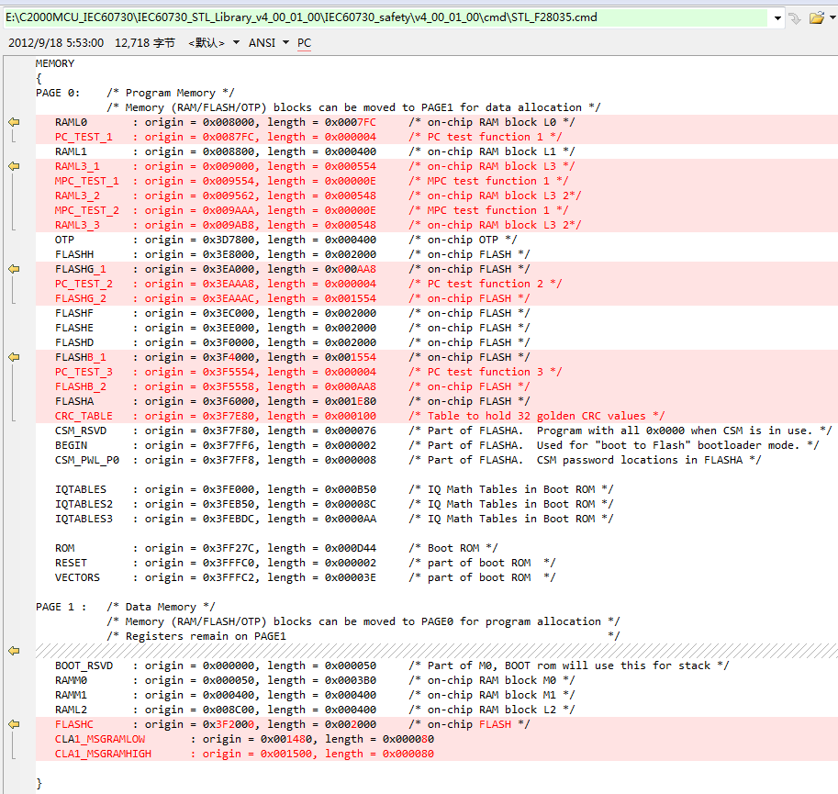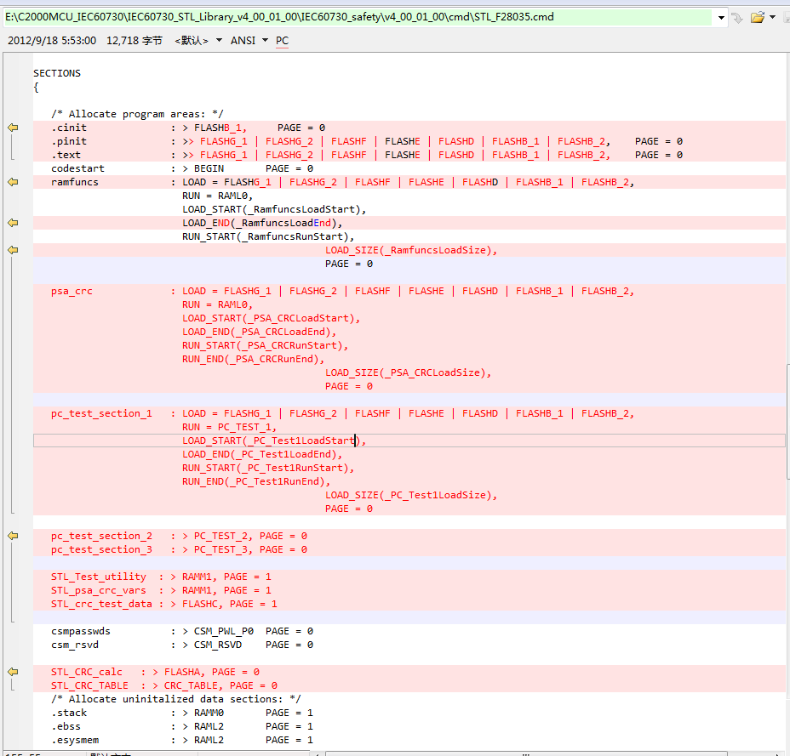
由于检测模块需要加入到正常的程序里运行的，而Demo里的CMD文件增加了许多区域（左图红色区域），该怎么改？直接在正常程序的CMD文件里加入这些么？
Since the detection module needs to be added to the normal program to run, and the CMD file in the Demo has many areas (red area on the left), how to change it? Add these directly to the CMD file of the normal program?
疑问3
Since the detection module needs to be added to the normal program to run, and the CMD file in the Demo has many areas (red area on the left), how to change it? Add these directly to the CMD file of the normal program?

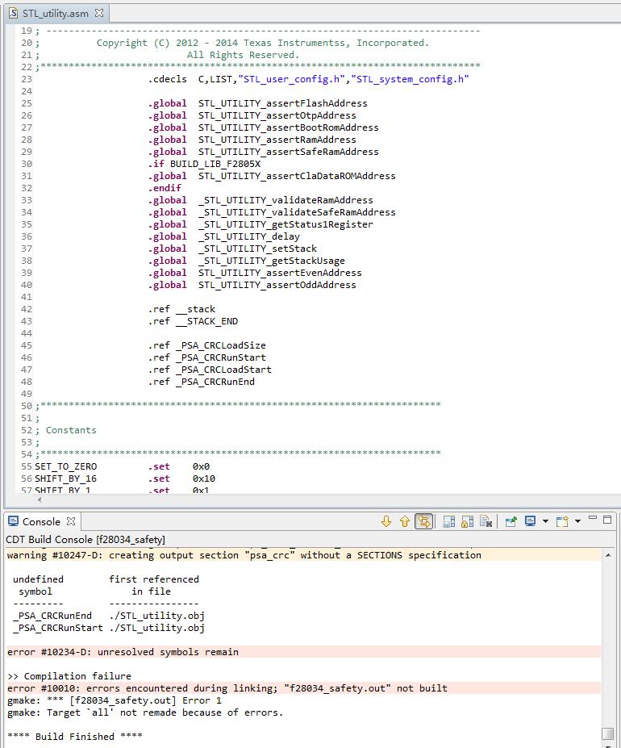
这几个变量在哪个地方定义才正确！（我试着在其它头文件里定义它们，但编译还是会报错！ ）Where should these variables defined correctly? I tried to define them in other header files, but the compilation reports errors!
What does this instruction mean
疑问4

