We are using the following MotorControl SDK solution:
C:\ti\c2000\C2000Ware_MotorControl_SDK_5_04_00_00\solutions\tidm_02010_dmpfc
Currently, we are working in DMC_LEVEL_2 and running a compressor PMSM motor successfully.
Our motor parameters are configured as below:
#define USER_MOTOR1_TYPE MOTOR_TYPE_PM
#define USER_MOTOR1_NUM_POLE_PAIRS (4)
#define USER_MOTOR1_Rr_Ohm (0.0)
#define USER_MOTOR1_Rs_Ohm (1.335f)
#define USER_MOTOR1_Ls_d_H (0.00895f)
#define USER_MOTOR1_Ls_q_H (0.01541f)
#define USER_MOTOR1_RATED_FLUX_VpHz (0.5415546)

#define USER_MOTOR1_MAGNETIZING_CURRENT_A (NULL)
#define USER_MOTOR1_RES_EST_CURRENT_A (3.5)
#define USER_MOTOR1_IND_EST_CURRENT_A (-3.0)
#define USER_MOTOR1_MAX_CURRENT_A (9.0)
#define USER_MOTOR1_FLUX_EXC_FREQ_Hz (20.0)
#define USER_MOTOR1_NUM_ENC_SLOTS (2500.0)
#define USER_MOTOR1_INERTIA_Kgm2 (0.000315)

#define USER_MOTOR1_RATED_VOLTAGE_V (200.0)
#define USER_MOTOR1_RATED_SPEED_KRPM (3.0)

#define USER_MOTOR1_FREQ_MIN_Hz (30.0)
#define USER_MOTOR1_FREQ_MAX_Hz (360.0)
#define USER_MOTOR1_FREQ_LOW_Hz (48.0)
#define USER_MOTOR1_FREQ_HIGH_Hz (480.0f)

#define USER_MOTOR1_VOLT_MIN_V (33.0)
#define USER_MOTOR1_VOLT_MAX_V (220.0)

#define USER_MOTOR1_ALIGN_DELTA_A (0.01f)
#define USER_MOTOR1_ALIGN_CURRENT_A (2.0f)
#define USER_MOTOR1_STARTUP_CURRENT_A (3.5)
#define USER_MOTOR1_OVER_CURRENT_A (16.0)
#define USER_MOTOR1_LOCK_CURRENT_A (1.0f)

#define USER_MOTOR1_SPEED_START_Hz (25.0)
#define USER_MOTOR1_SPEED_FORCE_Hz (20.0)
#define USER_MOTOR1_ACCEL_START_Hz (10.0)

#define USER_MOTOR1_ACCEL_START_Hzps (10.0f)
#define USER_MOTOR1_ACCEL_MAX_Hzps (15.0)

// eSMO sliding mode gains
#define USER_MOTOR1_KSLIDE_MAX (1.2f)
#define USER_MOTOR1_KSLIDE_MIN (0.15f)

// PLL gain window and scale
#define USER_MOTOR1_PLL_KP_MAX (10.0f)
#define USER_MOTOR1_PLL_KP_MIN (2.0f)
#define USER_MOTOR1_PLL_KP_SF (5.0f)

// BEMF detection & filtering
#define USER_MOTOR1_BEMF_THRESHOLD (0.5f)
#define USER_MOTOR1_BEMF_KSLF_FC_Hz (1.0f)
#define USER_MOTOR1_BEMF_KSLF_FC_SF (1.0f)

// Angle/Speed filter
#define USER_MOTOR1_THETA_OFFSET_SF (1.0f)
#define USER_MOTOR1_SPEED_LPF_FC_Hz (400.0f)

// Vibration compensation
#define USER_MOTOR1_VIBCOMPA_ALPHA (0.98f)
#define USER_MOTOR1_VIBCOMPA_GAIN (0.0f)
#define USER_MOTOR1_VIBCOMPA_INDEX_DELTA (10)
Current behavior:
- Up to speed_ref = 50
  - Phase current waveform is good
  - Generated angle (angleGenM1_rad) and estimated angle are matching properly
  - Motor rotation is smooth and stable

- Figure 1: Estimated angle good at lower speed
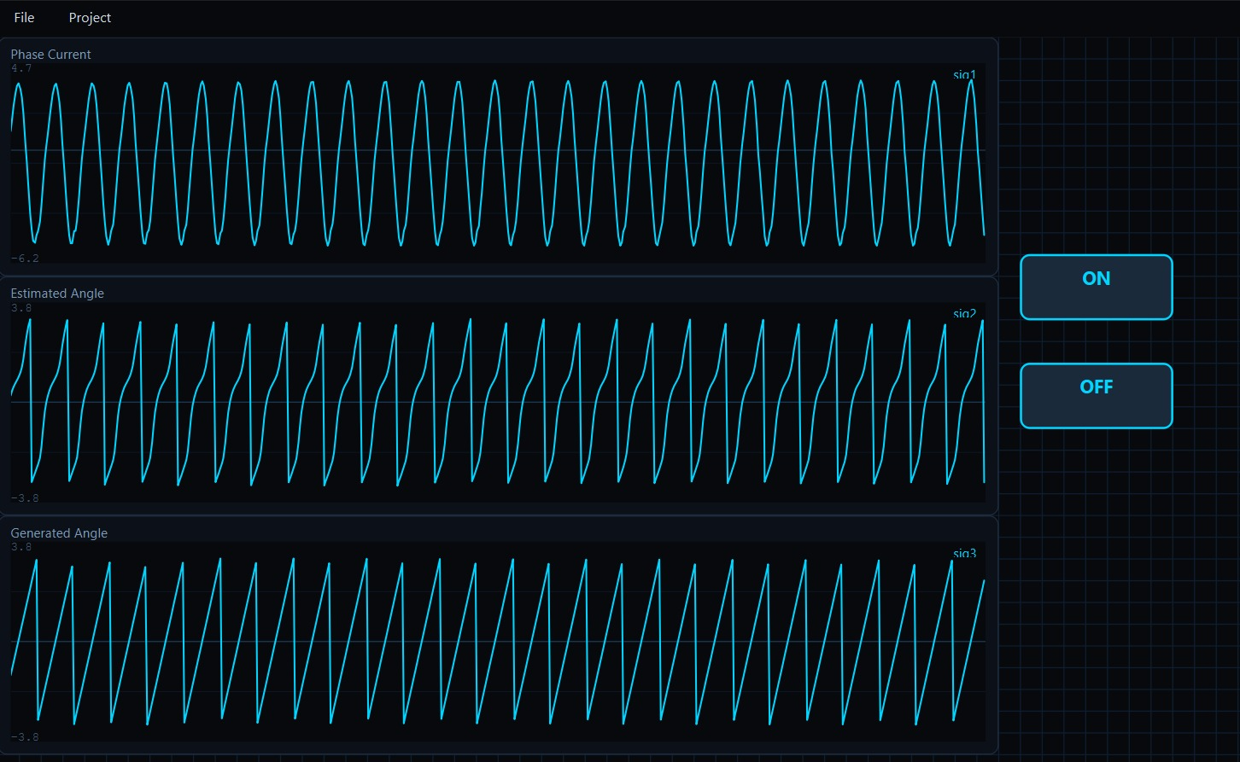

- When increasing speed_ref beyond around 65
  - Motor still rotates properly
  - Phase current and generated angle still appear good
  - But the estimated angle from ESMO becomes distorted/noisy as shown in the attached figure.

- Figure 2: Estimated angle distorted at higher speed.
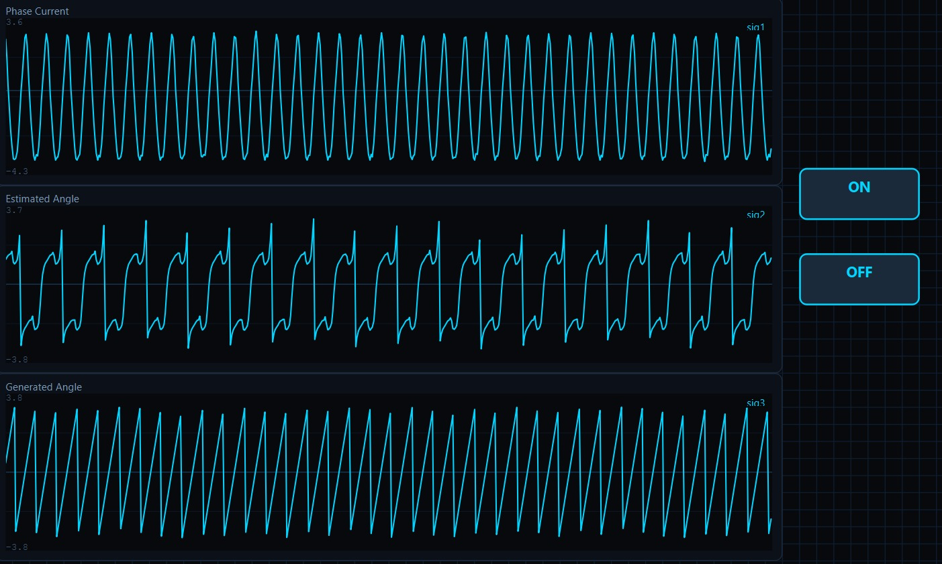
Because of this issue, we are unable to confidently move to DMC_LEVEL_3.
We would like guidance on the following:
- Which ESMO parameters mainly affect estimated angle quality at higher speed?
- Which parameters should be tuned first to improve the estimated angle waveform?
- Is this issue mainly related to:
  - Kslide tuning.
  - PLL gains
  - BEMF filter coefficients
  - Current sensing noise
  - Voltage scaling
  - ADC sampling timing
  - Motor parameter mismatch (Rs/Ls/Flux)?
- Is the current value of USER_MOTOR1_BEMF_KSLF_FC_Hz = 1.0f too low for higher speed operation?
- What is the recommended tuning sequence before moving to DMC_LEVEL_3?
- Which internal ESMO variables should be monitored in CCS graph/watch window for debugging?

