Dear Sir,

i bought a TI development tool with "Three Phase BLDC & PMSM Motor Kit with DRV8301 and InstaSPIN-enabled Piccolo TMS320F28069M MCU".

When i use a guicomposer named " InstaSPIN_MOTION_F2806xM.ext" to run the motor, some abnormal things happened as below:

- log phase current during "identify Motor"
issue: current are not sine wave
step a: normal current
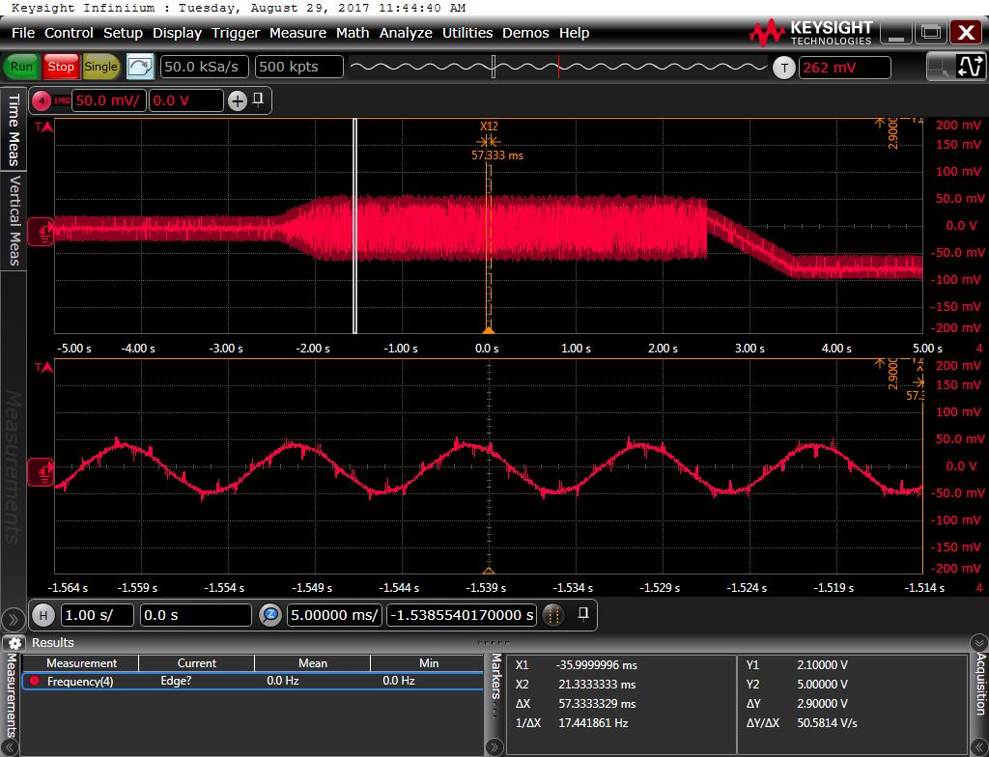
Step b: sharp current
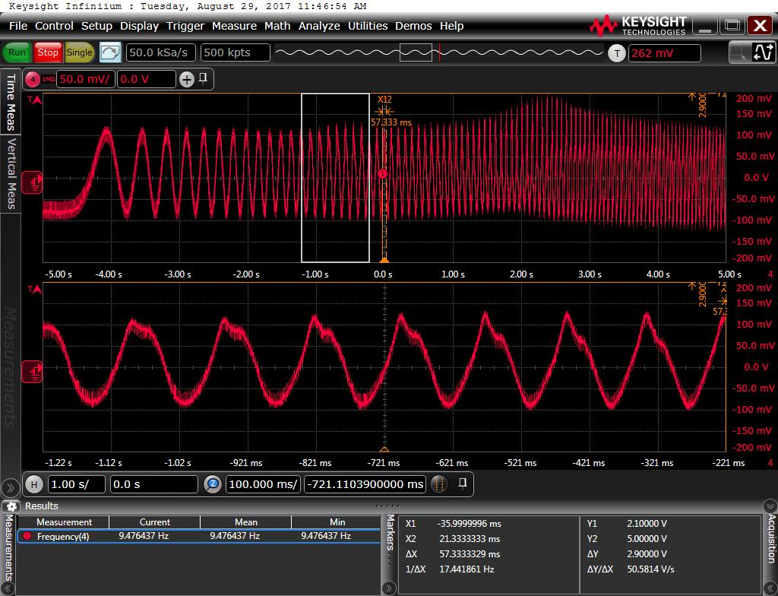

Step c: Triangle wave current
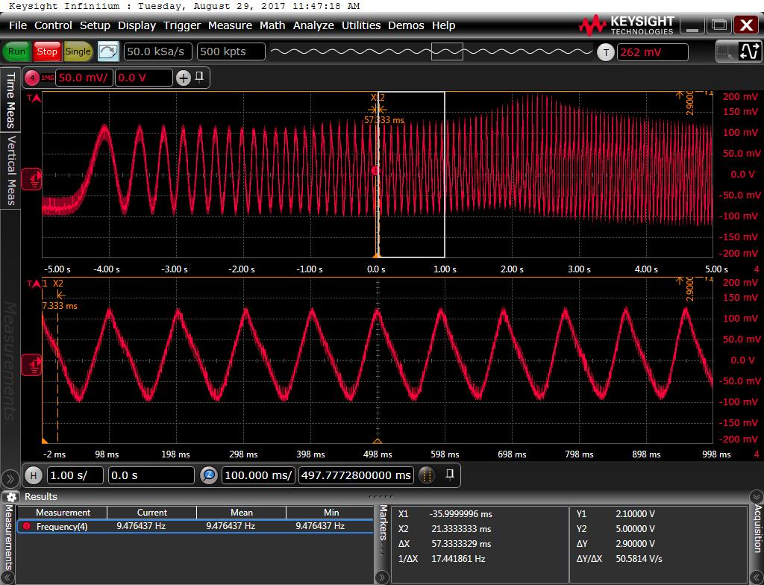
Step d:
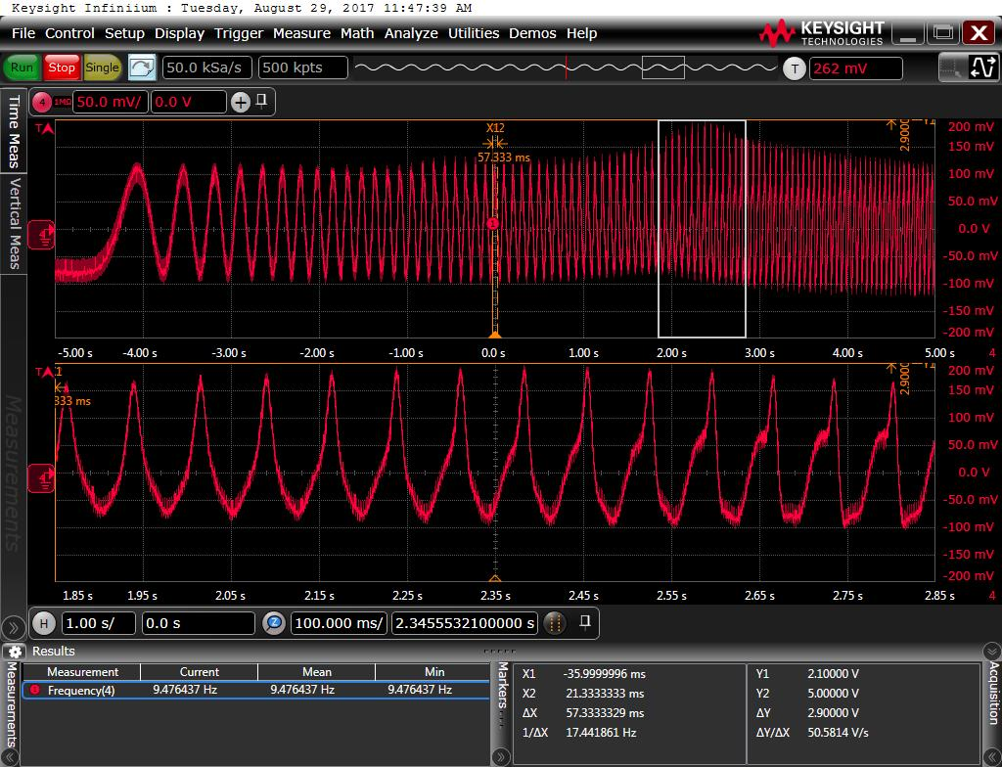

Step e:
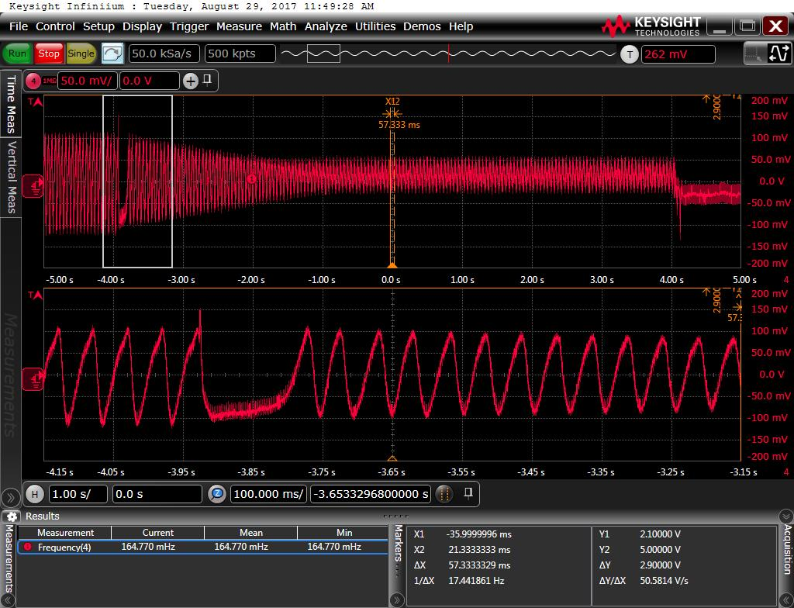
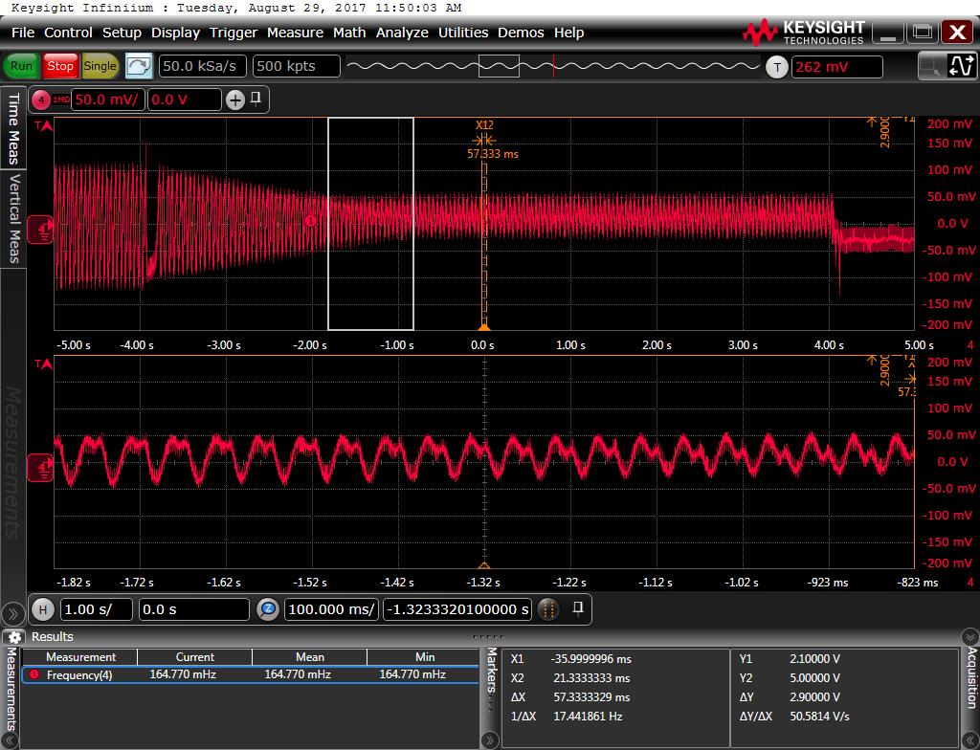
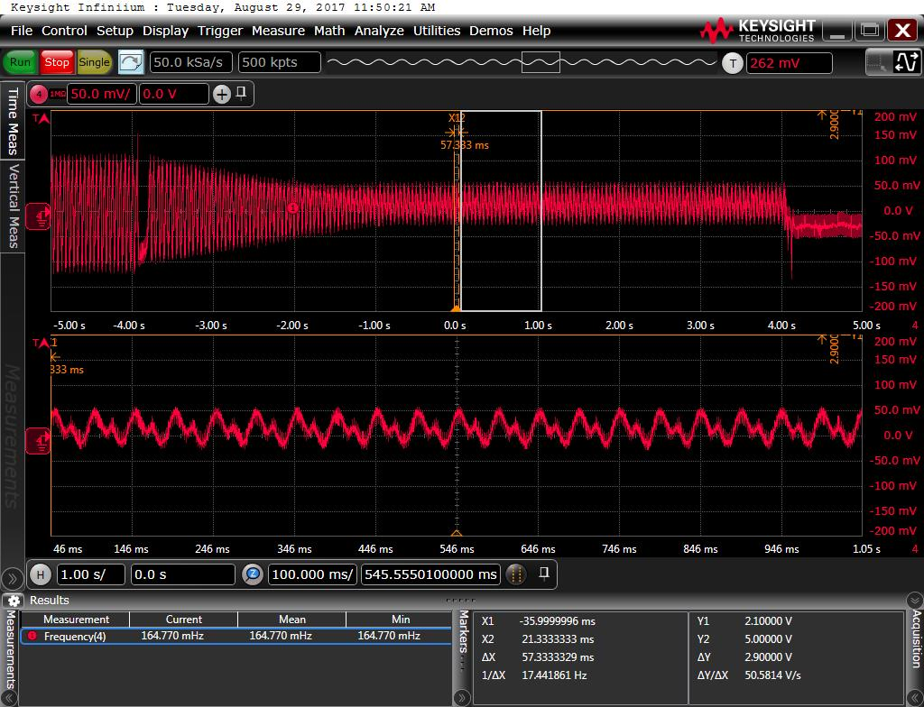
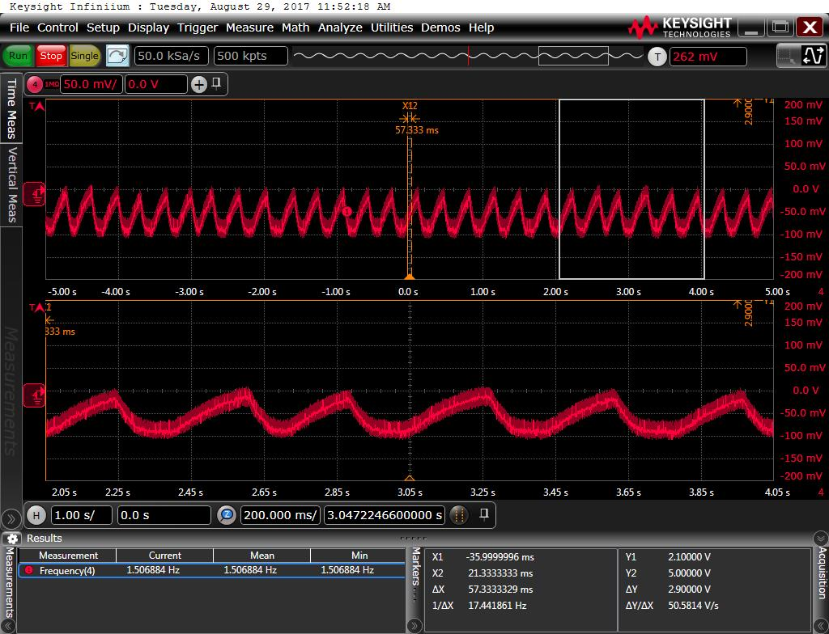
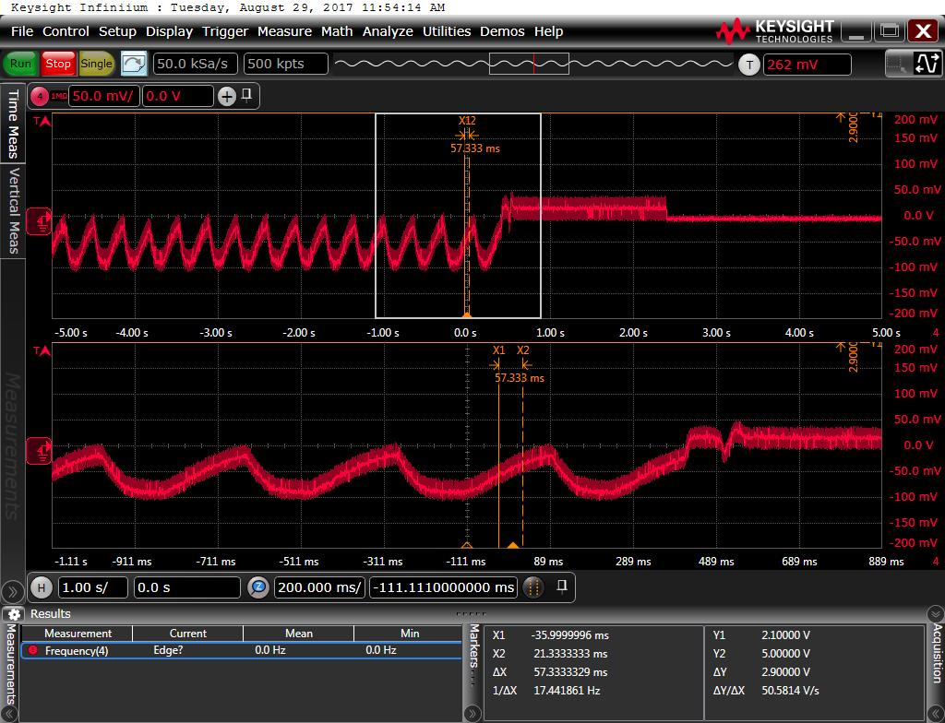

- log phase current during "current close loop with giving a constant iq"
issue: current are not sine wave
step a: sharp current
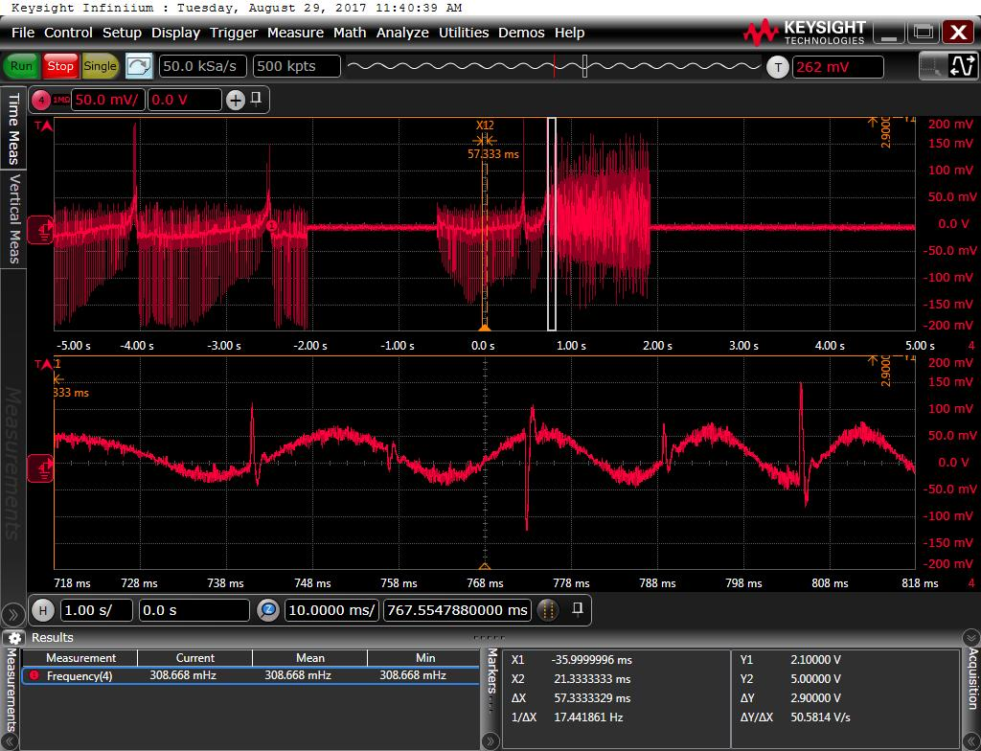
Step b: sharp current
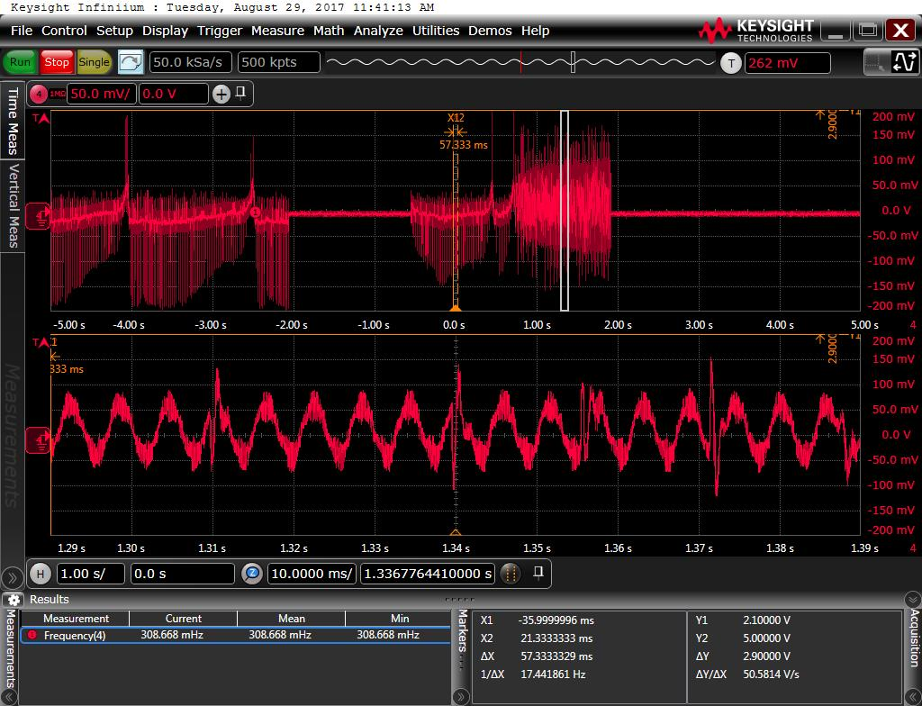
Step c:
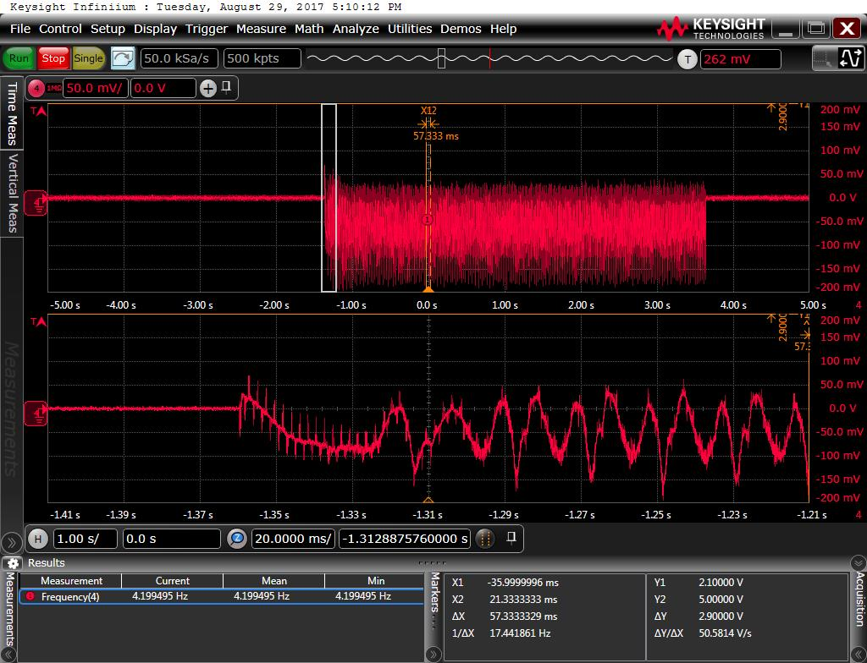
- log phase current during "speed mode"
issue: motor phase current are not sine wave.
No datalogging to show

