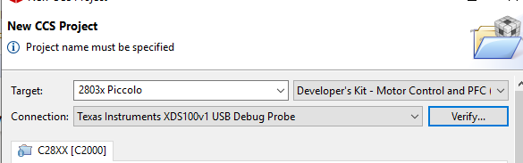
[Start]

Execute the command:

%ccs_base%/common/uscif/dbgjtag -f %boarddatafile% -rv -o -F inform,logfile=yes -S pathlength -S integrity

[Result]

-----[Print the board config pathname(s)]------------------------------------

C:\Users\SRM\AppData\Local\TEXASI~1\CCS\
ccs930\0\0\BrdDat\testBoard.dat

-----[Print the reset-command software log-file]-----------------------------

This utility has selected a 100- or 510-class product.
This utility will load the adapter 'jioserdesusb.dll'.

An error occurred while soft opening the controller.

-----[An error has occurred and this utility has aborted]--------------------

This error is generated by TI's USCIF driver or utilities.

The value is '-151' (0xffffff69).
The title is 'SC_ERR_FTDI_OPEN'.

The explanation is:
One of the FTDI driver functions used during the connect
returned bad status or an error. The cause may be one or
more of: no XDS100 is plugged in, invalid XDS100 serial number,
blank XDS100 EEPROM, missing FTDI drivers, faulty USB cable.
Use the xds100serial command-line utility in the 'common/uscif'
folder to verify the XDS100 can be located.

[End]

