A practical high voltage charger solution using bq24610 charger

Abstract
Battery powered applications requiring many cells stacked in series create the need for a high voltage battery charger. Most existing battery chargers are designed to charge less than seven Li-ion cells in series. The availability of chargers capable of charging greater than seven Li-ion cells is scarce. This application note shows how to configure the bq24610 to charge high voltage Li-Ion battery packs. The application note is based on the bq24610EVM-HV.

Introduction
The bq24610 is an integrated Li-ion or Li-polymer switch-mode battery charge controller. It offers a constant-frequency synchronous switching PWM controller with high accuracy charge current and voltage regulation. Other features include charge preconditioning, termination, adapter current regulation and charge status monitoring. The bq24610 charges the battery in three phases: preconditioning, constant current and constant voltage. Charge is terminated when the current reaches a minimum user-selectable level. A programmable charge timer provides a safety backup. The bq24610 automatically restarts the charge cycle if the battery voltage falls below an internal threshold. Figure 1 shows a typical bq24610 application circuit.

Power
Source
Selector

BATDRV

REGN

BTST

HIDRV

PH

LODRV
GND
SRP
SRN
VFB

ACN
ACP
ACDRV
VREF

CE
ISET1
ISET2
ACSET

TS
TTC

STAT1

STAT2

PG
Q5
L: 6.8µH
C2
10µF
SYSTEM LOAD
C8
10µF
RSR
10mΩ
C11
0.1µF
bq24610
C3
10µF
C4
10uF
VCC
Q1
Q4
Q2
Q3
C1
2.2µF
Adapter
RAC: 10mΩ
C7
10µF
Battery Pack
C10
0.1µF
C5:1µF
C12
1µF
C17
0.22µF
C7
0.1uF
C9
100pF
R1
953kΩ
R2
105kΩ
R7
100kΩ
R8
57.6kΩ
R5
100kΩ
R6
22.1kΩ
R3
100kΩ
R4
95.3kΩ
R9
9.31kΩ
R10
430kΩ
Pack
Thermistor
R11:10kΩ
R12:10kΩ
R13:10kΩ
Adapter
bq24610: 600kHz, Li-Ion
4x4mm QFN-24
R16
2Ω
1-6 Li-Ion Cells, VIN max: 28V
10Ω

Figure 1 A typical bq24610 application circuit
This EVM provides a practical solution for charging a Li-ion battery with more than 7 cells. It uses the bq24610 modified with the TPS54060, UCC2701, INA169, LM358 and LM2903.

There were 3 main challenges on this bq24610 solution that needed to be overcome:
- Isolation of IC from the high input voltage
- Maintain a refresh pulse on LODRV for UCC27201 bootstrap cap
- Building a current sense circuit that meets the special needs of the bq24610 high voltage application

This application note explains how this EVM resolves these challenges and elaborates on operation under low battery conditions and cleaning up of the gate drive waveform. Figure 2 shows the modified circuit for high voltage application.

BATDRV

REGN

BTST

HIDRV

PH

LODRV

GND

SRP

SRN

VFB
ACDRV

VREF

CE
ISET1
ISET2
ACSET

TS
TTC

STAT1

STAT2
Q2
VCC
Q1
Battery Pack
Pack
Thermistor
Vcc
Half Bridge
Gate
Drive
UCC27201
Vcc Bias
supply
TPS54060
Bq24610
8~14V Vcc
Vcc
Current
Sense
INA169
2~3V
Clamp
Buffer
LM358
VREF
Vcc
PG
ACN
ACP

Figure 2 the modified bq24610 circuit for high voltage application

EVM DESIGN

Because the bq24610 is a switching battery charger with a buck converter topology, the input voltage to the charger must be greater than the fully charged battery pack voltage. This application charges an 8-cell Li-Ion battery pack which has a fully charged voltage of 8x4.2V = 33.6V. This requires a system input voltage greater than 33.6V, which is above the bq24610’s normal operating range of 32V. A bias power supply must be used to isolate the bq24610 from the >32V input voltage. A switching power supply is used to isolate the IC’s VCC pin. The TPS54060 buck converter produces 8.5 V VCC from the high voltage input. The VCC bias supply also powers the external half bridge gate driver, pre-charge circuit, current sense circuit and OPAMP buffer. Any switching power supply capable of operating from the system’s maximum required input voltage that can generate an 8-14 V output voltage with at least 200mA can be used for this function. This output voltage range is set by the VCC requirement of the external half bridge gate driver, UCC27201. Use the lowest possible VCC voltage to minimize power loss in the half bridge gate drive circuitry.

The UCC27201 was selected because it met the following gate driver solution needs:
- 20% Input voltage margin
- Have 2 complementary inputs to match HIDRV and LODRV outputs of bq24610
- Input logic high thresholds lower than 3V to match the voltage level of bq24610’s HIDRV and LODRV output.

Figure 1 demonstrates how the bq24610’s BTST, PH, HIDRV, and LODRV pins are connected in normal applications. A bootstrap capacitor sits between BTST and PH and provides a power source for the high side N-channel FET. When (V_{BTST} – V_{PH}) is lower than 4V, bq24610 sends out a LODRV refresh pulse to charge the bootstrap capacitor. The high and low side FETs are connected the VCC line and controlled directly by HIDRV and LODRV. PH is connected to the inductor that is switched by these FETs.

In this application, to isolate bq24610 from the higher voltage, a different set of connections must be used. As you can see in Figure 2, HIDRV and LODRV control the FETs through the UCC27201 gate driver and PH is connected to ground. The (V_{BTST} – V_{PH}) voltage must now fall between 3V and 4V to keep refresh pulse on every switching cycle and keep correct HIDRV logic. This is achieved using a voltage divider from REGN and grounding PH pin.

The bq24610 SRP and SRN pins must be biased to greater than 2V. If they are not biased above 2V, the bq24610 detects a short circuit on its output and operates in short protection mode which turns the low side MOSFET off. Figure 3 illustrates how SRP and SRN pins are isolated and biased so the bq24610’s battery detection procedure can operate as outlined in the bq24610 data sheet. This EVM uses bq24610’s VREF to create a greater than 2V bias supply. The current sense circuit on the block diagram uses an INA169 current sensor which isolates these 2 pins. A standard bq24610 charger detects a battery at power up by sinking 8mA into the SRN/SRP pin. Because the INA169 output current can not support this much current, a LM358 OPAMP is inserted between INA169 and bq24610. The OPAMP is a buffer to provide enough driving current for SRP and SRN pin.

U1
bq24610
Rs
(R6)
R3
SRN
INA169
Current
sense
SRP
Rsns
L
Buffer
U5:LM358
R27
C30
VREF

Figure 3 Close Up of Battery Detection Circuit

Because the INA169 will not work properly if the battery voltage is less than 3V, a circuit is needed to disable charging in this condition and pre-charge the battery. Figure 4 shows the circuit schematic for pre-charging and controlling the bq24610 charge enable. An LM2903 comparator compares battery voltage to bq24610’s 3.3V VREF and disables the charger by pulling the CE pin low when the battery voltage is lower than VREF. According to CE pin characteristics, the internal pull-resistor is 1Mohm and the input bias current is 6uA. Therefore, R31 is selected so that Equation 1 holds true. In most cases 10kΩ to 100 kΩ will be enough.
$V_{\text{CE}}=\text{VREF}×\frac{1MΩ}{1MΩ+R\text{31}}−6μA×R\text{31}\text{>>}2\text{.}1V$ (1)
If the battery is deeply discharged, the charging circuitry remains turned off until the battery voltage rises above VREF. When system power is applied, the VCC bias supply provides a pre charge current to charge the battery above VREF. The pre charge current is set by Equation 2, where V_{diode} is the forward voltage drop of D8.
$I_{\text{pre}−\text{ch}\text{arg}e}=\frac{\text{VCC}−V_{\text{BAT}}−V_{\text{diode}}}{R\text{46}||R\text{47}}$ (2)
Once the battery voltage is higher than 3.3V VREF, the low battery comparator releases the CE pin and the bq24610 starts a normal charging cycle. D7 is a zener diode used to clamp the input pin to the LM2903 comparator to less than VCC. Select a diode with a zener voltage higher than 3.3 V at 1uA. R10 provides a current path for D7 and limits the current in that path. Also, LM2903 has a 0.25 μA input bias current. In order for the comparator to pull CE high, V_{BAT} > R10(1μA +0.25μA) + 3.3 V. So R10 sets the threshold. Power losses when VBAT is at a high voltage factor into the selection of R10. A higher R10 means less power dissipation. R10 was selected to be 100kΩ so that V_{BAT}= 3.425 V sets CE high.

TPS54060
VCC bias supply
D8
R31
R46
R47
VREF
VREF
BAT
R10
D7
CE
LM2903
Figure 4 Close Up of Pre Charging Circuit

Normally, the bq24610 controls the 30ns dead time between high side FET switching and low side FET switching to prevent shoot through current on buck FETs. Now, this higher voltage charger inserts UCC27201 as a buck FETs driver. This high voltage charger design reserved few components to adjust the dead time. A detailed gate drive circuit is shown in figure 5. R13 with C21 or R14 with C22 generate a delay from bq24610 gate drive signals to UCC27201 inputs. D3 or D4 provide a quick turn-off for the gate drive circuit. R25 and R26 can reduce the Q1 or Q2 switching transient speed to eliminate the ringing on the switching node.

HIDRV

PH

LODRV

PGND
Q2
Cin

bq24610
Q1
UCC
27201
UCC
27201
Vcc
HI
VDD
LI
VSS
HB
HO
HS
LO
R13

D3

D4

R14

C21
C22
R25
R26

Figure 5 Close Up of Gate Driver Circuit

Use the bq24610 application circuit calculator, found here, to select feedback resistors, the inductor, and output capacitor. Input the overall supply voltage and the voltage of the battery pack you are attempting to charge. Select an inductor that will produce a current ripple that is 30% or less of the charging current. Then, select an output capacitance based on your inductor and resonant frequency.

Performance
The modified bq24610 circuit of Figure 2 points out the changes for high voltage application. The current feedback loop was modified by inserting a current sensor, OPAMP, and 2~3 V clamp circuit. Figure 6 and Figure 7 show that the current loop performance is as good as normal bq24610 application circuits. The power stage (buck switching circuit) was modified by inserting external gate drive. Figure 8 shows that the efficiency stays above 90% for most of the charging current range. The voltage feedback loop was not altered for this application and neither did its performance.
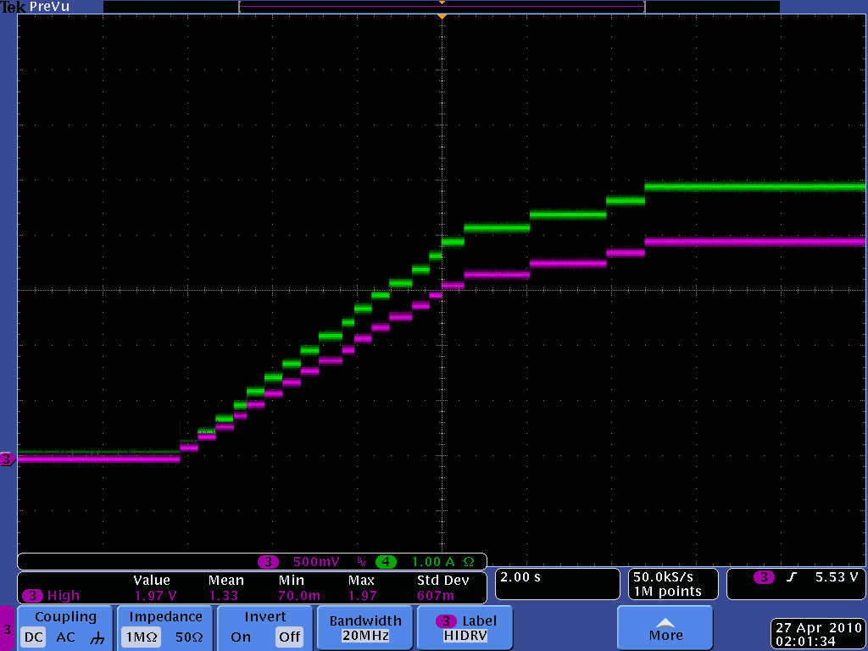
ISET1
IBAT
Figure 6. IBAT and ISET1 Waveform

Figure 7. Vsns Accuracy vs. ISET1

Figure 8 Efficiency and Power Dissipation vs Charging Current

Conclusion
This application note explains how to modify a standard bq24610 so it can charge a high voltage battery pack. It explains each required modification in detail. The concepts discussed in this application note can be modified to generate a higher voltage charger using the bq24610. They can also be applied to other switching ICs, such as bq2475x and bq2474x. The bq24610EVM-HV is available in Texas Instruments online eStore and available for online order.

Additional Resources:
bq24610EVM-HV User’s Guide: http://www.ti.com/litv/pdf/sluu447
Calculator for typical battery charger application circuits http://www.ti.com/litv/zip/sluc175c

