05/03/22

Configuration.

Ruv2 = 68k

Ruv1 = 3k

Css = 100nF

Rfb1 = 1k2

Rfb2 = 11k

Other values as per quick start

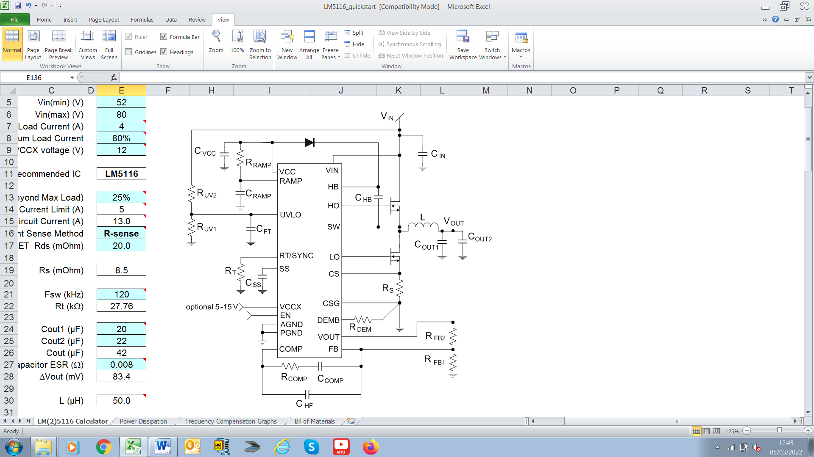

Under voltage lock out was shown to be 30V

The no load output voltage was 12.56V.

The start-up was clean, and the soft start took 12mS to rise to 12.56V.

The output was loaded with a 33R resistor. The output was 12.50V. The output was clean up to an input of 60V.

Rfb was changed to 22k. This was to raise the output voltage to 24V. No load

The input voltage was ramped up to the UVLO level. The output came live at 18V, but extremely noisy. This lasted for several seconds when the regulator failed.