08/03/22

Configuration.

As before, except:

Rfb2, (R29) = 12k

Cin, (C5). 22uF

H/S switch, (Q5) now FDB2532

Under voltage lock out was shown to be 29V

The no load output voltage was 14,84V.

The start-up was clean, and the soft start took 12mS to rise to 14,84V.

The output was loaded with a 33R resistor. The output was 14,80V. The output was clean up to an

input of 60V. The supply current was measured at 269mA

The supply at pin 1 of the LM5116 was “scoped” and found to be clean.

The waveform on the SW pin was:

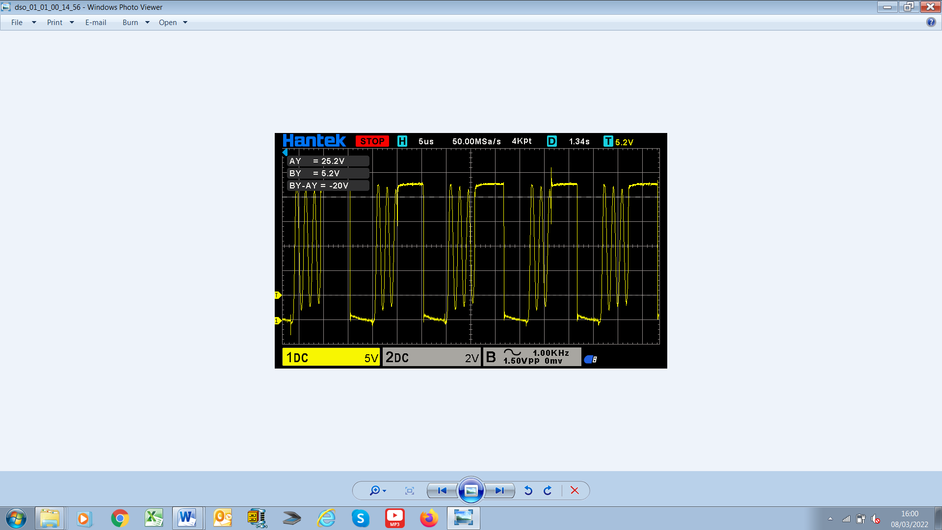

There is, what appears to be a damped sinusoid in between switching. This raises the question: Is this normal, or is a snubber required??