16/03/22

Configuration.

As before, except:

Rfb2, (R29) = 9k

Cin, (C5). 32uF

Under voltage lock out was shown to be 29V

The no load output voltage was 10,8V.

The start-up was clean, and the soft start took 12mS to rise to 10,8V.

The output was loaded with a 33R resistor. The output was 10,80V. The output was clean up to an

input of 60V. The supply current was measured at 269mA at 31V input

The supply at pin 1 of the LM5116:

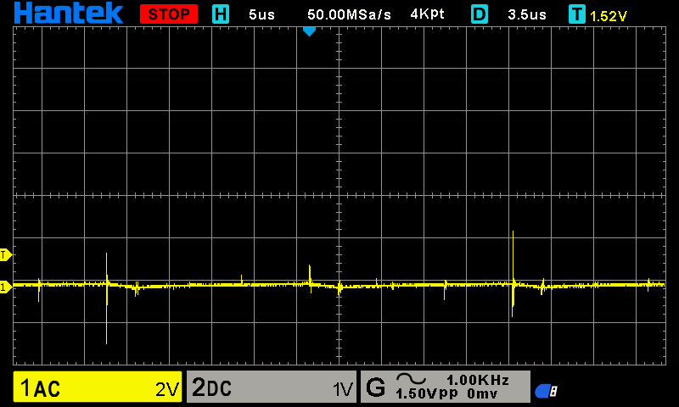

The waveform on the SW pin was:

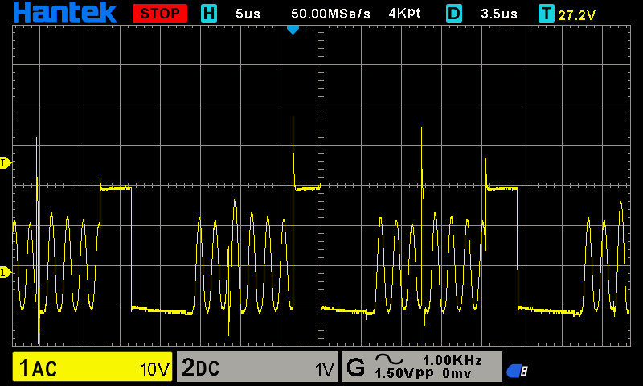

A snubber was applied. 10nF in series with 2R2. This reduced the over shoot to:

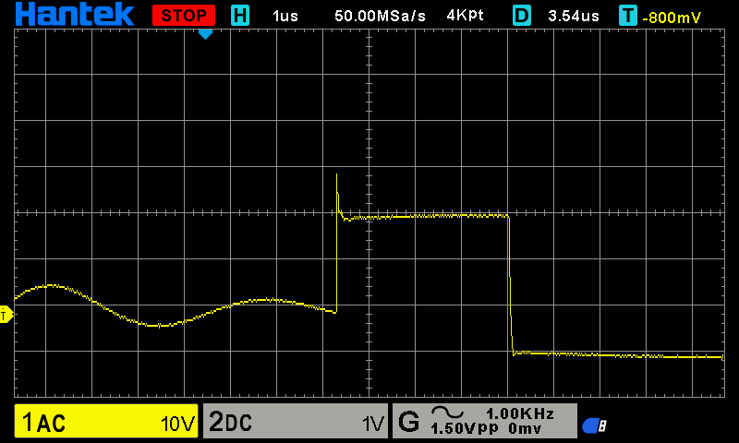

The value of Rfb2, (R29) was changed to 24k in order to increase the output voltage to 24V.

The supply was ramped up, and as the supply exceeded UVLO (nom 30V) the chip failed

Question. Why??