Board 003

New low temp chip. New adapter. 160K res on R29. See board mods tab ’18.02.22’ row

55V input

|  |  |
| --- | --- |
| Pin | V |
| 1 | 54.26 |
| 2 | 1.59 |
| 3 | 1.21 |
| 4 | 54.26 |
| 5 | 292mV |
| 6 | 0 |
| 7 | 296mV |
| 8 | 46.8mV |
| 9 | 5.46 |
| 10 | 111mV |
| 11 | 0 |
| 12 | 0 |
| 13 | 0 |
| 14 | 0 |
| 15 | 47.2 |
| 16 | 7.38 |
| 17 | 111mV |
| 18 | 58.17 |
| 19 | 54.25 |
| 20 | 52.64 |

Pin 20

Test with Inductor Fitted.

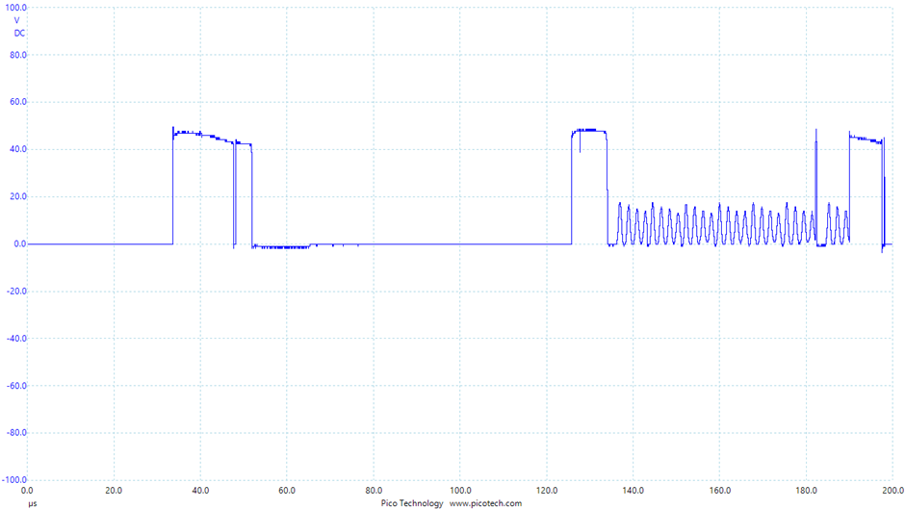

UVLO is set to 42V

V out has been changed to 36V

Chip blew around 43V