B-2 Current waveform at 1 A output load when paralleled with B1-1

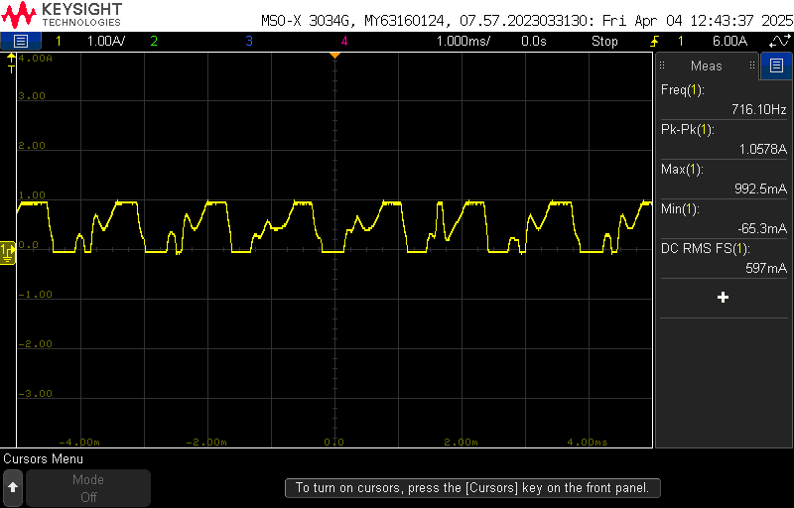

B-2 Current waveform at 2A output load when paralleled with B1-1

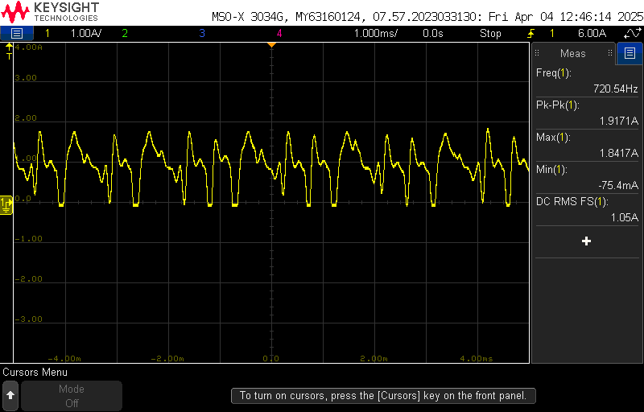

B-2 Current waveform at 3A output load when paralleled with B1-1

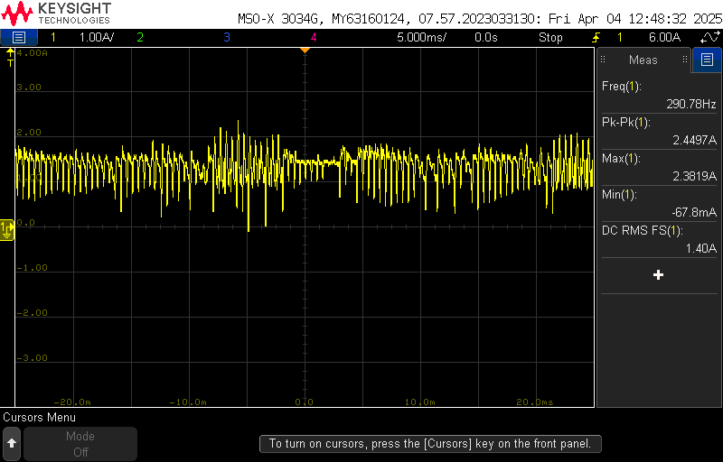

B-2 Current waveform at 4A output load when paralleled with B1-1

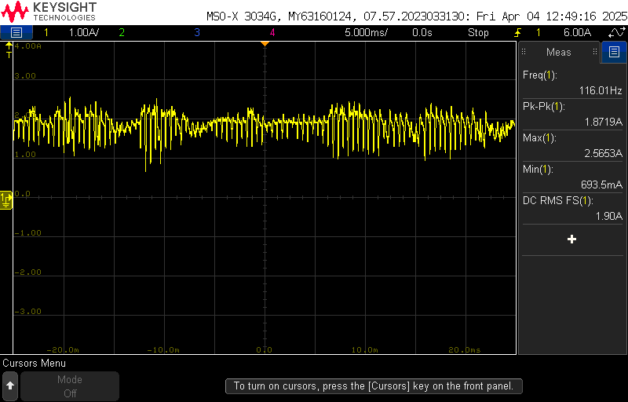

B-2 Current waveform at 5A output load when paralleled with B1-1

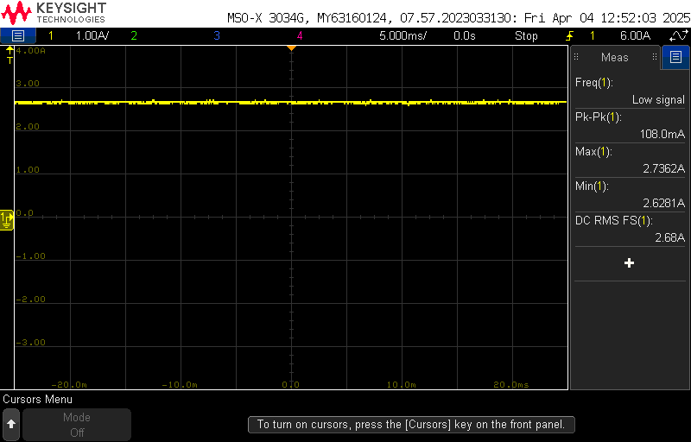

B-2 Current waveform at 6A output load when paralleled with B1-1

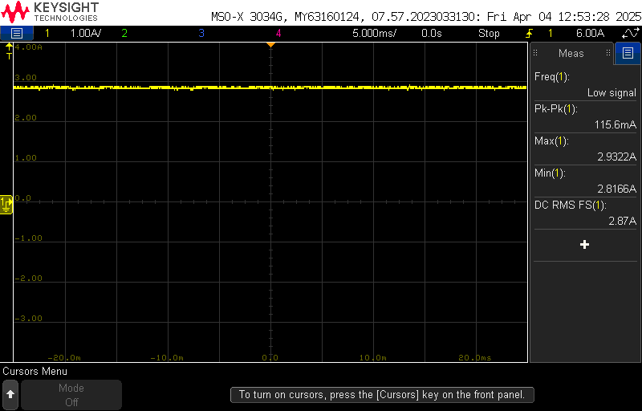

B-2 Current waveform at 7A output load when paralleled with B1-1

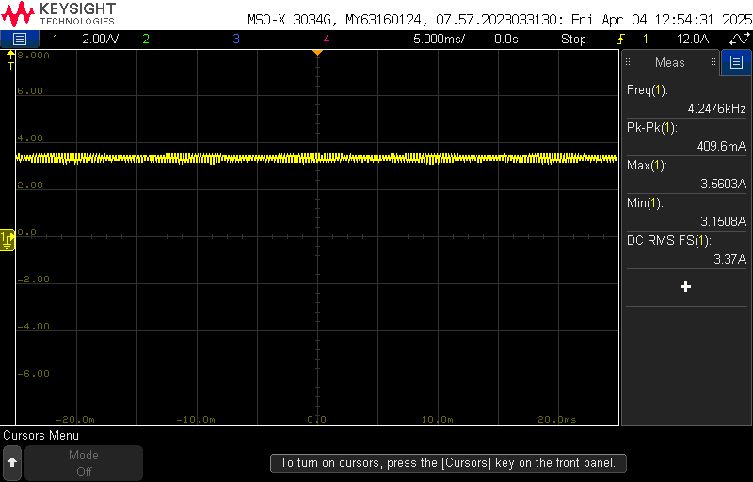

B-2 Current waveform at 8.33A output load when paralleled with B1-1

